PPIE Strategy (2020 - 2025)
The NIHR Health Protection Research Unit in Modelling and Health Economics
The NIHR Health Protection Research Unit in Modelling and Health Economics (HPRU MHE) is a collaboration between Imperial College London (ICL), the London School of Hygiene and Tropical Medicine (LSHTM) and the UK Health Security Agency (UKHSA). It combines the strengths of the three largest teams of infectious disease mathematical modellers in the UK.
The predecessor to the HPRU MHE was the NIHR Health Protection Research Unit in Modelling Methodology (HPRU MM) which was funded from 2015 to 2020 and was a collaboration between ICL and UKHSA. The key objective of the HPRU MM was to develop computerised models to analyse a broad range of health and social care data to deliver improvements to public health.
The core mission of the HPRU MHE is to identify ways that UKHSA can collect, analyse, model and interpret different datasets by developing easy-to-use computer software for use by non-modellers via a training and capacity building programme.
The HPRU MHE has four research themes, listed below. Each theme is co-led by representatives from each of the three collaborating institutes.
- Theme 1: Analysing, predicting, and responding to disease outbreaks and severe pressures on health systems
- Theme 2: Understanding changes to rates of disease: causes and potential interventions
- Theme 3: The behavioural and economic causes of the spread of diseases, and the effectiveness of interventions
- Theme 4: Turning research advances into practical improvements in public health practice

Our PPIE Vision
This strategy sets out the HPRU MHE’s vision and approach to public and community involvement, engagement (PPIE) and participation in research (where relevant). We want to meaningfully involve and engage members of the public and communities from diverse backgrounds and circumstances in as many HPRU (MHE) projects as possible and at as many stages of the research cycle as possible.
Our research is not usually patient facing and is typically of a highly technical nature, at the cutting edge of science developing techniques that are often not understood even by public health specialists, and we will therefore need to develop innovative means of involvement. We want to build closer relationships between the HPRU MHE researchers and public contributors to make our research accountable, transparent, meaningful and relevant to the public.
This strategy reflects the learnings from the PPIE structure which was employed in the preceding HPRU MM where we utilised the advice of a public involvement panel which met quarterly to provide project level advice to researchers. One public panel member sat on the Scientific Advisory Board which met annually. This strategy also aims to be complementary to the HPRU MHE Knowledge Mobilisation Strategy.
We are part of the national HPRU PPIE network and work collaboratively with other HPRUs at Imperial College, LSHTM and in other universities to ensure inclusive and impactful public involvement, public engagement and public participation in our research with patients and members of the public.
We are committed to the UK Standards for Public Involvement. This is reflected in our dedication to provide inclusive opportunities and support, produce accessible and relevant communications, promote collaboration and learning, and systematically collect and share the impact of public involvement, engagement and participation in our research.
We value transparency and accountability and will embed public (and community) representation in our research governance. Both Imperial College London and LSHTM have access to extensive public involvement and engagement resources to implement this strategy (these are set out in more detail at Annex A).
We also have access to a variety of public groups. At Imperial, these include the VOICE portal, our community contacts, the Imperial Young People’s Advisory Network and established mailing lists. LSHTM is a member of UCL Partners, which provides access to roughly 60 public and patient representatives. We also utilise wider networks, such as People in Research and RDS London, and links with other HPRUs hosted at LSHTM to advertise opportunities.

HPRU Governance
The HPRU MHE is led by Professor Neil Ferguson from Imperial College London and the Co-Director is Mark Jit from London School of Hygiene and Tropical Medicine. The Deputy Director is Professor Peter White from Public Health England.
The HPRU MHE is guided by an Executive Group which consists of the HPRU Director and Co-Directors, the Knowledge Mobilisation lead, the UKHSA lead and the HPRU MHE Manager. The Executive Group meets every 6 months and is advised by an Advisory Board which meets annually with a remit to provide an independent overview of research activities and advice on progress.

Responsibility for PPIE
The implementation of the Public Involvement and Engagement (PPIE) Strategy 2020 – 2025 is the responsibility of the PPIE Steering Group (acting on behalf of the HPRU MHE Executive Group). The PPIE Steering Group will comprise five members of the public, the three HPRU PPIE co-leads from each of Imperial College London, London School of Hygiene and Tropical Medicine and Public Health England and the HPRU Manager.
The PPIE Steering Group will act as a critical friend to the HPRU MHE in relation to strategic PPIE. Two public members of the PPIE Steering Group will sit on the Advisory Board to act as a link between the PPIE Steering Group and the Advisory Board. The PPIE Steering Group will meet up to four times a year to review activities set out in the PPIE strategy and/or to provide any other strategic PPIE advice required by the HPRU. An organogram is shown below.
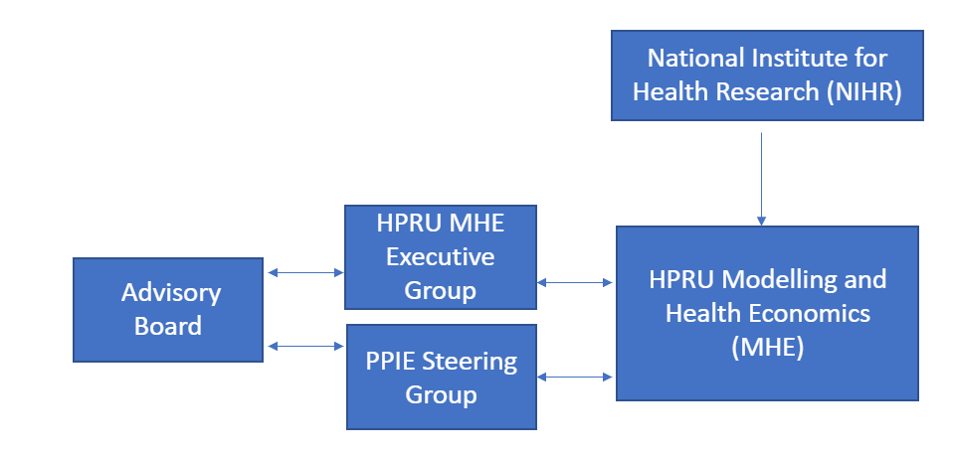
Figure 1: Organogram for PPIE
PPIE Aims
Our aims are:

- To involve members of the public from diverse backgrounds (including age, disability, gender, gender reassignment, ethnicity, sex, sexual orientation, religion and belief, geographical location, marriage and civil partnership, pregnancy and maternity, socioeconomic status, and access to health or social care) by offering inclusive and accessible opportunities.
- To enable meaningful involvement and engagement with our research, we will offer mutually beneficial support and training to both our researchers and public contributors and recognise our public contributors in ways which value their contributions.
- To communicate in plain and accessible ways so the public can understand and use the results of our research.
- To collect, reflect and share the benefits and challenges of public involvement, engagement and participation in our research to improve the experience of public contributors, participants and researchers and the impact of our PPIE activities.
- To include public representation within our research management and leadership.

Approach
These are the activities through which we intend to achieve our aims.
- To involve members of the public from diverse backgrounds (including age, disability, gender, gender reassignment, ethnicity, sex, sexual orientation, religion and belief, geographical location, marriage and civil partnership, pregnancy and maternity, socioeconomic status, and access to health or social care) by offering inclusive and accessible opportunities.

Aim 1 – Activities | Success Criteria | How/who/when
Establish relationships with at least 3 representatives from different underserved or under-represented (in research) communities to join our PPIE Steering Group | Recruit 3 representatives from different underserved or under-represented (in research) communities to our PPIE Steering Group | PPIE Leads recruit 3 representatives to PPIE Steering Group by end of 2021  PPIE Leads manage diversity monitoring to prioritise involvement reviewed annually.
Review and monitor:  - research participants’ anonymised demographic data to ensure research samples are representative of the population  - PPIE contributors’ anonymised demographic data to ensure representative involvement | Ensure study activities and results are generalisable and representative of the public.  Ensure public involvement activities are as representative as possible of the public | Researchers to use/collect demographic data to ensure research samples are representative of the population.  PPIE Leads to collect demographic data to ensure public contributor involvement is representative of the population.  HPRU Manager and PPIE Steering Group (or by the Executive Group) annually.

- To enable meaningful involvement and engagement with our research, we will offer mutually beneficial support and training to both our researchers and public contributors and recognise our public contributors in ways which value their contributions.

Aim 2 – Activities | Success Criteria | How/who/when
Researchers in all themes will undertake PPIE training (See examples in Annex A) | Staff undertake training and follow guidance on basic principles of PPIE.  Staff will utilise learnings from PPIE training and follow appropriate PPIE policies | Provide public involvement online training as part of induction.
Develop alternative and meaningful incentives for public involvement alongside remuneration for time (using NIHR’s 2020 payment policy) | Access provided to incentives such as:  - courses at ICL/LSHTM,  - work experience opportunities  - complimentary food/ refreshments during in-person sessions. | PPIE leads to monitor records of payments/incentives provided annually.  PPIE Steering Group to review annually.

- To communicate in plain and accessible ways so our research population can understand and use the results of our research.
Aim 3 – Activities | Success Criteria | How/who/when
Develop guidance/resources for researchers to produce engaging information such as lay summaries, interactive educational content including infographics, animations, short videos | Each project produces a plain language summary for dissemination to wider public (as per dissemination plan) | HPRU Manager, HPRU PPIE leads, assist project leads to identify research specific dissemination requirements by end of 2021  PPIE Leads consolidate public involvement feedback on adhering to UK Standards into guidance document by June 2021  PPIE Steering Group review and monitor impact annually.
Co-design all public engagement communications and events with public contributors | Hold at least one co-designed PPE event per year | Deliver PPIE event by end of each of: 2021, 2022, 2023 and 2024  PPIE Steering Group to review and monitor impact of lessons learnt after each event

- To collect, reflect and share the benefits and challenges of public involvement, engagement and participation in our research to improve the experience of public contributors, participants and researchers and the impact of our PPIE activities.
Aim 4 - Activities | Success Criteria | How/who/when
Each project lead to complete PPIE impact form (see Annex A) on each project’s PPIE activities and impact (including impact on the research project, public contributors and the researchers) | Achieve meaningful public involvement in at least one stage of the research cycle in every project. | PPIE Steering Committee to review forms every 6 months  PPIE Leads to provide feedback to public contributors after each PPIE activity/ task (within 1 month).  HPRU publishes at least one PPIE paper by 2023
Collaborate with other HPRUs, the HPRU Knowledge Mobilisation Leads, and other organisations to streamline communications and ensure PPIE opportunities are maximised and learnings/resources shared | Establish information and knowledge sharing process which explores impact of delivery of meaningful PPIE in HPRUs | HPRU Leads contribute learnings, knowledge and resources to established HPRU forum/NIHR by end of 2021  PPIE Leads to procure at least 2 blogs on the impact of PPIE on research are published each year.  PPIE Leads to procure presentations on impact of PPIE in HPRU projects at HPRU events  Reviewed by PPIE leads, at least annually.
PPIE strategy to be reviewed by the PPIE Steering Group | Review aims of strategy where little or no progress has been made or amend strategy where activities are not feasible | PPIE leads review and monitor anonymous feedback from PPIE contributors (collected after PPIE activities) and from public members of the PPIE Steering Group re progress with our aims.  PPIE Steering Group discuss how PPIE Strategy improvements and challenges can be addressed in the following months:  - April 2022  - April 2023  - April 2024

- To include public representation within our research management and leadership.
Aim 5 - Activities | Success Criteria | How/who/when
Recruit 5 members of the public with lived experience of our research areas and/or links to underserved (in research) communities to form a PPIE Steering Group to include the PPIE Leads and HPRU Manager | PPIE Steering Group established to provide strategic PPIE advice to the HPRU theme leads and to HPRU PPIE Leads which meets quarterly | PPIE Leads to recruit Steering Group members by end of 2021  PPIE Steering Group to review effectiveness of the PPIE Steering Group annually.
Appoint 2 members of the PPIE Steering Group to sit on the Advisory Board | Two public contributors attend and share their views at the annual Advisory Board meetings | PPIE leads to appoint by end of 2021 and procure feedback from public contributors after each Advisory Board meeting re their experience of their involvement. Using this feedback, PPIE leads to review the appropriateness of public contributors sitting on the Advisory Board annually.

Annex A
PPIE Resources available to the HPRU MHE
Public Involvement Resources
- NIHR Imperial Patient Experience Research Centre Public Involvement Resource Hub
- NIHR Imperial Patient Experience Research Centre’s blog
- LSHTM Patient and Public Involvement (PPI) in Research (a guide for LSHTM researchers):
Public Involvement Training for Researchers and Members of the Public
- Public Involvement in Research online training course (suitable for researchers and public contributors)
Public Networks to involve in Research
- VOICE – online platform for disseminating public involvement and engagement opportunities
- Imperial Young People’s Advisory Network - enables and empowers young people (between 17-25 years old) to shape and influence current and future health and services research
- People in Research – a platform which links members of the public with researchers undertaking PPI. Researchers can advertise opportunities for involvement and members of the public can express their interest in taking part -
- UCL Partners - partnership of academic and clinical research centres, NHS organisations, industry, patients and others which aims to harness research and innovation for excellent patient care and a healthier population
Public Involvement Policies and Standards
- UK Standards for Public Involvement: a public involvement quality benchmark
- NIHR payment policy for public involvement
Public Involvement Impact
- Public involvement Log (People in Health West of England (PHWE) template) - to record feedback from public contributors in order that you can track what changed (or didn't) as a result of their input and use this to complete the GRIPP2 checklist.
- PPIE impact form – for completion after each PPIE activity and at the end of each project
Public Engagement
- Imperial College Societal Engagement team’s public engagement training courses
- LSHTM Public Engagement Advice Surgeries
- LSHTM Public Engagement Network. For further information please see the LSHTM staff and student intranet.
- LSHTM Introduction to Public Engagement Training
PPIE Leads
- Imperial College, London PPIE co-lead – publicinvolvement@imperial.ac.uk
- LSHTM PPIE co-lead - Anna.Carnegie@lshtm.ac.uk
- UKHSA PPIE Co-lead - dale.weston@phe.gov.uk

The term reflects the perspective that the research community needs to provide a better service for people in these groups – the lack of inclusion is not due to any fault of the members of these groups. NIHR - https://www.nihr.ac.uk/documents/improving-inclusion-of-under-served-groups-in-clinical-research-guidance-from-include-project/25435

