**Information for GP Surgeries**

This document contains further details you may find useful regarding the CHARIOT register:

**1)** The main findings of the CHARIOT Study  
**2)** The roles of Neuroepidemiology and Ageing (NEA) Research Unit, Imperial College London and your GP surgery should you wish to join the register  
**3)** The procedures detailing your receipt of payment should you choose to join the register

1. **CHARIOT Study**

**Larsen, M. E., Curry, L., Mastellos, N., Robb, C., Car, J., & Middleton, L.T. (2015)**

**Developing A Register of Cognitively Healthy**

**Older Volunteers: A Descriptive Case Study**

**Background:** There is an increasing focus on identifying people at risk of developing dementia prior to the onset of disease, for inclusion in observational and interventional studies aimed at dementia prevention. The success of this research is predicated on having access to a well characterised, representative and sizeable population of individuals. Contrary to the historical focus on secondary and tertiary care within dementia research, the primary care system in the United Kingdom allows access to a prodromal population prior to symptoms emerging. Here, we assess the feasibility of building a primary care-based recruitment register and discuss the methodological and operational considerations in developing such a tool.

**Aims:** This project aims: To evaluate the willingness of individuals to consent to join a register focused on recruitment for dementia prevention studies and to discuss the development of this research register, outlining the conceptual, practical and ethical challenges.

**Methods:** General Practices across West and Central London were recruited. General Practitioners (GPs) were asked to conduct a database search for cognitively healthy individuals who were between the ages of 60 and 85. GPs then sent an invitation letter to eligible individuals, together with a participant information sheet, consent form and a pre-paid reply envelope.

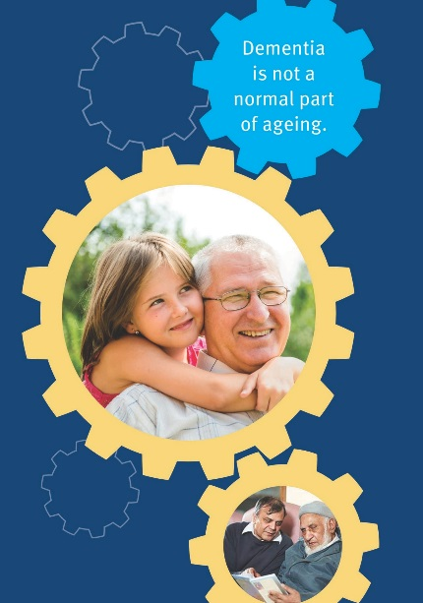

**Results:** 123 surgeries participated in the register, recruiting a total of 24,509 participants (22.3% response rate). Response rates between practices varied between 14% and 34%. Recruitment rates were similar across age and sex, leading to a representative sample of the invited population; higher response rates were noted in the 65-69 age group.



**Conclusion:** Response rates of individuals consenting to join the register indicate strong interest in participation in research studies focusing on neurodegenerative disease and dementia. The simplicity and low cost of the approach point to its scalability across the UK, heralding a novel approach to dementia prevention recruitment.

|  |  |  |  |
| --- | --- | --- | --- |
| What | Who | Where | When/Duration (approx.) |
| **Initial Meeting:** Presentation and questions | Practice Manager and CHARIOT Register Team | GP Surgery | When: After initial agreement from PM via email  Duration: 20-30 minutes |
| **Database search:** identification of eligible participants at the GP practice | CHARIOT register team | GP Surgery | When: After initial meeting  Duration: One hour |
| **GP approval:** GPs review and approve the participant list (optional) | GP Practice team | GP Surgery | When: Within one week of database search |
| **Mailing Invitations**: invitation letter, participant information sheet and consent forms are sent to patients | CHARIOT register team | Docmail (NHS-approved online mail management system) | When: Within 6 weeks of database search |
| **Consent forms processing:** returned consent forms are processed and filed | CHARIOT register team | Imperial College London | When: Immediately when received |
| **First data extraction:** for those who have consented to be on the register – (GP Practice joins the Chariot Register) | CHARIOT register team | GP surgery | When: 2-4 months after invitations are sent  Duration: 2-4 Hours depending on number of consent forms |
| **Payment processing:** £300-500 (depending on size of surgery) | Practice Manager and CHARIOT register team | Imperial College London | When: Process will begin immediately after the extraction  Duration: 2-4 months |
| **Participation:** consented candidates start participating in CHARIOT research projects | CHARIOT register team | Imperial College London | When: Once participant details are put on the CHARIOT database |
| **Subsequent extractions:** £100 typically performed as consent forms continue to arrive | CHARIOT register team | Imperial College London | When: as and when needed  Duration: Ongoing |

**2. Timeline for CHARIOT Register enrolment**

**3) Payment Procedures**

1) Once the first extraction has been completed, the CHARIOT Register team will email the Practice Manager asking for the GP surgery’s bank details with the surgery’s letterhead

2) Finance team at Imperial College London will verify the bank details provided

3) Payment will be made soon after the invoice is received