An Investment in Human Capital and Rural Economies

Annual Report 2021

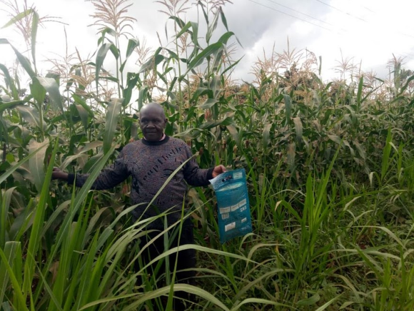

January 2022
Table of Contents
1. Introduction 4
2. Activities that were implemented during the year (2021) 4
2.1 Training on Post-Harvest Handling and Storage 4
2.2 Award of small grants to FBOs for enhanced production 6
2.3 Demonstration Farms 8
2.4 Seed Distribution in Kitui and Kilifi Counties 10
2.5 Monitoring of Individual Farmers and FBOs 11
2.5.1 Records Kept by FBOs 11
2.5.2 Aggregated Quantities of Produce 11
2.5.3 Quality Control Measures by FBOs for moisture content 11
2.5.4 Targeted Markets for Sale of Produce 11
2.5.5 Status of Storage Facilities 12
2.6 Mobile Phone Platform Teachers Refresher Training in Tharaka- Nithi County 12
2.7 Monitoring of Selected Home-Grown School Feeding Programme Schools 12
2.8 Workshops with MOE and Partners 13
2.9 Status of food procurement by schools using the MPP 13
3. Conclusion and Way Forward 17
4. Appendices 18

Executive Summary

Smallholder farmers in Kenya face many production and marketing challenges. These include lack of certified seeds, insufficient knowledge and skills on Good Agricultural Practices (GAP), poor storage of harvested crops, and lack of readily available market to sell their produce. To mitigate these challenges and improve the welfare of targeted farmers, PCD implemented various strategies in 2021 under the investment in human capital and rural economies project. These include training farmers on GAP, setting up demonstration farms, and distribution of certified seeds and farm equipment. The 200 trained FBO leaders have in turn trained a total of 2,909 individual farmers from their groups.
Farmers received small grants to purchase production inputs and equipment to build market systems and boost crop production. Some of the equipment included hermetic bags, tarpaulins, knapsack sprayers and protective gear for post-harvest handling and insect control. These were presented to the FBO’s in all three project areas in June 2021 in the presence of the Sub-County Agricultural Officers (SCAOs), field coordinators and administrative officers (chiefs) in the respective counties. Certified seeds were the production input distributed to the farmer groups in October 2021 just in time for planting during the rainy season that commenced in November 2021. Prior to this, demonstrations farms were established in Kilifi and Kitui Counties in collaboration with two major seed companies (Bayer provided certified maize seeds and Simlaw) to train farmers on Good Agronomic Practices (GAP) to adapt in their farms thus increase production.
PCD in collaboration with the Ministry of Agriculture, Cereal Growers Association (CGA) and Rafiki Development Participatory Partners conducted monitoring visits to selected FBOs and individual farmers to assess the use of the certified seeds by the farmers, other aspects such as keeping records, aggregated quantities of produce and readiness to supply food to HGSF schools when cash is finally received from the government were also assessed during the visits. The schools were also monitored to assess their willingness and ability to procure food through the mobile phone platform (MPP). The response from the monitoring activity was positive; farmers were ready to supply schools that were also willing to procure from smallholder farmers.
Several schools received the school meals money from the government between December 2021 and January 2022. The amount of money disbursed by the government was only enough to cover few days of feeding. Forty-nine schools published tenders on the MPP. Fourteen of these procured the food from FBOs through the MPP. The food items procured through the system included maize (12,040kg), beans (3,490kgs), rice (250kgs), oil (420 liters) and salt (73kgs).

Introduction
On 8th September 2021, the president of Kenya declared drought as a national disaster. The cumulative impact of two consecutive poor rainy seasons, coupled with the COVID-19 pandemic, insecurity, pests and diseases had caused humanitarian needs to rapidly rise in the Arid and Semi-Arad Lands (ASAL) of Kenya. Smallholder farmers across Kenya face many challenges including lack of certified seeds, insufficient knowledge and skills on Good Agricultural Practices (GAP), poor storage of harvested crops, manual harvesting of crops which is time-consuming and lack of readily available market to sell food. An Investment in Human Capital and Rural Economies project contributes to the mitigation of these challenges through various activities which include awarding grants to selected Farmer Based Organizations (FBOs), training on production and, linkages to the school feeding market.

The year 2021was marked with significant development in the implementation of the project activities after the relaxation of Covid 19 infections and restrictions. Most of the activities that had been delayed in 2020 due to the pandemic were undertaken. The activities were aimed at boosting crop production and building market systems for FBOs enrolled in the project and schools participating in the Home Grown School Feeding Production (HGSFP). These activities are enumerated in the following sections;

Activities that were implemented during the year (2021)

2.1 Training on Post-Harvest Handling and Storage
Training on Post-Harvest Handling and Storage was conducted between January to March 2021 to FBO leaders in Kilifi, Tharaka-Nithi and Kitui Counties. The objective of the training was to enlighten farmers on how to maintain the quality and food safety of the harvested produce and empower them to reduce post-harvest losses i.e. losses between harvesting and consumption/marketing of the crop thus increasing household income. It was done in collaboration with experts from our partner (Cereal Growers Association) and Rafiki Participatory Development Partners and Ministry of Agriculture. Each FBO was represented by two leaders thus a total of 60 farmers in Kilifi, 68 in Tharaka Nithi and 72 in Kitui County. All COVID-19 rules were observed strictly with small groups of farmers being trained per day.
The training focused on the following areas;
- Grain quality issues - the importance of producing good quality grain
- Post-harvest handling of new produce - how to prepare for the harvest including proper timing and transportation of harvest to storage
- Drying grain - how to dry grain and determining when the grain is dry enough for storage
- Threshing and cleaning grain - how to thresh, sort, and clean grain
- Grain storage - different methods of storing grain including insect-proof and hermetic bags, plastic bags, and plastic/metal drums
- Insect pest control - how to use insecticidal dust to control pests and the solarization of grain
- Collective aggregation, marketing and its benefits - the benefits of conducting joint aggregation of produce and marketing

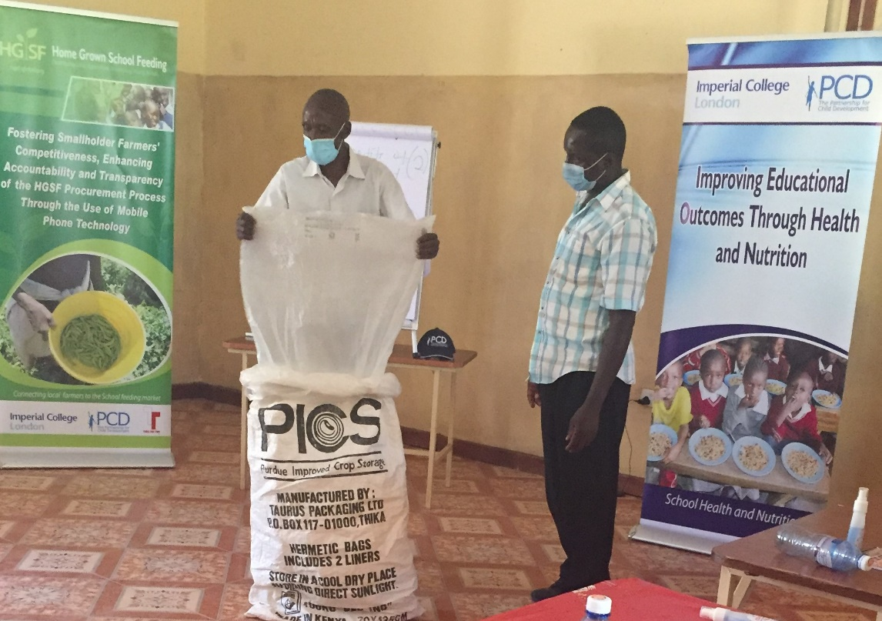
Figure 1:A trainer (CGA) demonstrating how to use a hermetic bag for long term storage of grains

A follow-up was made to FBOs to ensure that the training was passed down to the rest of the members. Table 1shows the number of farmers trained by the FBO leaders.

Table 1: Number of farmers trained on Post-Harvest Handling and Storage
County | No. of farmers trained on GAP |  | Total
 | Male | Female
Tharaka Nithi | 405 | 519 | 924
Kitui | 421 | 762 | 1,183
Kilifi | 239 | 563 | 802
Total | 1,065 | 1,844 | 2,909

Emerging Issues
During the plenary discussions at the trainings, the following issues emerged;
- Some of the farmers did not have storage facilities and therefore stored grain inside their houses; in the living room and even bedrooms for security reasons. This has negative effects on the food quality and on their health as the rooms have little or no ventilation and they end up inhaling the insecticides in the grain.
The farmers were sensitized on the safe storage of grains even without a storage facility. A lot of emphasis was put on the use of hermetic bags which are airtight and insect-proof when used properly; thus no insecticides are required when it is in use. It can therefore be used safely inside the house without exposing members of the household to danger while preserving the quality of the food.

- Mechanical threshers are quite expensive hence out of reach to a lot of farmers who use outdated methods to thresh their grains such as beating with sticks. The threshers are used to separate grains such as maize, beans and green grams from the pods and husks after the harvest. None of the FBOs reported owning one.
PCD managed to procure five multi-crop threshers which were issued to FBOs that requested for them through proposals. These will serve members of the respective FBO and the larger community at a fee for maintenance and sustainability.

- Farmers are still using very traditional methods of cleaning their grains especially winnowing. These methods can only be used for very little quantities of grain and are therefore time-consuming and inefficient. Farmers needed support to acquire modern equipment that will help to save time and energy.
Four sieves were awarded to four FBOs to clean larger quantities of grains; they can be used for cleaning grains at the aggregation center/store or individually at their homes after harvesting. Farmers were also advised to use locally available materials to construct sieves for their use at home.
- The traditional method of keeping some of the harvested and dried grains to be used as seed during the next planting season is still being practiced by some farmers. This was highly discouraged since recycling seeds lowers productivity hence lower incomes.
Farmers were advised to use certified seeds for higher productivity and income. Further, demonstration farms were set up where certified seeds were used to sensitize the farmers on the value of using certified seed thus encouraging adoption.

Recommendations
The following recommendations were made to the government officers present and the participating farmers and stakeholders.
- A more sustainable approach is the government through the Ministry of Agriculture to provide mechanical threshers at a subsidized price to the farmers.
- Farmers are encouraged to register as members of FBOs to benefit from equipment, safe storage and security to which individual members would otherwise have no access.

2.2 Award of small grants to FBOs for enhanced production
Following the proposal writing training exercise that was done along with GAP training in 2020, FBOs were encouraged to write grant proposals for the award of farm input and equipment to enhance their production. 25 proposals were reviewed from Kilifi County, 29 from Tharaka-Nithi County and 17 from Kitui County.
The proposals were reviewed at two levels in February-March 2021, first by the field coordinators in the respective counties, followed by final authentication by a panel of assessors drawn from PCD, M-Farm, and Cereal Growers Association (CGA) at Nairobi. The majority of the FBOs requested hermetic bags which are used for long-term storage of grains, tarpaulins for drying grains after harvest, knapsack sprayers for insect and pest control while a few requested for ox ploughs, threshers and pallets. They were evaluated on a 50-point scale for;
- Clarity in the FBOs’ vision, mission, objectives and main activities
- Justification for funding
- A clear, realistic and achievable budget
- A realistic demonstration by the FBO to mobilize some percentage of the resources needed

The procurement process
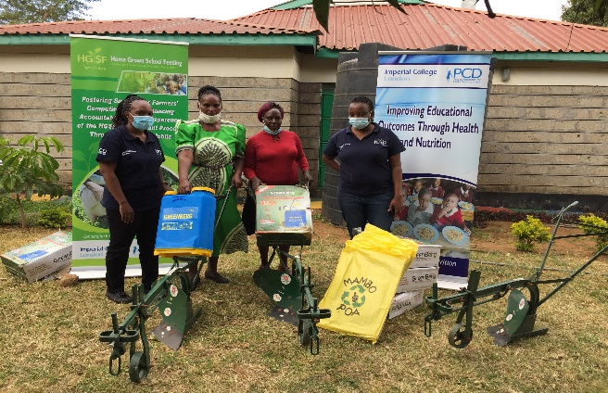
Three quotations were obtained for each piece of equipment that was requested by the FBO’s in each county. One final quotation was then chosen. Contact was made with the chosen supplier to ensure the availability of equipment/tools at the warehouse. The items were then purchased and delivery dates to the FBOs’ store/location and the necessary logistics were agreed upon. They were then presented to the FBOs in all three project areas in June 2021 in the presence of the Sub-County Agricultural Officers (SCAOs), field coordinators and area administrative officers (chiefs). A list of tools and equipment issued to specific FBOs in the respective counties is provided in the annex.
Figure 2: Representatives of an FBO in Kitui County receiving ox ploughs, knapsack sprayers and tarpaulins

Table 2 presents a summary of the tools and equipment issued to the farmer groups in the three counties.

Table 2: Summary of equipment issued
ITEM | Kilifi | Kitui | Tharaka-Nithi | TOTAL
Knapsack sprayers | 38 | 32 | 18 | 88
Protective gear | 19 | 18 | 12 | 49
Hermetic bags | 457 | 690 | 0 | 1147
Tarpaulins | 70 | 38 | 5 | 113
Seal stitching machine and thread, wiring of the store and electric cables | 0 | 1 | 0 | 1
Wooden Pallets | 0 | 10 | 0 | 10
Sieve | 0 | 4 | 0 | 4
Ox plough | 0 | 8 | 3 | 11
Multi-crop Thresher | 0 | 1 | 4 | 5

Of the 71 proposals received, 45 were funded. The rest failed to get the grant because they had requested funding outside the scope of this project, mostly in the area of water and sanitation, for example, irrigation equipment, water tanks and boreholes. However, quite some FBOs specifically in Kilifi and Kitui Counties requested certified seeds and it was apparent that they needed support for the same. There will be a second round of assessment this year (2022) where a few deserving FBOs will benefit from grants.

2.3 Demonstration Farms
Our interaction with farmers revealed the need to emphasize the use of certified seeds to increase yields. This was especially so among farmers in Kilifi and Kitui Counties where reports including baseline and monitoring indicated that there was a big number of farmers who used the previous years’ harvest for planting in the new season. As a result, PCD, in collaboration with seed companies established demonstration farms to encourage the adoption of certified seeds. Bayer Seed Company provided certified maize seeds, fertilizer and technical support from land preparation to the entire process of growing maize while Simlaw Seed Company provided certified bean seeds and technical support on the same. These demonstration farms were used as a learning platform to teach farmers Good Agronomic Practices (GAP) to adapt them to their farms.
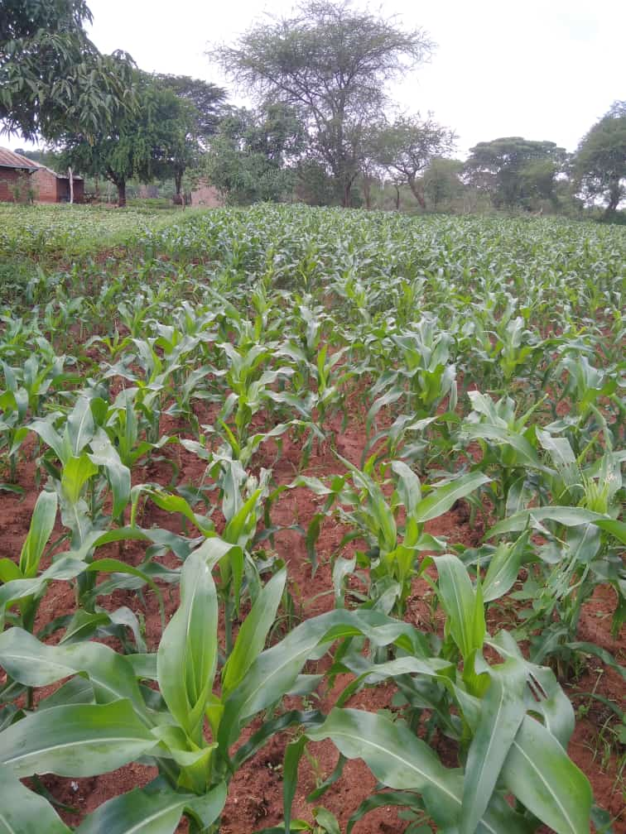  Figure 3: Maize demo farm in Kitui County | 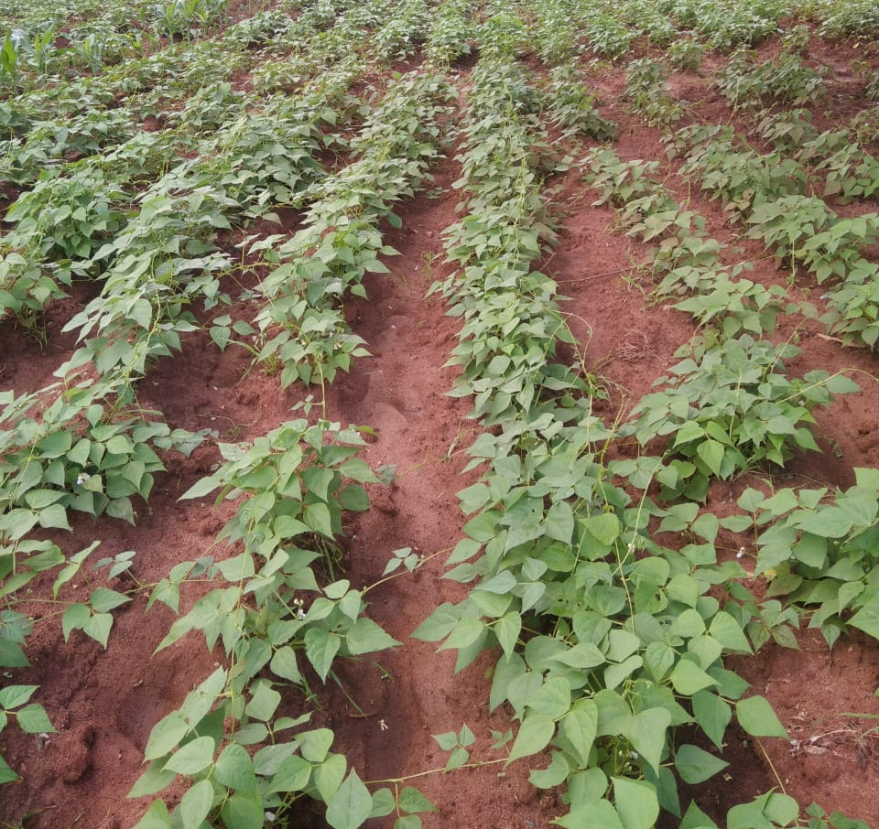  Figure 4: Beans demo farm in Kitui County

There were four demo farms each in Kitui and Kilifi County. Those in Kilifi County were done in June while the ones in Kitui were done in November 2021. Despite the little rainfall that was received during the short rains season in Kilifi County, the farmers learned valuable lessons in GAP such as land preparation, spacing and placement of seeds during planting, how to determine soil fertility through soil testing and taking appropriate action (application of suitable fertilizers). Farmers have started using organic manure which was previously thought to make the soil hard and they are practicing conservation agriculture such as terracing and growing cover crops such as grass. They also reported that certified seeds seemed to withstand harsh climatic conditions better than recycled seeds. The demo farms in Kitui County are doing well and farmers are replicating the activities undertaken in the demo farms in their farms.

2.4 Seed Distribution in Kitui and Kilifi Counties
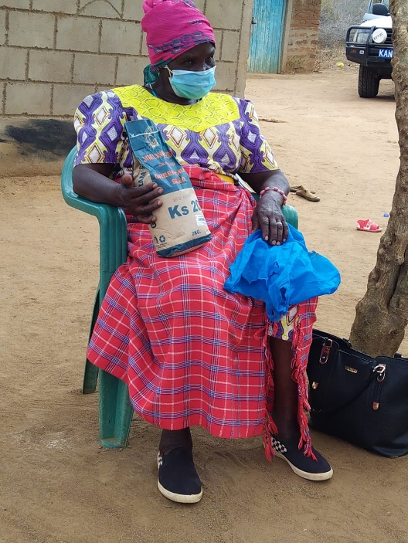
To reinforce the lessons learnt from the demo farms, PCD distributed certified seeds to selected FBOs in Kitui and Kilifi Counties in October 2021, to increase the production of maize and beans for sale to schools. Research has shown that certified seeds prevent the spread of weed species via seed, thereby reducing the number of treatments required with herbicides while also reducing costs and increasing yields by up to 30%. The objectives of seed distribution were;
Figure 5: A farmer holding a bad of certified seeds in Kilifi County
- To promote the culture of using certified seeds among farmers for improved crops
- To increase the yield of crops harvested to have adequate quantities to sell to the HGSFP market
The entire process from the delivery of seeds from the supplier to the FBOs and from the FBOs to the individual farmers was monitored to ensure that the seeds were received by all selected farmers. To ensure accountability in the process there was;
- A focal person (field coordinators from our partner organizations) at the county to receive the seed from the supplier during delivery
- A specific central delivery location where all FBOs could easily collect their seed in each county
- An FBO leader to ensure that the supplied seeds were distributed to the farmers
Table 3 gives a summary of the quantity of seeds supplied to selected farmers in Kitui and Kilifi Counties
Table 3: Summary of acreage and quantity of certified seeds issued to selected FBOs
Particulars | Kitui County | Kilifi County | Total
Maize
Size of land (acres) | 187 | 140 | 327
Quantity of seed (kgs) | 1,496 | 1,120 | 2,616
Beans
Size of land (acres) | 96 | 73 | 169
Quantity of seed (kgs) | 1,440 | 1,095 | 2,535

A monitoring visit was done one month after planting had commenced ensuring that the seeds were received by the identified farmers and planted. All FBOs collected the seed from the pickup point at their own cost. Acceptability of certified seed was high as farmers had already observed the quality and quantity of harvest produced by certified seeds planted by other farmers in the neighborhood. We anticipate that farmers will be willing to buy and use certified without external support after they witness the positive results by the farmers who used the seeds during the November 2021 planting season. Attached in the appendix are the monitoring forms that were used to account for seed collection and distribution to individual farmers.

2.5 Monitoring of Individual Farmers and FBOs
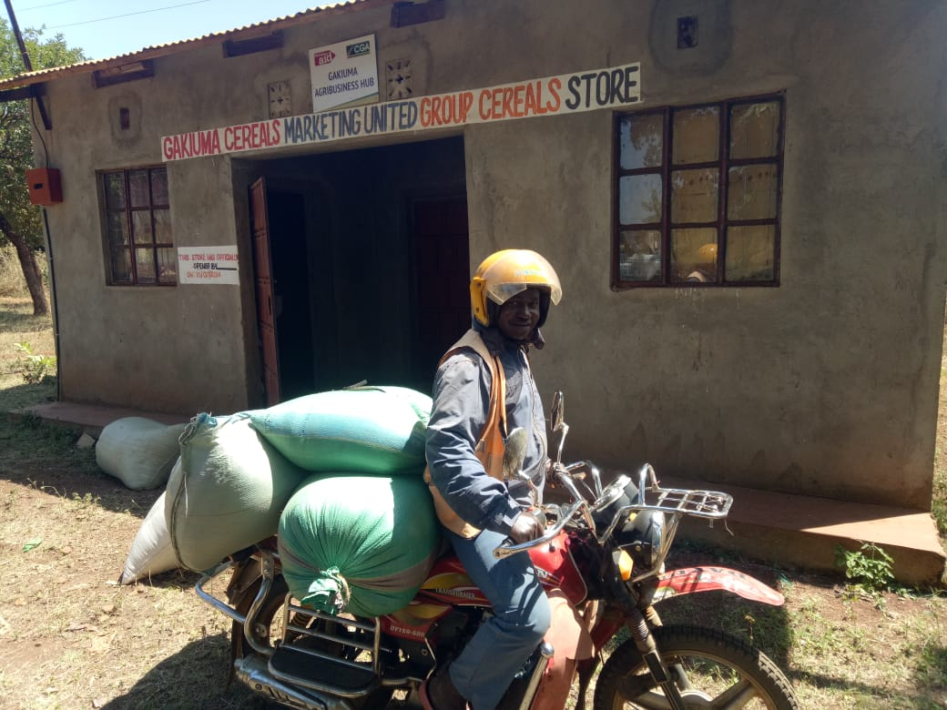
As part of monitoring of project activities undertaken thus far, a survey was conducted in the three project counties to assess various aspects of the project. The indicators monitored were records kept by FBOs, aggregated quantities of produce, quality control measures practiced by FBOs, target markets for the sale of produce, the status of storage facilities, acceptance and use of certified seeds and lessons learned from the training on Good Agricultural Practices and Post-Harvest Handling. Key highlights of the monitoring are presented below;
Figure 6: A farmer delivering his produce to the FBO aggregation center

2.5.1 Records Kept by FBOs
A variety of records are kept by FBOs including receipt books, delivery books, visitors’ books, minute books, stock in and out forms, and registers. They were encouraged to keep up-to-date records as some were outdated or irregularly recorded.

2.5.2 Aggregated Quantities of Produce
Crops with the highest aggregated quantities in 2021were maize (232,300kgs), green grams (140,900kgs) and sorghum (56,650kgs). The largest producer of maize (154,500kgs), green grams (116,150kgs) and sorghum (55,750kgs) were Kilifi, Kitui and Tharaka Nithi respectively.

2.5.3 Quality Control Measures by FBOs for moisture content
Most FBOs measured the moisture content using traditional methods. These include biting the grain, analyzing sound made by the grain and the salt method. In the latter, some grains are put in a glass container with some salt, shaken together and left to stand for a few hours. If the bottle remains dry, the grains are well dried but if the salts stick to the sides of the bottle, the grains need further drying. The more advanced FBOs used moisture meters.

2.5.4 Targeted Markets for Sale of Produce
By the time the survey was done, HGSFP schools had not received cash to buy food, therefore, most farmers sold their crops to local traders and households. However, most FBOs declared that they were ready to sell their aggregated produce to the HGSFP schools when cash will be availed. They requested a refresher training on the mobile phone procurement system (MPP) as they were trained over a year ago and had not had a chance to use it. A refresher training will take place in February after the current cycle of procurement where gaps observed will also be addressed.

2.5.5 Status of Storage Facilities
The storage facilities among FBOs ranged from poor to well-kept but needed improvement. Group stores have more elaborate equipment such as weighing machines and moisture meters; for instance, Kawongo CBO in Kitui County has metal silos and a posho mill for value addition. A large proportion of individual farmers kept their grains in one of the rooms in the house.

2.6 Mobile Phone Platform Teachers Refresher Training in Tharaka- Nithi County
A Mobile Phone Platform (MPP) refresher training was conducted for headteachers and home-grown school feeding programme teachers in Tharaka- Nithi County between 30th August and 1st
September 2021. A total of 37 schools were involved in the MPP training. The training covered the background of PCD and its partnership with MoE, World Food Programme (WFP), CGA and FBO’s (Farmer Based Organizations) to bring together a team of people that could support the HGSFP in selected counties in Kenya. The teachers were then taken through an overview of the HGSFP; objectives, scope, the food basket and rations and some of the key lessons learnt from the HGSFP thus far.
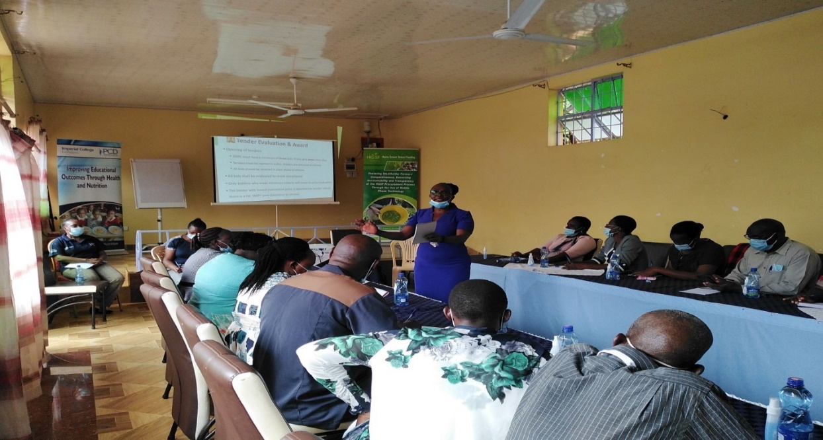
Figure 7: Ms. Bernett Walema from the Ministry of Education giving an overview of the HGSFP

The teachers were also briefed on the HGSFP implementation guidelines particularly on the selection of school meals committees, qualifications for FBOs and other suppliers, food quality control measures, school health, hygiene and nutrition and the reporting and monitoring process after food purchases. Finally, the teachers were reminded of the tendering system flow, that is, registration of their schools, school feeding management, creating tenders, bid opening, price information details and food delivery.

2.7 Monitoring of Selected Home-Grown School Feeding Programme Schools
A school monitoring exercise was conducted in selected schools from the three counties from November to December 2021. The activity was undertaken in conjunction with officers from the Policy Department of the Ministry of Education. The objective of the monitoring activity was two-fold; to determine the readiness of the schools in procuring food using the mobile phone platform and for the officers from the Policy Department to confirm that we are implementing the project according to the concept presented to them when renewing our terms of engagement with MoE.
The teachers were well versed with the MPP for use in purchasing food in the HGSFP. They were able to confidently explain the tendering process to the officers from the MoE. The schools were therefore ready to purchase food as soon as school meals money was released to them from the government. Schools already had cooks, water for cooking, and in some cases, newly built kitchens awaiting the food that will be purchased.
Challenges experienced by schools included the high cost of data bundles that are needed to do online procurement, failure to remember the procurement procedures as time goes by without the release of funds from the MoE and network challenges are experienced in some areas.

Emerging Issues/recommendations
- Teachers were encouraged to make use of the mobile phones provided by PCD to avoid the sim card being blocked by the service provider due to inactivity. This has been the case in several schools where they had to replace the sim cards.
- Technical support and/or refresher training was required as most teachers are not technologically savvy and needed to be reminded of the procurement procedures ahead of the release of funds for HGSF procurement.

2.8 Workshops with MOE and Partners
One of the sustainability plans for this project is for the Ministry of Education (MoE) to adopt the MPP model on a national scale. PCD has had a series of meetings with MoE to discuss how best to integrate or adopt this system of procurement at schools. MoE through the support of WFP has already digitized the in-kind school feeding modality which involves MoE procuring the food centrally at the national level and distributing it to schools in the arid regions of the country. The discussions are therefore on how to best integrate or adopt the PCD model of a digitized Cash modality school feeding. The discussions are still underway. If the integration is successful, Kenya will have a fully digitized National School Feeding Program.
In addition, PCD is participating in the development of the Kenya School Meals Policy. The policy highlights procurement of school food from local small holder farmers as one of the promotion of food quality strategies.

2.9 Collaborations and Partnerships
PCD maintains relevant partnerships and collaborations with government and other development partners as well as forge new ones. Some of the existing partnerships are with the World Food Program(WFP), Kenya Medical Research Institution(KEMRI), Ministry of Education- School Health and Nutrition Unit, Ministry of Agriculture, and Cereal Growers Association(CGA). In 2021-22, PCD initiated new partnerships that leverage on this project’s objectives. The partnerships include with Food for Education(F4E), a local NGO that serves food to over 30,000 school children through a central kitchen. F4E is committed to purchasing Iron/Zinc fortified beans from PCD project pool of farmers through M-Farm to prepare for the school children. This is an initiative funded by the Rockefeller Foundation through WFP regional office. Discussions on the partnership model are still in process.

2.10 Status of food procurement by schools using the MPP
Schools finally received school meals money from the national treasury for the procurement of food. The fund disbursement has been halted for the last three years following the COVID outbreak. The funds disbursement was done from December 2021 to February 2022. Through the field coordinators, we intensified technical support to the teachers on how to publish tenders through the MPP and also to the farmers so that they could bid for tenders through the platform. M-Farm was also readily available for support to both schools and FBOs during the tender submission and bidding processes.
  - Number of schools that published tenders and procured food through the MPP
By the end of February 2022, 49 schools out of the 100 participating in the project had published their tenders on the MPP. Notably, not all the schools received cash from the government; there were hitches with the disbursement of the cash due to inactive bank accounts and other logistical issues. Therefore, some schools did not receive their cash by the time they closed for March/April school holidays. Out of the 49 schools that published tenders on the MPP, 14 procured food commodities from FBOs through the system (Table 4)
Table 4: Number of schools that procured food through the MPP by county
County | No. of schools participating in the project (N) | No. of schools that published tenders on the MPP | No. of schools that procured food from FBOs through the MPP
Kitui | 36 | 14 | 7
Kilifi | 30 | 18 | 5
Tharaka Nithi | 34 | 17 | 2
Total | 100 | 49 | 14

Fourteen schools purchased the food through the platform. Several reasons were given by both the teachers and the farmers on this suboptimal utilization of the MPP as outlined later in the challenge section of this report.

    - Food commodities and quantities that were purchased through the MPP
The food basket for the HGSFP consists of four food categories; cereals, pulses, oil, and salt. Each school is required to purchase food items from the four categories while trying to achieve dietary diversity for optimum nutritional benefits to the children. However, there is an overreliance on maize and beans as the major sources of carbohydrates and proteins respectively. The schools are also at liberty to purchase vegetables and fruits if their budgets allow. Table 5 illustrates the food commodities and quantities that were procured by the schools through the MPP.
Table 5: Type and quantity of food purchased from FBOs through the MPP by county
County | Food commodities procured from FBOs through the MPP
 | Maize (kg) | Rice (kg) | Beans (kg) | Oil (lts) | Salt (kg) | Onions (kgs)
Kitui | 6,030 | - | 1,890 | 220 | 13 | -
Kilifi | 4,550 | - | 1,200 | 160 | 50 | -
Tharaka Nithi | 1,460 | 250 | 400 | 40 | 10 | 10
Total | 12,040 | 250 | 3,490 | 420 | 73 | 10

As observed, maize and beans were the cereal and legume of choice to the schools. A total of 12,040 kgs of maize and 3,490 kgs of beans was procured through the MPP. A few schools added rice to their diet while one school in Tharaka Nithi County procured onions through the platform.
    - Challenges encountered during the procurement process

Challenges experienced by schools
School teachers reported experiencing challenges as below.
- Schools received less than expected amount of the school meals money from the government for the purchase of food. Schools that received very little money did not publish tenders on the MPP but instead opted to buy the food from the local traders.
“I had only Kshs 9,240 (USD 82), so nobody would have tendered with such money”.
Head teacher, Tanganyika Primary School
PCD will clarify to teachers that the system does not discriminate on the amount of money teachers receive, it is good for accountability and transparency, therefore teachers should ensure to use it regardless of the amount of money they receive from the MoE.

- Some teachers struggled with issues such as freezing/hanging of the mobile platform and very slow responses when attempting to publish a tender, thereby reverting to manual tendering. Others had forgotten their login credentials and parts of the process and gave up before they could be supported by the field coordinators and/or PCD/M-Farm team.
“Several teachers tried placing the tender but it didn't go through”.
School meals teacher, Mamole Primary School
Farmers and teachers will be reminded to hold the tender opening and bidding committee meeting in an area that has a good network, maybe near the closest town so that they can negate the issue of network. Refresher training for teachers will be done in 2022.

- Some teachers expressed disappointment after finding out that some individual farmers in their neighborhood were unaware of the platform. They advised that more farmers in their locality should be trained on the use of the MPP so that they could buy food from them.
“The farmers around are not well versed with the system”.
Head teacher, Nzeve Primary School
PCD will further encourage the local farmers to register with the FBOs to benefit from the MPP system. It will also be clarified to schools that only farmers registered in FBOs can participate in HGSFP food procurement through the MPP.

- Some of the bids received from FBOs were too high (prices quoted were too high) and therefore opted to procure manually from traders in the market.
FBO refresher training conducted in March 2022 addressed the issue of high bid prices. Some FBOs quoted high prices erroneously, for instance quoting the cost of the entire quantity requested instead of the price of one bag of food. During the re-fresher training for the teachers, PCD will encourage the process of communication or negotiations such that, the teachers contact FBOs and find out why their prices are way above market prices before resolving to use traders.

- Many FBOs registered in the MPP did not bid/respond promptly. Some schools received 1 or 2 bids and some got none. The schools that did not receive bids promptly from FBOs procured from traders.
“I feel as though the platform did not have enough farmers”.
Head teacher, Gakurungu Primary School
Procurement procedures states that it should take 14 days from tender publication to the opening of bids. This was a special case scenario where teachers needed the food urgently and therefore not keen on the procedures.

- It was also reported that despite receiving school meals funds from the government, some schools did not publish tenders through MPP or buy food from traders. This is because some schools received funds too close to the end of the school term, they are therefore expected to publish tenders at the beginning of the next term which begins in May 2022.

Challenges experienced by Farmer Based Organizations

- Majority of FBOs did not bid for school tenders as they did not have food in their stores. Kenya experienced sparse and poorly distributed rainfall in all the cropping seasons in 2021 that resulted in little or no harvest among smallholder farmers throughout the country. However, a few farmers harvested smaller quantities than usual and when put together, they were able to supply a few schools.

- Few FBOs had forgotten the process of registering their bids and therefore halfway through the process, they were unable to complete the registration of their bids. Others forgot their login credentials and therefore did not even begin the bidding process.
PCD advised the FBO leaders to use the project phone in the daily activities of the FBO and log into the system every so often and practice how to bid for tenders. This will solve the issues of forgetting the pin and login credentials during procurement.

- FBOs wrongfully assumed that they could only register a bid for one school. During the refresher training exercise, it was clarified that FBOs should bid for as many tenders as possible provided they have the capacity to supply the required commodities.

- As it was the first time that schools used the MPP to publish tenders, they made errors such as requesting documents such as income tax compliance and certificates of incorporations from FBOs which is a stipulation for traders, not FBOs. This disqualified FBOs as they did not have such documents.
PCD will clarify to schools what documents are required for FBOs and what documents are required for traders.

Conclusion and Way Forward
It is evident that the project is on course and the objectives will be met. The first round of tendering using the MPP shows that both schools and FBOs put a great deal of effort to participate. It has also paved the way for the uptake of the HGSFP objectives of strengthening the local economy and feeding children nutritious and locally available food as well as increasing transparency on the use of funds. We are enthusiastic that HGSF schools will continue procuring food through the mobile phone platform thereby providing a market for the smallholder farmers and improving their incomes. A lot of effort has been put to build the capacity of farmers through their FBOs for them to produce food that meets the quantity and quality requirements of the HGSFP and other markets. We hope that the government will be consistent in transferring cash to schools for the benefit of school children and smallholder farmers. This being the last year of project implementation, we intend to do the following to maximize the impact;
- Support the Ministry of Education in the digitization of the school feeding programme specifically the cash transfer model which is the HGSFP. This includes the integration or adoption of functions of our Mobile Phone Platform (MPP) for procurement into the National Education Management Information System (NEMIS).
- Continue to support farmers on Good Agricultural Practices and Post-Harvest Handling to enhance productivity and linkages to markets. We are working closely with field officers from the Ministry of Agriculture for continuity.
- Carry out regular monitoring of schools and FBOs to give support on the use of the MPP.
- Use the feedback from the first cycle of procurement to draw recommendations for changes/modifications in the MPP system functionalities. This will ensure that the process is more efficient and easy to follow by both the schools and FBOs.
- Link FBOs to other market through the MPP.

Appendices
- Tools and equipment issued to specific FBOs by county
Kilifi County
No | Name of FBO | Item granted | Quantity
1 | Mikahani Farmers Association | Knapsack sprayer  Protective gear  Hermetic bags  Tarpaulin | 2  2  25  4
2 | Mavuno Bora | Hermetic bags  Tarpaulins  Knapsack sprayer  Protective gear | 20  4  2  2
3 | Kuna Nuru Shambani | Hermetic bags  Tarpaulins  Knapsack  Protective gear | 50  4  4  2
4 | Mwakuhenga KCEP CRAL | Knapsack sprayer  Protective gear  Tarpaulins  Hermetic bags | 2  2  4  25
5 | Vindakala SHG | Tarpaulins  Hermetic bags | 2  10
6 | Wakulima Mwembekati | weighing scale  Tarpaulins  Hermetic bags | 1  2  10
7 | Kizingo Faidika farmers | Knapsack sprayer  Spraying gear  Tarpaulin | 2  1  2
8 | Galilaya SHG | Knapsack sprayer | 1
9 | Mwakuhenga Youth group | Knapsack sprayer  Protective gear  Hermetic bags | 1  1  12
10 | Chimangaro SHG | Hermetic bags  Tarpaulin  Knapsack  Protective clothing | 10  2  2  2
11 | Mwawesa Agrobiz | Tarpaulins  Knapsack  Protective gear | 2  2  2
12 | Tunaweza SHG | Knapsack sprayer  Tarpaulin2 large  Hermetic bags | 1  4  20
13 | Kuluhiro farmers | Hermetic bags  Tarpaulins | 25  4
14 | Imani Maandani | Hermetic bags  Tarpaulins  Knapsack  protective gear | 20  4  2  2
15 | Wesa KCEP | Knapsack sprayer  Hermetic bags  Tarpaulin | 4  40  4
16 | Ebenezer FFS Self Help Group | Knapsack Sprayer  Protective gear  Tarpaulin  Hermetic bags | 1  1  3  25
17 | Katsungwini Lakani Women Group | Hermetic bags  Tarpaulins  Knapsack sprayer | 30  3  2
18 | Majajani KCEP-CRAL SHG | Hermetic bags  Tarpaulins | 20  4
19 | Kizurini Ukulima | Hermetic bags  Tarpaulins | 30  4
20 | Kuna Nuru Angani | Tarpaulins  knapsack sprayer  Hermetic bags | 4  4  30
21 | Uwezo women group | Knapsack sprayer  Tarpaulin  Hermetic bags | 1  4  30
22 | Mwakuhenga Tumaini Magungu | Tarpaulin | 3
23 | Tumaini farmers SHG | Knapsack sprayer | 2
24 | Mwakunde women group | Hermetic bags  Tarpaulin  knapsack sprayer  Protective gear | 25  3  3  2

Kitui County
No | Name of FBO | Support granted | Quantity
1 | Kawongo CBO | Hermetic bags  Seal stitching machine  Stitching thread  Wiring of store  Electric cables25m | 200  1  1  1  1
2 | Ngone Mwaitu | Knapsack sprayer | 5
3 | Kyeni kya Ndunguni | Tarpaulins  Pallets  Sieve | 8  10  4
4 | Zombe youth group | Hermetic bags | 100
5 | Mavoo farmers’ cooperative Society | Hermetic bags  Knapsack sprayers  Tarpaulin large | 50  8  15
6 | Ukiakianyo wa Aka Women Group | Protective equipment  Rubber gloves  Gumboots  Face masks  Tarpaulins  Hermetic bags  Knapsack sprayer | 1  2  2  2  4  10  2
7 | Muthethya Mbitini Women Group | Hermetic bags | 50
8 | Total SHG | Knapsack sprayer  Hermetic bags  Ox plough | 3  50  3
9 | Ndoowa Uwoki CBO | Weighing scale  Tarpaulin  Hermetic bags | 3  8  80
10 | Ndooa women SHG | Multicrop Thresher | 1
11 | Wendo wa Konza CBO | Ox plough  Knapsack  Hermetic bags  Tarpaulins | 5  4  50  3
12 | Mutomo farmers SACCO | Hermetic bags  Knapsack sprayers  Spraying gear | 100  10  10

Tharaka Nithi County
No. | Name of FBO | Support awarded | Quantity
1 | Mworoto SHG | Support ongoing construction of a store to the tune of KES 150,000 (USD 1,350) | 1
2 | Kinyuru SHG | knapsack sprayers  Tarpaulins | 2  2
3 | Ruka Ntugi Farmers’ Cooperative Society | Engine Propelled multi-crop thresher machines | 2
4 | Matendo Self Help Women Group | Tarpaulin  knapsack sprayers | 4  4
5 | Umoja Mukothima CBO | Knapsack sprayer  Spraying gear | 9  9
6 | Gakurungu Farmers SHG | Multicrop thresher machine and accessories | 1
7 | Matakiri CBO | Ox plough  Multicrop threshing machine | 3  1
8 | Nkumburu KCEP Arimi Group | Knapsack sprayers  Protective clothing | 3  3

- Monitoring tools for seed collection and distribution
FORM 1: FBO SEED COLLECTION FORM
Please fill out this form as you issue seeds to the FBO’s
County:
Sub-County:
Ward:

NO | Name of FBO leader | Name of FBO | Type of seed | Quantity (kg) | Condition of the seed
1
2
3
4
5
6
7
8
9
10
11
12
13
14
15

Received by-
Name of focal person: | Date:
Mobile No: | Sign
Total quantities supplied (kg):

FORM 2: INDIVIDUAL FARMER SEED COLLECTION FORM
Please fill out this form as you issue seeds to the farmers
Name of FBO: | County:
Mobile of FBO leader: | Sub-County:
Date: | Ward:

NO | Name of farmer | ID NO | Mobile No | Maize (kg) | Beans (kg) | Condition of the seed | Signature
1
2
3
4
5
6
7
8
9
10
11
12
13
14
15

Name of FBO Leader: | Sign:
Total Quantities distributed (kg):

