ZANZIBAR HOME GROWN SCHOOL FEEDING PROGRAM

ANNUAL REPORT 2021

EXECUTIVE SUMMARY
With funding from Table for Two International (TfT), The Revolutionary Government of Zanzibar (RGoZ) through the ministry of Education and Vocational Training (MoEVT) and with technical support from Partnership for Child Development (PCD) has since 2014 implemented a Home Grown School Feeding (HGSF) model in selected schools across the country. Targeting was guided by the poor economic status of the surrounding community, low nutrition and health status, low pupil attendance, and poor academic performance. When the program started in 2014, it targeted only 5,250 children from 9 schools. To date, the programs feed more than 14,000 children from 27 schools. The increase in the number of children fed has been gradual but has significant impacts. The provision of meals at school has improved nutrition and health status simultaneous with pupils' attendance, resulting in improved academic performance.
The HGSFP model has further improved living standards for smallholder farmers who supply food to the schools. These farmers are also the parents of the children. The program has, therefore, so far shown evidence of a win-win situation. Not only benefiting the children but contributing to the economic empowerment of the society.
RGoZ is committed to school feeding. This commitment is seen in the involvement of top officials from MoEVT and other key ministries. The Principal Secretary MoEVT has visited schools implementing the program to witness and assess the progress of feeding the children. The government key ministries also work closely to ensure the program is implemented effectively and efficiently. Such collaborations are seen during the National Coordination meetings that are attended by representatives from, MoEVT, Ministry of Agriculture (MoA), and Heath (MoH). MoA further works closely with MoEVT during the farmers contracting process.
To ensure the sustainability of HGSFP in Zanzibar, the government has committed funding to enroll nine more schools in the program. In addition, the government will take over 20% of the current schools under TfT financing by the end of this year. In collaboration with PCD and stakeholders, the government has also developed a school meals strategy to act as a road map for a national feeding program. This document will be used by current and future supporters of the school feeding program. Community participation is also identified as a critical ingredient to the program's sustainability. Therefore, PCD and government officials have ensured that advocacy campaigns aimed at improving the participation of communities are conducted at all levels.

Introduction

The Ministry of Education and Vocational Training (MoEVT) collaborating with Partnership for Child Development (PCD) under support of Table for Two International (TfT) of Japan; continued providing one meal to 14,437 pupils in 27 public schools in Zanzibar. The program report in 2020 outlined the improvement of pupils’ attendance, academic performance and farmers’ income as they had permanent market for their products at school for their children feeding. The Revolution Government of Zanzibar has started preparations to take over twenty percent (20%) of schools which will be handed over from the TfT funding this year. In addition, the government has set aside a budget to added nine more schools in the program. In total the government will directly support 12 schools initially and scale up yearly based on budget allocation.
At the beginning of 2022, Government of Zanzibar through MoEVT changed the structure of education in primary level to seven years instead of six years. In the new structure, pupils to study up to Standard seven instead of Standard six as it was in the previous structure. Therefore, final examination for completing primary level from this year will be in standard seven. The pupils in standard seven for this year (2022) were obtained from 2021 Standard Six National Examination with average of Grade D. Pupils with Grade A, B and C were selected to Secondary level and whose failed exams and who did not attend national examination are repeating Standard Six in 2022.

Outcomes of HGSFP

Educational Indicators
  - Enrolment
In 2021, eighteen schools in the program reported higher increase of pupils compared to the previous school year. The increase of the enrolment is related to the nutritious feeding in the schools. The total enrolment at the 27 schools was 14,437 pupils comparing to 14,184 pupils in 2020. This is 1.8 percent increase.
The following table shows the total number of students in 2021 comparing to 2020.

SN | Name of School | 2021 |  |  |  |  |  | 2020
 |  | Number of Students |  |  | Number of Teachers |  |  | Number of Students |  |  | Number of Teachers
 |  | Male | Female | Total | Male | Female | Total | Male | Female | Total | Male | Female | Total
1 | Mfurumatonga | 410 | 385 | 795 | 7 | 13 | 20 | 402 | 389 | 791 | 6 | 11 | 17
2 | Mbuyutende | 270 | 291 | 561 | 7 | 5 | 12 | 272 | 290 | 562 | 11 | 5 | 16
3 | Kijini | 345 | 380 | 725 | 9 | 8 | 17 | 335 | 376 | 711 | 8 | 9 | 17
4 | Kigunda | 279 | 290 | 569 | 4 | 11 | 15 | 283 | 283 | 566 | 5 | 11 | 16
5 | Kidagoni | 211 | 209 | 420 | 5 | 5 | 10 | 214 | 208 | 422 | 5 | 5 | 10
6 | Bwereu | 199 | 213 | 412 | 03 | 11 | 14 | 187 | 201 | 388 | 3 | 10 | 13
7 | Mto wa Pwani | 131 | 113 | 244 | 2 | 11 | 13 | 124 | 106 | 230 | 2 | 11 | 13
8 | Kiyongwe | 324 | 330 | 654 | 9 | 6 | 15 | 327 | 334 | 661 | 9 | 6 | 15
9 | Upenja | 271 | 266 | 537 | 3 | 14 | 17 | 248 | 247 | 495 | 4 | 15 | 19
10 | Panga tupu | 135 | 137 | 272 | 7 | 8 | 15 | 132 | 131 | 263 | 7 | 8 | 15
11 | Mgonjoni | 97 | 59 | 156 | 03 | 08 | 11 | 85 | 50 | 135 | 3 | 9 | 12
12 | Bambi | 424 | 349 | 773 | 7 | 22 | 29 | 410 | 332 | 742 | 7 | 22 | 29
13 | Charawe | 201 | 186 | 387 | 6 | 9 | 15 | 191 | 179 | 370 | 8 | 10 | 18
14 | Ukongoroni | 126 | 99 | 225 | 7 | 7 | 14 | 128 | 98 | 226 | 7 | 7 | 14
15 | Kibuteni | 70 | 69 | 139 | 05 | 09 | 14 | 68 | 71 | 139 | 5 | 9 | 14
16 | Michamvi | 154 | 140 | 294 | 5 | 11 | 16 | 130 | 145 | 275 | 6 | 11 | 17
UNGUJA TOTAL |  | 3647 | 3516 | 7163 | 89 | 158 | 247 | 3536 | 3440 | 6976 | 96 | 159 | 255
17 | Kipangani | 287 | 230 | 517 | 03 | 05 | 08 | 302 | 230 | 532 | 3 | 6 | 9
18 | Makangale | 575 | 528 | 1103 | 06 | 06 | 12 | 604 | 606 | 1210 | 5 | 6 | 11
19 | Kinowe | 538 | 537 | 1075 | 3 | 10 | 13 | 544 | 508 | 1052 | 4 | 10 | 14
20 | Mkia Ngombe | 177 | 170 | 347 | 05 | 01 | 06 | 170 | 163 | 333 | 5 | 1 | 6
21 | Mgogoni | 359 | 346 | 705 | 6 | 5 | 11 | 348 | 320 | 668 | 6 | 5 | 11
22 | Mjini Kiuyu | 416 | 349 | 765 | 5 | 8 | 13 | 395 | 335 | 730 | 5 | 8 | 13
23 | Maziwani | 220 | 193 | 413 | 05 | 03 | 08 | 207 | 191 | 398 | 7 | 2 | 9
24 | Mtuhaliwa | 198 | 172 | 370 | 02 | 09 | 11 | 157 | 182 | 339 | 2 | 9 | 11
25 | Kunguni | 333 | 305 | 638 | 03 | 03 | 06 | 315 | 287 | 602 | 3 | 2 | 5
26 | Tasini | 566 | 493 | 1059 | 02 | 12 | 14 | 508 | 560 | 1068 | 2 | 12 | 14
27 | Tironi | 145 | 137 | 282 | 05 | 03 | 08 | 146 | 130 | 276 | 5 | 3 | 8
PEMBA TOTAL |  | 3,814 | 3,460 | 7,274 | 45 | 65 | 110 | 3,696 | 3,512 | 7,208 | 47 | 64 | 111
ZANZIBAR TOTAL |  | 7,461 | 6,976 | 14,437 | 134 | 223 | 357 | 7,232 | 6,952 | 14,184 | 143 | 223 | 366

  - Attendance
The average attendance of the pupils in 27 primary school years in 2021 is as shown in the table below:
SN | SCHOOL | AVERAGE ATTANDANCE  2021
1 | Mfurumatonga | 91.2
2 | Mbuyutende | 96.4
3 | Kijini | 87.6
4 | Kigunda | 98.0
5 | Kidagoni | 86.6
6 | Bwereu | 94.3
7 | Mto wa Pwani | 89.5
8 | Kiyongwe | 91.8
9 | Upenja | 89.7
10 | Panga tupu | 89.1
11 | Mgonjoni | 82.8
12 | Bambi | 86.1
13 | Charawe | 95.0
14 | Ukongoroni | 92.9
15 | Kibuteni | 99.5
16 | Michamvi | 95.0
17 | Kipangani | 91.1
18 | Makangale | 96.9
19 | Kinowe | 88.0
20 | Mkia wa Ng’ombe | 95.3
21 | Mgogoni | 87.9
22 | Mjini Kiuyu | 90.0
23 | Maziwani | 91.7
24 | Mtuhaliwa | 91.2
25 | Kunguni | 85.2
26 | Tasini | 85.5
27 | Tironi | 91.2
AVERAGE |  | 91.2

April to June 2021 was clove harvesting season, especially in Pemba Island. Teachers reported a decrease in school attendance in some schools during this period. Cloves picking causes some community members to temporarily move from their homes to other places whereby children follow their parents. Parents who understand the importance of education to their children took temporally transfer to other schools. Other parents let their children to be involved in clove picking as they earn some money instead of schooling. However, MoEVT's sensitization on the importance of education to children for some extent increased the commitment of parents to their children's education.

Academic Performance
One of the education indicators measured by the program is the pupils’ academic performance. The Standard Six National Examination results in 2021 showed the pass rate increase by 1% comparing with the previous year; the average pass in 2021 is 99.3% while in 2020 was 98.3%. Meanwhile, the number of pupils that were selected to special classes in secondary schools increased from 31pupils in 2020 to 49 pupils in 2021 (Average Grades A and B). Those pupils passed with grade A up to C have continued their studies in secondary schools, while those with grade D continued with their studies in Standard VII completing the seventh year of primary level.
The table below shows the results for Standard Six National Examination in 2021 and 2020 by school
NATIONAL EXAMS RESULTS FOR STANDARD SIX PUPILS’
UNGUJA
SCHOOL | 2021 |  | 2020
 | % PASS | SPECIAL CLASS | % PASS | SPECIAL CLASS
BAMBI | 99.1 | 1 | 85.54 | 4
BWEREU | 100 | 1 | 100 | 0
CHARAWE | 100 | 0 | 100 | 0
KIBUTENI | 87.5 | 0 | 95 | 0
KIDAGONI | 100 | 3 | 82.8 | 1
KIGUNDA | 100 | 2 | 100 | 4
KIJINI | 100 | 0 | 100 | 0
KIYONGWE | 100 | 0 | 100 | 0
MBUYUTENDE | 100 | 2 | 100 | 0
MFURUMATONGA | 99.1 | 1 | 99.3 | 0
MGONJONI | 100 | 0 | - | -
MICHAMVI | 100 | 0 | 100 | 1
PANGATUPU | 100 | 0 | 100 | 1
UKONGORONI | 100 | 7 | 100 | 0
UPENJA | 100 | 2 | 97.87 | 0
AVR/TOT UNGUJA | 98.8% | 19 | % | 11
PEMBA
SCHOOL | 2021 |  | 2020
 | % PASS | SPECIAL CLASS | % PASS | SPECIAL CLASS
KINOWE | 100 | 14 | 100 | 5
KIPANGANI | 100 | 2 | 100 | 0
KUNGUNI | 100 | 0 | 100 | 0
MAKANGALE | 100 | 3 | 100 | 3
MAZIWANI | 100 | 1 | 100 | 2
MGOGONI | 100 | 4 | 100 | 6
MJINIKIUYU | 100 | 2 | 100 | 2
MKIANG’OMBE | 100 | 1 | 100 | 0
MTUHALIWA | 97.5 | 1 | 97.1 | 1
TASINI | 100 | 2 | 100 | 0
TIRONI | 100 | 0 | 100 | 1
AVR/TOT PEMBA | 99.8% | 30 | 99.7% | 20
AVR/TOTAL | 99.3% | 49 | 98.3% | 31

Stakeholders Participation

Community contribution
Communities have continued to be motivated to participate in the HGSFP as a way to support their children's education. MOEVT conducted mobilization campaigns for communities in some schools. The campaigns have influenced awareness of the program and building ownership concepts while knowing the beneficiaries are their children. Monitoring visits observed the community continue to cook pupils' foods and construct kitchens in some schools. At some schools, including Mtowa Pwani, Mbuyutende, and Kunguni schools, the cooks prepare food without payment. Some parents cook by receiving a small amount of charge from the community. A farmer group at Kidagoni primary school is cooking for free.
Some schools have reached a remarkable stage of permanent kitchens construction. The schools are using the Kitchens for food preparation. Other schools, including Kiyongwe and Ukongoroni, are in an early stage of construction, whereas Kidagoni and Upenja schools have temporary kitchens.

School Meals

Meals Provision
Since April 2019, the feeding program has served children with porridge and Orange Fleshed Sweet Potatoes(OFSP) five days per week. However, starting January 2022, farmers in Pemba Island faced a shortage of the OFSP. Therefore, MOEVT did not get into contracts with farmers to supply OFSP for schools in Pemba for the January-April 2022 period. Cooking oil was also not procured as it is used in cooking OSFP. Farmers from Unguja could not sell OFSP to Pemba schools because available quantities were inadequate. There is also an additional transportation cost to Pemba Island.

Food Procurement and Milling
Food procurement from January to June 2021 was under PORALGSD since the implementation of all Primary activities, including school feeding, was under their mandate. After the Government of Zanzibar stopped the decentralization by devolution in July 2021, MOEVT resumed the coordination and execution of the food procurement for the HGSF program.
In January-December 2021, 25 farmers’ groups and 8-grain millers signed contracts to supply food and milling of the sorghum and cowpeas at the program schools. Farmer groups were required to complete the registration at an institution dealing with cooperative groups and to have a bank account with the group name to avoid depositing money into an individual account. The groups mentioned above have completed the registration and have a bank account with the group name as required by MoEVT and the Ministry of Finance. A few groups are in the process of completing the registration. Some groups have merged to have a more substantial farmers group.

Ongoing Effort to make the school Feeding Program sustainable

Community advocacy campaigns
MOEVT in collaboration with PORALGSD through Town Councils and Councils conducted an advocacy campaign on the involvement of the community in the HGSF program and the importance of nutrition to their children in seven districts. The campaign that was led by assistant’s directors of education in Town Municipals and Councils with collaboration with other officers covered 17 schools (10 Unguja and 7 Pemba). Priority was given to those schools that have more challenges of community participation and schools located in more rural areas. Approximately 1500 parents and community members participated in the campaign in all districts. The expected results are the increase of awareness and participation in the program and improved nutrition intake in their families. It was reported by some School Management Committee chairpersons and teachers that the campaign significantly helped the food program in their respective schools.
‘The meeting has really helped my people to open their eyes on the program. Now I believe we will do better than before. Frequent awareness campaigns are needed to ensure we reach our targets’
The chairperson of Charawe School
Brochure development & Distribution
MoEVT, in collaboration with PCD, developed HGSFP brochures. The brochures include objectives and benefits of school feeding and messages of stakeholders and communities’ awareness and participation in the program. The distribution of brochures will facilitate the sustainability of the program. It is expected that additional supporters can contribute or fund the neediest pupils or schools after understanding the objectives and the benefits of the HGSFP modality to children and the community. A total of 1000 brochures have been prepared and printed as the first edition.
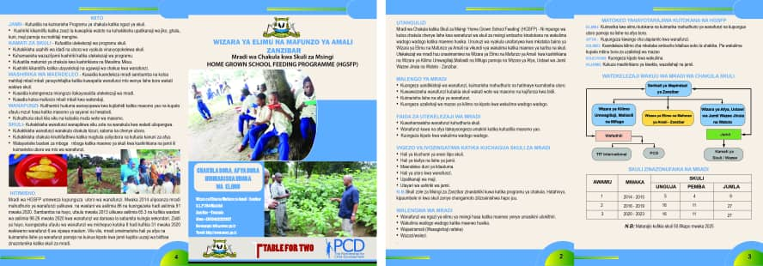

Development of HGSFP Strategy
The School Feeding Strategy intends to strengthen the implementation and sustainability of a national school feeding program in Zanzibar. The development of the strategy has been very participatory, ensuring the involvement of all key stakeholders. The process of its development included putting together a first draft through the National Coordination Committee (NCT) for school feeding. The committee then circulated to all relevant stakeholders, including the senior staff at MOEVT (Retired Director of Pre-primary and Primary Education and Retired Deputy PS) and PCD for input. The draft of HGSFP strategy was further presented and discussed at a multi-stakeholder meeting that was attended by school feeding stakeholders and development partners. Their contributions have greatly helped in improving and shaping of the document. Launching of the strategy will take place after final editing and printing processes are completed. The tentative timelines for the launch are end of June 2022.
The strategy will act as a guiding tool for implementing the HGSF program beyond the current funding period. It provides guidelines on targeting schools for a feeding program, among other key highlights. MoEVT targets at least fifty (50) primary schools by 2025.
National Coordination Team (NCT) members, with the support of Dr. Amran and Mr. Ali Mohamed Ali (Ugoda) from the Department of Teacher Training, spearheaded the strategy development process.

Establishment of School Garden
Since 2015, MOEVT and PCD have advocated and supported the establishment of vegetable and fruit gardens in the school compound as a learning platform and, to a small extent, complement the school feeding menu. The number of schools with gardens has since slowly increased. However, head teachers reported that inadequate water and spaces for gardens and animals (goats) that are kept around the schools hinder the effort of establishing gardens in the school areas. Schools are, nevertheless, showing efforts and commitment to ensure the established gardens are secured. For instance, the Head teacher from Mbuyutende said that the community bought a net to protect the school garden from goats.
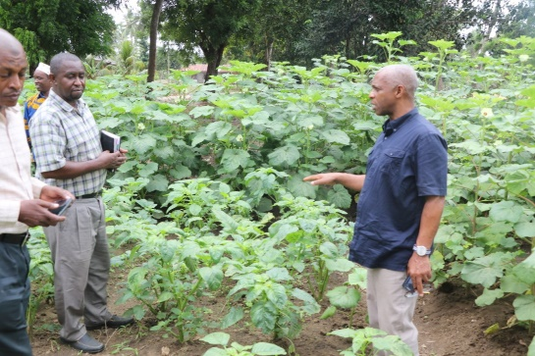
PS MoEVT (right) at Makangale school garden

Enrollment of Nine new schools in the Program
The Revolution Government of Zanzibar (RGoZ), through MoEVT has taken its responsibility to ensure the sustainability of the school feeding program after the support by TfT comes to an end. MoEVT plans to target fifty (50) primary schools for school meals by 2025. In addition to the current 27 schools, the government will enroll 23 more schools for school meals under the government's budget. As the first step towards this commitment, the government has committed funding to serve meals to 9 primary schools. MoEVT has visited the nine schools to assess their readiness and that of the host communities to implement the program.

HGSFP Implementation

HGSFP implementation in the third phase (2020) was under President Office Regional Administration Local Government and Special Department (PORALGSD) collaborating with MoEVT. Pre-primary and Primary education activities were decentralized by devolution to local government under PORALGSD since 2018. The same way as other activities under Ministry of Agriculture and Ministry of Health. Revolution Government of Zanzibar handed back the Pre-primary and Primary education to MoEVT and other decentralized agriculture and health units to the mother Ministries in July 2021. Currently, the program implementation is going on as it was before the decentralization, whereby the district level is supervised by District Education Officer (DEO) with collaboration with District Agriculture and Health Officers. The coordination and planning activities of the program are headed by the MOEVT national office.

Program Management and Coordination
In 2018, pre-primary and primary school programs were handed over to Local Government Authorities (LGA) under President Office Regional Administration, Local Government and Special Department (PORALGSD) after the decentralization by devolution directive. MOEVT handed over the implementation of HGSFP to PORALGSD in 2020. In July 2021, the Revolution Government of Zanzibar issued another notice for all the programs to be handed back to the respective ministries. The PORALGSD was required to focus only on its core functions.
The National Coordination Team (NCT) resumed their coordination meetings, monitoring the program and reporting at the national level, while District Education Offices coordinated the program at their respective Districts.
NCT is composed of members from Ministries of Education, Agriculture and Health, District Education Officers, a representative from program schools, and a representative from Pemba Island. The team holds quarterly meetings to discuss the implementation progress and plan for the next quarter. The last NCT meeting in October 2021 was attended and chaired by the PS (MoEVT). Other arrangements were in March and June.

Monitoring and Evaluation
MoEVT conducted monitoring visits at the program schools in March and October 2021. The Principal Secretary (PS) MoEVT participated in the activity in March. The team visited Makangale, Mgogoni, Maziwani, and Mjini Kiuyu Schools in Pemba. The PS witnessed the feeding process and was impressed with the short-term and long-term results of the program, including improvement of pupils’ attendance and performance at the target schools. The presence of the PS during these monitoring exercises improved the implementation of the program in Zanzibar. The community, teachers, and children further understood the importance of the program by seeing the importance attached to the government.

Program implementation challenges and recommendation
  - Remarks by school principals and teachers

Salim Mkadam, a head teacher at Makangale School, Micheweni District, reported that different guests, including (government and ruling party leaders) are frequently visiting his school to witness the school feeding. He said that he has always received positive comments for providing meals to the children at school and establishing a school garden. He added that school feeding is one of the positive steps taken by the government and donors to ensure that children remain in school at all times. Further, the head teacher reported that school feeding increased cooperation between school and community, facilitating improvement in children's education.

Mohamed Salim, a head teacher at Mgogoni School, Wete District Pemba Island, said that April and May 2021 were Clove harvesting seasons in Pemba. School children in the Island were involved in cloves harvesting to get money. Those pupils missed some days at school, which affected school attendance and academic performance. He added that his school was not seriously affected this year as it was before the school meals started at his school.

  - Challenges and recommendations

- Although community participation in supporting school feeding is increasing, there is a need for more awareness creation for more involvement to ensure the program's sustainability, especially for communities around schools newly enrolled in the program.
- The MoEVT system deploys new teachers and transfers others to schools on a frequent basis. This means that new teachers need training on coordination of the school feeding implementation at the school level. For this funding period, the trainings have been staggered to ensure the gap is mitigated. However, for future, MoEVT will need additional budget aside from the food menu budget to sustain the training.
- In addition to the head teachers, and most of the selected District Education Officers are new and not trained to coordinate the program at their districts. With the current funding, some short-term trainings will be organized. For future trainings, MOEVT will need additional support.
- Some schools are in more remote areas that face teachers’ shortage. However, recently MoEVT assessed teachers’ shortage/excess at pre-primary, primary and Secondary schools. Meanwhile the ministry is dropping teachers from secondary to primary schools in order to cover teachers’ shortage in primary schools.
- There is evidence of children transferring from the schools that do not offer school meals to nearby schools that serve the meals. To avoid this scenario, further discussion with the government and donors is needed to increase the program coverage within a shorter timeframe.

  - Conclusion
HGSFP program in Zanzibar has shown remarkable achievement in improving enrollment, attendance, and academic performance, especially in the standard IV and standard VI National Examinations. Reports indicate that girls have performed better compared to years before program inception (2014). Also, the income for smallholder farmers has increased. Some farmer groups who produce and sell OFSP have graduated to value add the OFSP and make flour, among other products. A more extensive program scope will benefit more farmers who will have more market to sell their crops which translates to more income. The benefits of HGSFP in Zanzibar crosscut Education, Social, Health, and Economic pillars of development.

Annexes
Annex I: Photos

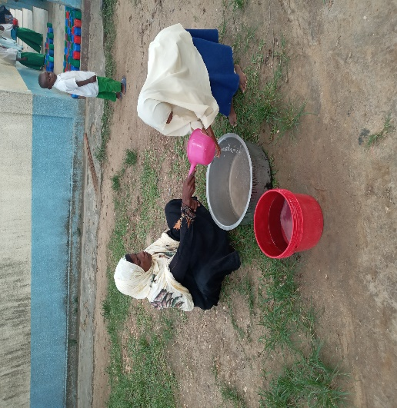 | 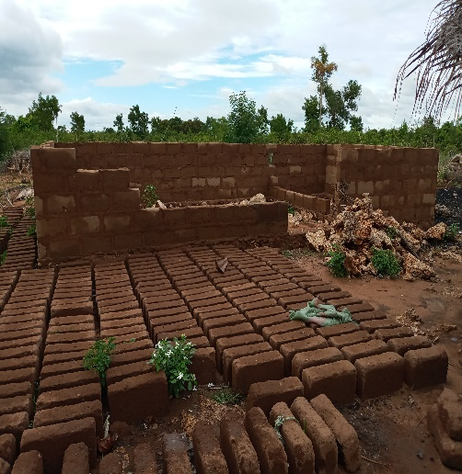 | 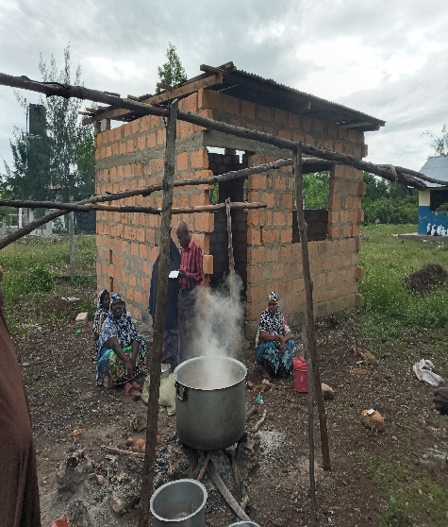
Community participating in hands washing pupils at Tironi, construction of kitchen at Kiyongwe and Ukongoroni and cooking at Ukongoroni school
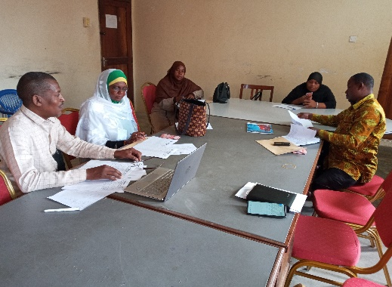 | 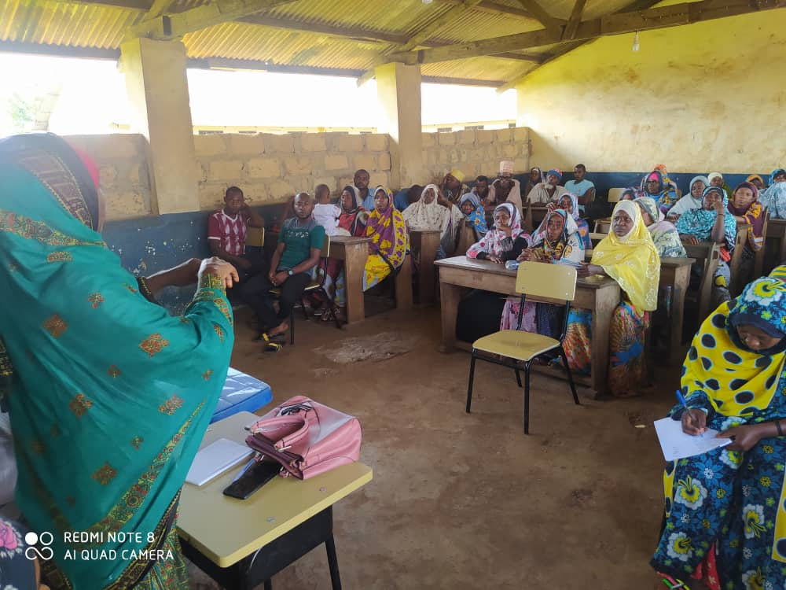 | 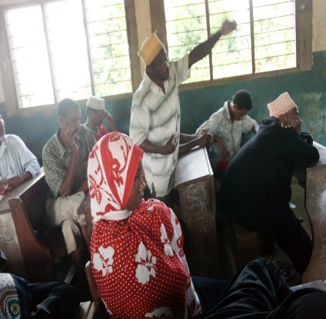
Planning Meeting at Pemba for community advocacy | Community advocacy at Charawe | Community advocacy at Tironi
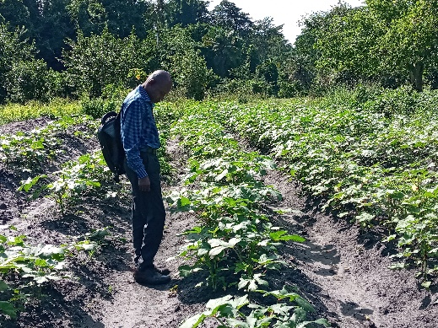 |  | 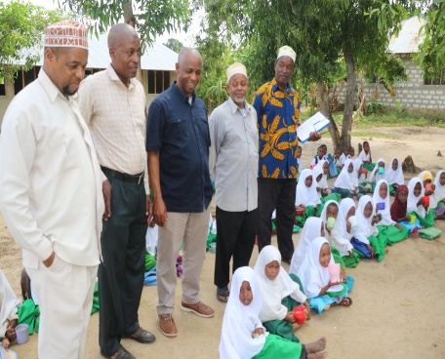
School Garden at Mkiang’ombe |  | PS MoEVT (right) at Mjini Kiuyu school
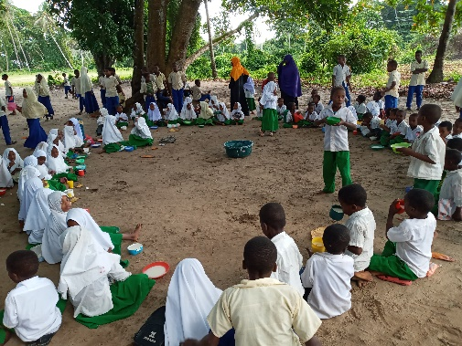 | 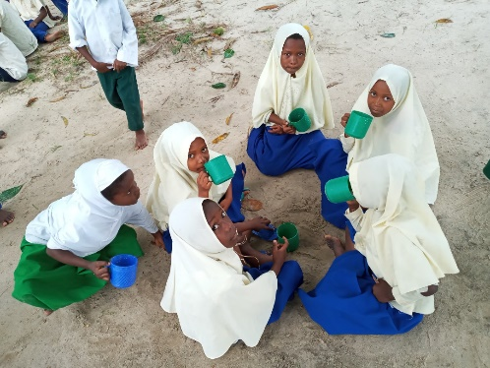 | 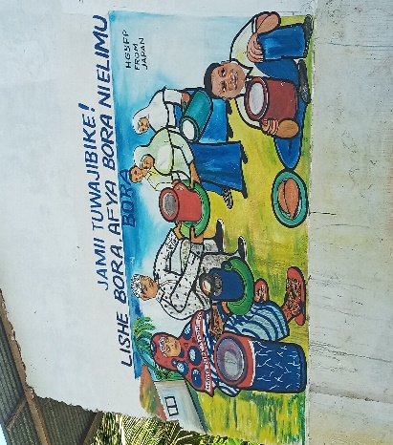
Children having meal at school | Children having meal at school | Community Advocacy message on supporting school meal at Kunguni school wall
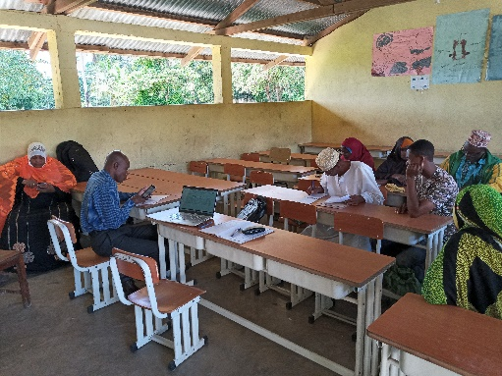 | 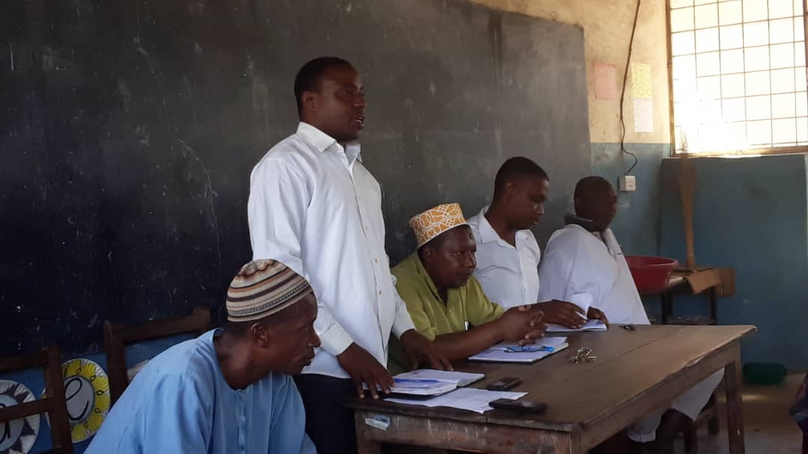 | 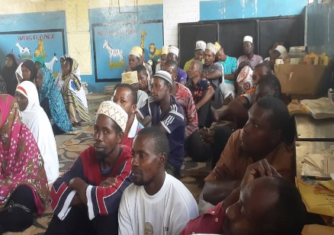
Contracts filling with groups of farmers at Makangale | Community advocacy at Tasini School | Community advocacy at Tasini School
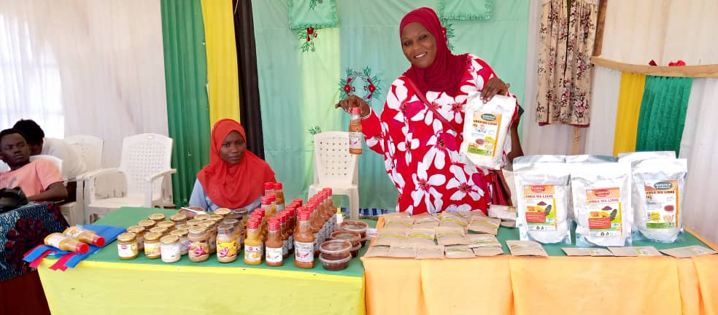 | 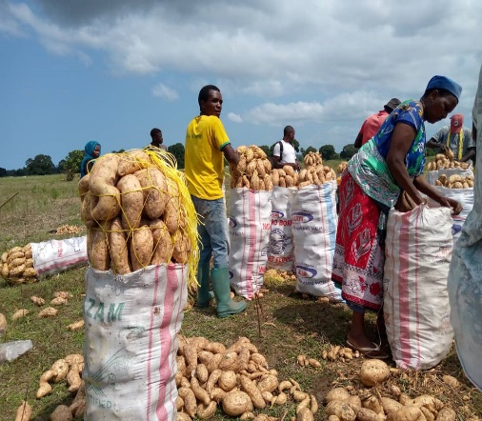
Farmer group (JUWA) showing OFSP flour made at farmers’ exhibition | OFSP packing
 |  | 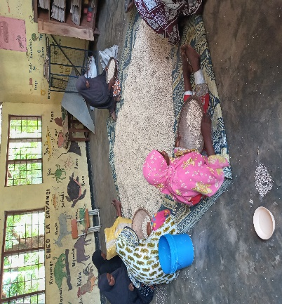
 |  | Community participation at Makangale
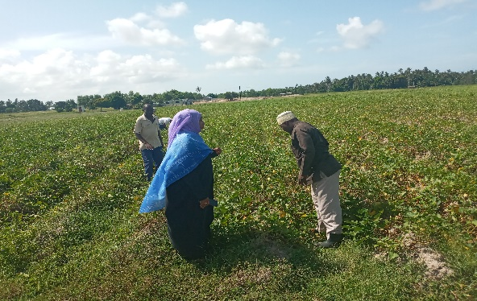 | 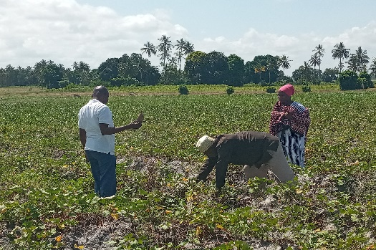
DADO North B and Director for DPPE (Before appointed) visits OFSP farm at North B District | DADO North B visits OFSP farm at North B District
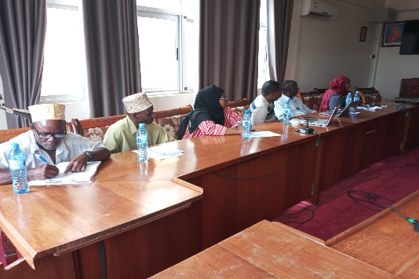 | 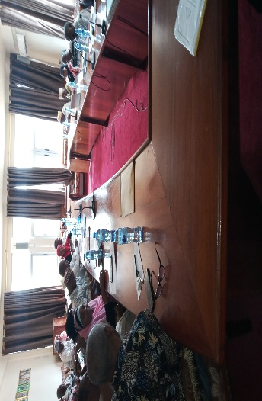 | 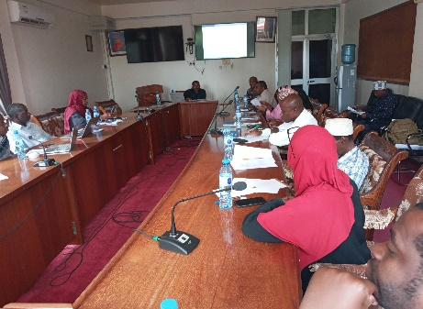
Stakeholders meeting for HGSFP Strategy at MoEVT, Zanzibar
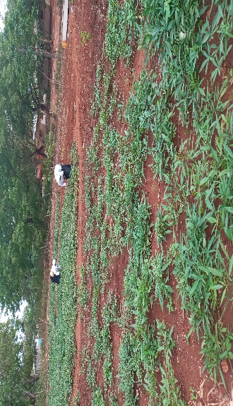 | 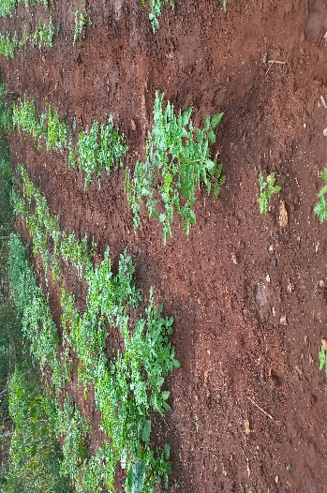
Vegetable garden at Kigunda

