PARTICIPANT INFORMATION SHEET

EARNEST Trial - Early Aortic Repair in patients Needing Endovascular/open Surgery for Type B Aortic Dissection

Principal Investigator -
Protocol ID - 174766
IRAS ID - 327350

You are being invited to take part in a research study. Before you decide, it is important for you to understand why the research is being done and what it will involve. Please take time to read the following information carefully and discuss it with others if you wish. Ask us if there is anything that is not clear, or if you would like more information. Please ensure you take time to decide whether or not you wish to take part.

PART 1 tells you the purpose of this study and what will happen if you choose to take part.

PART 2 gives you more detailed information about the conduct of the study.

Please ask questions if there is anything that is not clear or if you would like more information (contact details below). You are free to decide whether or not to take part in this study. Please remember that your normal medical care will not be affected if you decide to not take part. Thank you for reading this.

PART 1

What is the purpose of the study?

The aorta is the main blood vessel in the body; it carries blood full of oxygen from the heart to all the arteries that supply individual organs. It runs from the heart, in the chest, initially supplying blood to the head and arms and then it arches around and goes down to supply blood to all the other organs.
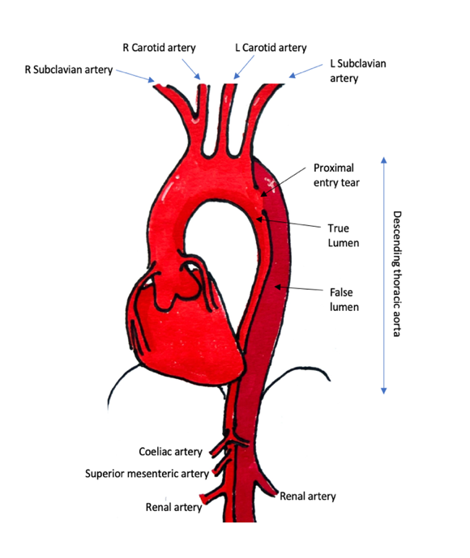
An aortic dissection is a painful life-threatening condition caused by a tear in the lining of the aorta.

Blood flows through this tear and forces the layers of the aortic wall apart creating an unintended false channel, often referred to as a false lumen. The true lumen is where the blood normally flows.

A dissection involving the descending thoracic aorta at the back of the chest is called a type-B aortic dissection (TBAD) and occurs in both sexes and at all ages. Diagram 1 shows the heart and aorta and what a type-B aortic dissection looks like.

Diagram 1: An aortic dissection.

In some patients this can lead to immediate life-threatening complications such as a burst aorta with bleeding, or a significant restriction in blood flow to vital organs that requires emergency surgical treatment.

However, more than eight in every ten patients with a thoracic aortic dissection (TBAD) do not experience an immediate life-threatening complications. These cases are called uncomplicated TBAD (uTBAD), and they are usually managed with medical treatment. This includes taking blood pressure tablets to control blood pressure (BP) and having regular CT scans of the aorta each year to monitor for any long-term problems.

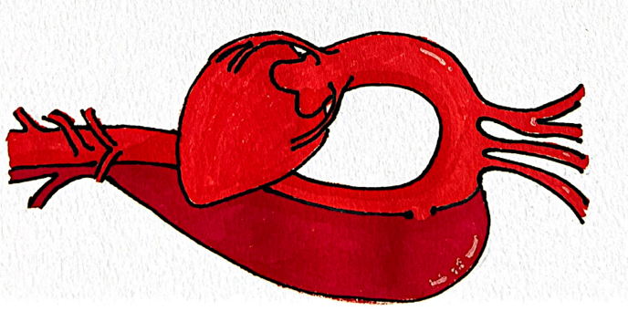
Of those eight in ten patients that are treated initially with standard medical treatment, around three in ten may go on to develop an aortic aneurysm. This is shown in Diagram 2 and refers to a condition where the body’s main blood vessel starts to balloon. If an aneurysm forms, it can increase the risk of bursting or rupture, which can cause life-threatening internal bleeding..

Repair is offered if the aorta reaches 5.5-6cm in size. These procedures are often complex, extensive operations with significant risk of death and major complication such as heart attack, stroke, kidney failure and paraplegia (paralysis of the legs).

Diagram 2: An aortic aneurysm.

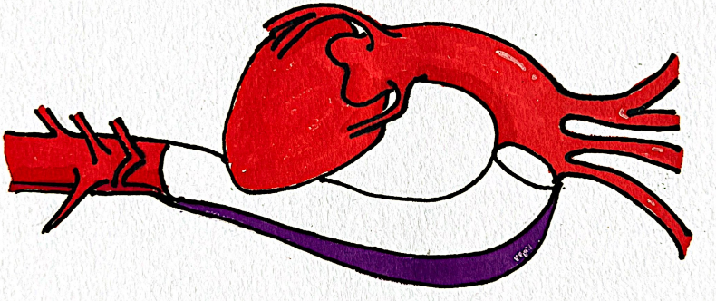
It has been proposed that an early operation may be effective in allowing the aorta to remodel (heal) and avoid long-term expansion. The aorta is relined within 3 months to close the aortic tear with a stent graft. This is known as thoracic endovascular aortic repair (TEVAR). Surgeons use a small incision in the groin to insert a stent, which is a fabric tube with a metal scaffold, into the aorta under X-ray guidance.

As shown in diagram 3, TEVAR relines the aorta and closes the tear, obliterating the false channel and leads to healing (remodeling) of the aorta in many cases. This operation reduces the risk of expansion and rupture and the need for complex operations in the years to come.

Diagram 3: A TEVAR inserted into the aorta.

The TEVAR procedure is a well-established vascular surgery procedure which is minimally invasive – in other words surgeons use a keyhole approach, but with all operations there are some risks that may occur and of course some patients will get an operation who wouldn’t have gone in to form an aneurysm in the long term.

Currently, there is no evidence that early TEVAR is better than medical treatment alone after aortic dissection. This study, which is explained in detail below, is a “randomised trial” to assess the clinical and cost-effectiveness of thoracic endovascular aortic repair (TEVAR) in patients with dissection.

Why have I been invited to take part?

You have been invited to take part in this trial because you have recently had an aortic dissection within the last three months. You have been assessed as not having the life-threatening complications of a complicated dissection. You are being looked after by a specialist vascular surgery service conducting the trial and have been identified as suitable to receive either of the treatments being compared.

The trial aims to recruit 470 participants from 25 centres across the UK and will collect data for five years following your treatment.

Do I have to take part?

It is up to you to decide whether or not to take part, and participation is entirely voluntary. If you do decide to take part, you will be given this information sheet to keep and be asked to sign a consent form. If you decide to take part, you are still free to withdraw at any time and without giving a reason. A decision to withdraw at any time, or a decision not to take part, will not affect the standard of care you receive.

You are encouraged to take as much time as you need to decide whether you would like to participate in the trial. However, it is important to note that the timing of one of the treatments, TEVAR, is critical. For early TEVAR to be effective, it must take place within a specific time frame—between 5 days and three months after the aortic dissection. This is because, during this period, the dissection flap is still mobile. If the procedure is performed while the flap is mobile, the true lumen of the aorta can expand fully, and remodelling of the aorta is much more effective. After three months, the majority of patients no longer have a mobile flap, as it becomes fixed, which reduces the effectiveness of the intervention.

Thus, while you have time to make an informed decision, please keep in mind that TEVAR can only be performed within this three-month window following your aortic dissection.

What will happen to me if I choose to take part?

This study is a randomised controlled study. We undertake these studies when we do not know which way of treating patients is best, so need to make comparisons. Participants are randomly allocated into two groups, and each group will receive a different treatment. The groups are selected by a computer which has no information about the individual – i.e. participants are selected into groups by chance. The outcomes in each group can then be compared to see which treatment is best.

Firstly, patients who agree to be part of the trial will be assessed for eligibility. If eligible, participants will be randomly allocated – half the participants have a stent placed (or TEVAR) the other half will not.

The group that are chosen to receive TEVAR will be in the “stented” group

The group that are chosen not to receive TEVAR will be in the “unstented” group, also known as standard care.

The infographic below shows the way that the trial is structured:
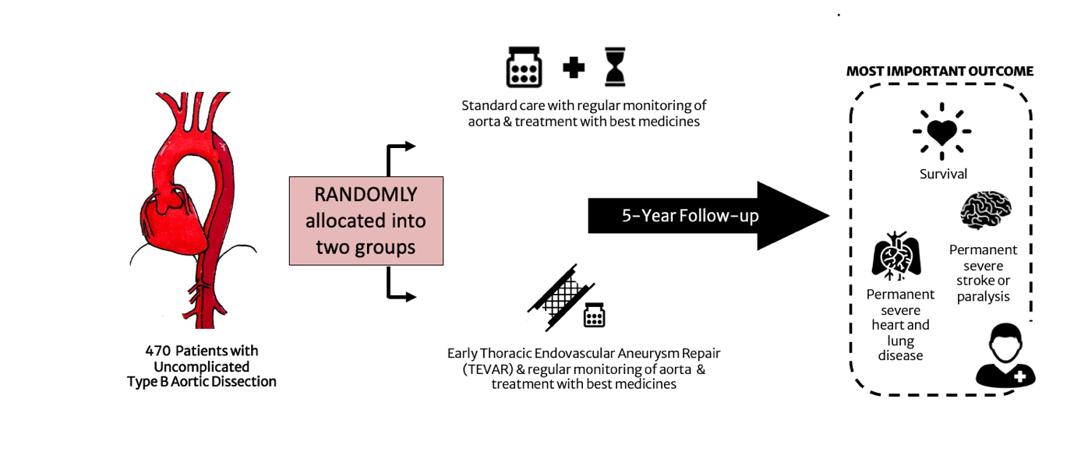
All participants in the trial will receive the care that they would normally receive in the UK. This involves blood pressure monitoring and tablets if needed. Also, all participants in the trial will be offered the best available medicines to reduce their risk of heart disease and other diseases of the blood vessels.

Those who are allocated to the stented group will undergo the procedure between ten days and three months after the dissection occurs.

Follow up visits will take place within 6 weeks after your dissection or stent, then at 6 months, and then annually after enrolment up to 5 years. During each visit, we will gather information about your health, and you will be asked to complete a questionnaire regarding how easy and enjoyable your life is and any treatments you may have received from other healthcare professionals since your last visit.

If you join the study more than 6 weeks after your dissection, and are allocated the unstented group, you will not need to repeat the 6 weeks visit at the hospital for the study.

All participants will have regular scans to check their aorta. These will usually be CT (Computerised Tomography) scans. You will have a scan within 6 weeks of your dissection/TEVAR, then at 6 months, and once a year after that. In years 2, 3, and 4, your doctor may decide to use an MRI (Magnetic Resonance Imaging) scan instead of a CT scan. These scans help us monitor your aorta and any stent that may have been placed. To avoid repeating tests, we may also use scans you had before joining the study.

This pattern of visits is no different to the normal care that you would receive whether you take part in the trial or not to monitor you and to identify any change in the size of your aorta.

If there is expansion of the aorta, or other major issues with the aorta during the trial this may need to be treated.

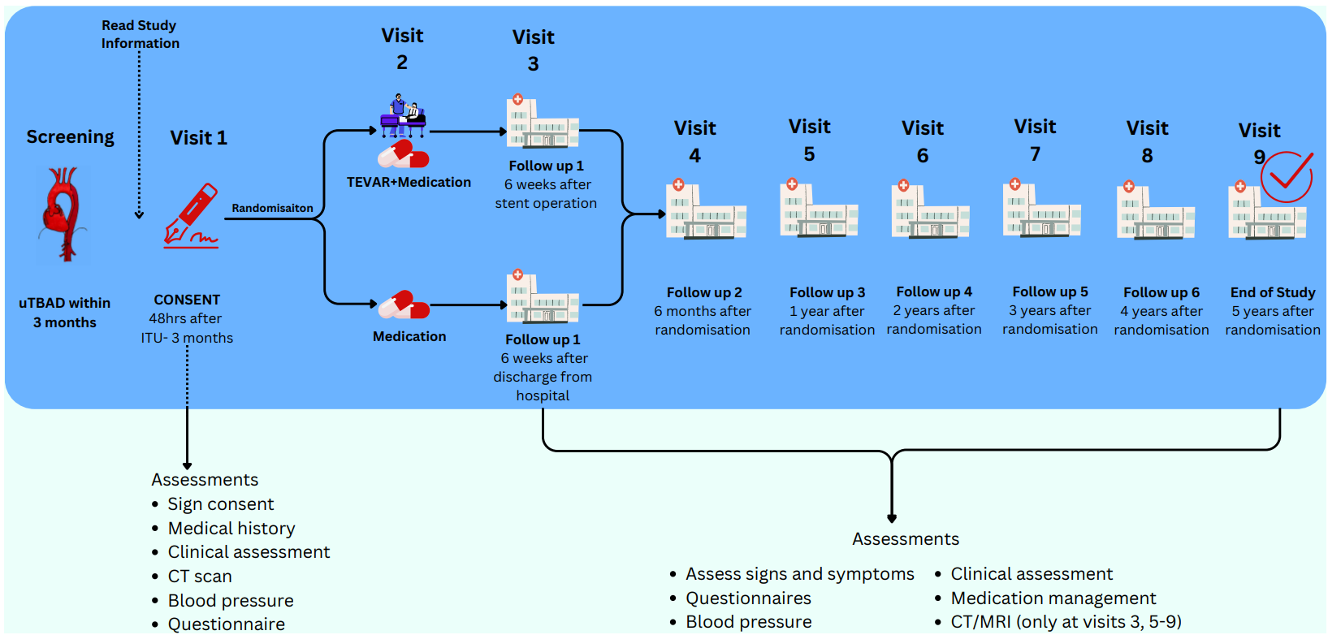
A summary of what will happen to you as a participant is provided below:

We will need to use information from you for this research project. This information will include your:
- Initials
- Age
- Gender
- NHS number
People within Imperial College will use this information to do the research or to check your records to make sure that research is being done properly and the information held (such as contact details) is accurate.
People who do not need to know who you are will not be able to see your name or contact details. Your data will have a code number instead.
We will keep all information about you safe and secure.
Once we have finished the study, we will keep some of the data so we can check the results. We will write our reports in a way that no-one can work out that you took part in the study.
All data collected will be input into a database to be analysed. The data in the database will be anonymised, which means that no one will be able to identify you as the participant.
Documents which contain any identifiable information will be kept in a secure location on the hospital site.
Summaries of anonymised findings will be presented to all those involved in the study, but no identifiers of individuals or clinical centres will be shown in presentations or reports.
Because uTBAD can take many years to cause problems, we would also like your consent to store and access your health data for up to 15 years. This will help us study long-term health outcomes. We will do this by using national databases, such as NHS Digital, the Office of National Statistics (ONS), and hospital records, to track survival rates and other important health information. To keep your information safe, any personal details (like your NHS number) will be encrypted, meaning they will be turned into a code that cannot be traced back to you directly.

If you choose to take part in this study, there are no specific restrictions or lifestyle changes required, although smoking cessation is advised. You should take all your medications and attend all medical appointments as directed. If you agree to take part, you should inform the study team prior to taking part in any other clinical trials. You should inform the study team if you become pregnant.

What is the intervention that is being tested?

This trial is comparing the effectiveness of TEVAR compared to normal care. The clinical team looking after you feel that you would be suitable to receive either the intervention (TEVAR) or standard of care, the two treatments are being compared as part of this trial.

TEVAR is a well-established procedure with a firm evidence-base for is safety and effectiveness in general. All participants randomised to undergo TEVAR will be specifically and individually consented for the procedure by the surgical team performing it.

The procedure usually involves a general anaesthetic. Surgeons use a small incision in the groin to access the common femoral artery and position a stent, which is a fabric tube with a metal scaffold, in the correct site in the aorta under X-ray guidance. Once correctly sited the stent is deployed and the TEVAR stent relines the aorta.

The procedure may take place during your initial hospital admission, or as a planned subsequent admission. After the procedure you will typically be looked after in a high dependency area for a short period of time, and you would typically stay in hospital for 3-5 days in total.

What are the possible benefits of taking part?

It may be that early TEVAR after your type of dissection will lead to better outcomes for patients on average, however, we cannot promise the study will help you individually. The information we get from this trial may help improve the treatment of all patients with dissection in the future.

As part of the trial, you will receive regular surveillance imaging and clinical follow-up. If as part of this, we discover any incidental findings that are relevant to your health we will report this to your GP and the relevant clinical teams locally.

What is the current standard of care?

Normal care in the management of uTBAD is using medicine to effectively control your blood pressure, with the need for surgical intervention decided on by the clinical team looking after you only if there are complications that occur as a result of the dissection or there is dilatation of the aorta and a risk of rupture.

If you choose not to take part in this trial, then you will continue to receive normal care as decided by your local clinical team. This is a nationwide multi-site trial and so all treatment is undertaken according to local variation and protocols.

What are the foreseeable disadvantages or risks of taking part?

Risks of TEVAR

Participants randomised to the stented (or TEVAR) group will all receive a stent. For some participants a stent will help to avoid future problems with the aorta, however, some participants will undergo an operation which has not benefitted them.

TEVAR carries some specific procedural risks which will be explained to you as part of the consent process by the clinical team looking after you.

The specific potential risks of TEVAR for you will be carefully explained, and all procedures will be performed in line with existing clinical protocols and standards at the centre looking after you.

The main risks from TEVAR should be discussed in detail with your surgeon. These risks are rare. There have been two previous randomised trials that have stented patients with uncomplicated type B aortic dissection as part of the trial. The combined risk of death in these trials at operation was less than 1 in 50 patients.

Risks of TEVAR do include:
- Access site complications:
  - Bleeding, narrowing or blockage of arteries
  - Wound infection/breakdown
- General complications:
  - Heart attack
  - Pneumonia (this is inflammation of the lungs)
  - Clots
- Ischaemic (reduction in blood supply) complications:
  - Stroke
  - Kidney ischaemia
  - Gut ischaemia
  - Loss of mobility or sensory function in lower body
  - Limb ischaemia and limb loss
- Further aortic dissection
- Need for further procedures.

The chance of the specific risks can only be given accurately by your surgeon. We do know overall, that in one trial with 70 patients with uTBAD who underwent stenting, the chance of access site complications was 1 in 70; the chance of further aortic dissection was 1 in 70; the chance of stroke was 1 in 70 and the chance of loss of mobility or sensory function in lower body was 2 in 70, with one patient having a full recovery.

We will collect safety data related to adverse events or other complications that occur during the trial which will be reviewed by an independent panel as part of the trial.

Radiation

All patients with an aortic dissection receive investigations and treatments that use radiation (X-Rays). These procedures use ionising radiation to form images of your body, provide treatment, and give your doctor important clinical information.
Some of these may be in addition to those you would have if you did not take part.

If you don’t take part in this study, you will be monitored with seven CT scans as standard over five years. If there are any further concerns or complications, further CT scans may be necessary. There is also a possibility you will have to have an intervention if there is growth of the aorta, and your doctor determines that surgery is necessary.

If you take part in this study, you will also have seven CT scans whichever group you are randomly allocated to. If there are any further concerns or complications, further CT scans may be necessary. This is the same as you would receive if not in the study.

If you join the study and are in the group that are chosen to receive TEVAR (the stented group) you will definitely receive one procedure involving radiation when undergoing TEVAR and possibly further procedures if there are any issue with the stent or complications.

Alternatively, if you are randomised to standard care, you could still require a TEVAR procedure as part of your usual clinical care if your aorta dilates and your doctor determines that surgery is necessary and possibly further procedures if there are any issue with the stent or complications.

Ionising radiation is used in both the CT scans and TEVAR procedures. While this is necessary for your treatment and monitoring, it’s important to note that ionising radiation can increase the risk of cancer many years or even decades after exposure. However, the amount of radiation you receive will be carefully managed to minimise your risk.

We are all at risk of developing cancer during our lifetime, with approximately 50% of people likely to develop one of the many forms of cancer. There is a very small chance that taking part in this study may increase your chances of developing cancer slightly, to 51%

What happens when the research study stops?

We will specifically collect data for five years as part of this trial. When the study stops you will continue to be followed up and receive ongoing care by your local clinical team as normal. We will seek to routinely collect healthcare data to look at longer term outcomes for 15 years.

What if something goes wrong?

Imperial College London holds insurance policies which apply to this study. If you experience harm or injury as a result of taking part in this study, you will be eligible to claim compensation without having to prove that Imperial College is at fault. This does not affect your legal rights to seek compensation. If you are harmed due to someone's negligence, then you may have grounds for a legal action. Regardless of this, if you wish to complain, or have any concerns about any aspect of the way you have been treated during the course of this study then you should immediately inform the Principal Investigator:

(Insert site PI name and nhs email address contact details).

The National Health Service mechanisms are also available to you. The Patient Advice and Liaison Service (PALS) is an independent source of information on studies and also a route to raise complaints about treatment in the NHS.

The PALS office at the hospital can be reached using the below contacts”

(Insert PALS office contacts)

If you are still not satisfied with the response, you may contact the Imperial College, Research Governance and Integrity Team.

Can I change my mind?

Yes, at any time you can decide to withdraw from the study. You will continue to receive ongoing care from your local clinical team as usual.

If you do decide to withdraw from the study or you want to discuss this option, you should contact the site research team.

(Insert site PI name and nhs email address contact details).

What should I do if I find this information worrying?

We appreciate that having an TBAD can be worrying. It can also be worrying to be told a lot about the risks of having operations. You may be finding it difficult to decide what you should do for the best. Remember that your surgeon and team will guide you through the options and will help you every step of the way.

Please don’t hesitate to ask your team more questions today, or you can contact the us on (Insert site PI name and nhs email address contact details).

If you find it helpful to talk to your family or a close friend and would like them involved in discussions, we are happy to do this, with your permission.

What happens if relevant new information becomes available?

Sometimes, during a research project, new information becomes available about the treatments that are being studied. If you are in the study and this happens, your study team will inform you and discuss whether you want to, or should, continue in the study. If you decide to continue in the study, you will be asked to sign a consent form that includes the new information. If you decide to withdraw your consent, your study team will plan for your care to continue in alignment with standard practice. You can stop taking part in the study at any time without giving a reason, and without your rights or care being affected in any way. If you do decide to withdraw then you should inform your clinical and study teams of your decision.

What will happen to the results of the research study?

We will share the results of the study with all participants and wider audiences. We will maintain and develop a study website used as a public and participant information tool and to disseminate our findings once available. We will produce a short, easy to understand summary of our research findings (written and as a short video) that will be available from our website and that will be sent out widely to participants and the families of participants with aortic dissection and the wider population via national patient organisations, charities and relevant professional societies. We will also prepare an internal report to inform the Sponsor of results.

Will my taking part in this study be kept confidential?

Yes. All information that is collected about you during the study will be kept strictly confidential. All data will be identified by a study number which can link to your personal details. This link will be held separately from all other data collected on you. If you consent to take part in this study, we will collect information on you and your test results, and we will enter it into a study database held at Imperial College Trials Unit, London. This is for the purpose of analysing the results. Employees of the Imperial Clinical Trials Unit (ICTU) and staff from Imperial College London Research Governance and Integrity Team may need to examine your medical records to ensure the study is being run properly, but your confidentiality will be protected at all times, and your name will not be disclosed outside the study. Your information may also be looked at by an independent quality control agency to check that the study is being carried out correctly.

Your GP will be informed in writing of your participation in this study. They will also be advised of any medically relevant events during the study as well as any clinically relevant study results.

We may ask your GP for medical information about you in the future if we cannot obtain this from your hospital records. We will ask for your permission to do so at the same time we ask you to sign the study consent form. It is standard practice to inform your GP about your participation in a study. If you do not wish this to happen, you cannot participate in EARNEST.

Who is organisation and funding the research?

This trial is being funded by the National Institute for Health and Care Research (NIHR) - https://www.nihr.ac.uk/explore-nihr/funding-programmes/health-technology-assessment.htm

Who has reviewed this study?

This study has been independently reviewed and approved by an NHS Research Ethics Committee 25/WM/0005 and is registered with the NHS Health Research Authority 327350.

Will I get paid for taking part?

There is no payment for taking part in this study.

Will researchers receive any payments for conducting the study?

The researchers won’t receive any personal payment over and above normal salary, or any other benefits or incentives.

What do I have to do now?

You will be given as much time as you feel you need to discuss any issues or questions. If you have any concerns or wish to discuss the study further

This completes Part 1 of the information sheet. If you are considering participating in the study, please continue to read the additional information in Part 2 before making your decision.

PART 2

General Data Protection Regulations (GDPR)

How will we use information about you?
Imperial College London is the sponsor for this study and will act as the Data Controller for this study. This means that we are responsible for looking after your information and using it appropriately. Imperial College London will keep your personal data for:
- 10 years after the study has finished in relation to data subject consent forms.
- 10 years after the study has completed in relation to primary research data.

The main study is expected to finish in February 2035, but information may be collected from hospital administrative databases until 15 years after you start the study. For more information / confirmation regarding the end date please contact the study team.

We will need to use information from you and your medical records for this research project. This information will include your (initials, date of birth, NHS number, name, contact details, medical history and pictures from the CT scan of your aorta).

People within the College and study team (see section sharing your information with others) will use this information to do the research or to check your records to make sure that research is being done properly and the information held is accurate.

People who do not need to know who you are will not be able to see your name or contact details. Your data will have a code number instead. We will keep all information about you safe and secure. Once we have finished the study, we will keep some of the data so we can check the results. We will write our reports in a way that no-one can work out that you took part in the study.

As a university we use personally identifiable information to conduct research to improve health, care and services. As a publicly funded organisation, we have to ensure that it is in the public interest when we use personally identifiable information from people who have agreed to take part in research. This means that when you agree to take part in a research study, we will use your data in the ways needed to conduct and analyse the research study. Our legal basis for using your information under the General Data Protection Regulation (GDPR) and the Data Protection Act 2018, is as follows:
- Imperial College London - “performance of a task carried out in the public interest”; Health and care research should serve the public interest, which means that we have to demonstrate that our research serves the interests of society as a whole. We do this by following the UK Policy Framework for Health and Social Care Research.
- Where special category personal information is involved (most commonly health data, biometric data and genetic data, racial and ethnic data etc.), Imperial College London relies on “scientific or historical research purposes or statistical purposes.”

International transfers

There may be a requirement to transfer information to countries outside the United Kingdom (for example, to a research partner, either within the European Economic Area (EEA) or to other countries outside the EEA. Where this information contains your personal data, Imperial College London will ensure that it is transferred in accordance with data protection legislation. If the data is transferred to a country which is not subject to a UK adequacy decision in respect of its data protection standards, Imperial College London will enter into a data sharing agreement with the recipient research partner that incorporates UK approved standard contractual clauses or utilise another transfer mechanism that safeguards how your personal data is processed.

Sharing your information with others
We will only share your personal data with certain third parties for the purposes referred to in this participant information sheet and by relying on the legal basis for processing your data as set out above.
- Other Imperial College London employees (including staff involved directly with the research study or as part of certain secondary activities which may include support functions, internal audits, ensuring accuracy of contact details etc.), Imperial College London agents, contractors and service providers (for example, suppliers of printing and mailing services, email communication services or web services, or suppliers who help us carry out any of the activities described above). Our third-party service providers are required to enter into data processing agreements with us. We only permit them to process your personal data for specified purposes and in accordance with our policies.
- The pictures of CT scans will be shared with the laboratory responsible for measurements of your aorta. This laboratory is based at St George’s Hospital, London. Information about quality of life and costs will be shared with health economists at Northumbria University. The data from the study will be analysed by the Department of Medical Statistics and Clinical Trials at the London School of Hygiene and Tropical Medicine. The study recruitment will be studied in a separate study by the Population Health Sciences department at the University of Leicester. Research partners and collaborators who are part of the research team are listed below:
  - Core Laboratory, St Georges’ Vascular Institute, St George’s University Hospitals NHS Foundation Trust.
  - Department of Medical Statistics and Clinical Trials, London School of Hygiene and Tropical Medicine.
  - Department of Economics, Northumbria University.
  - Population Health Sciences, University of Leicester

Potential use of study data for future research
When you agree to take part in a research study, the information collected either as part of the study or in preparation for the study (such as contact details) may, if you consent, be provided to researchers running other research studies at Imperial College London and in other organisations which may be universities or organisations involved in research in this country or abroad. Your information will only be used to conduct research in accordance with legislation including the GDPR and the UK Policy Framework for Health and Social Care Research. This information will not identify you and will not be combined with other information in a way that could identify you, used against you or used to make decisions about you.

What are your choices about how your information is used?
You can stop being part of the study at any time, without giving a reason, but we will keep information about you that we already have because some research using your data may have already taken place and this cannot be undone. If you choose to stop taking part in the study, we would like to continue collecting information about your health from central NHS records. If you do not want this to happen, tell us and we will stop. This will not affect any healthcare or support you may be receiving separately.

If, unexpectedly, you lose capacity during the study we will stop collecting information about you, but we will keep information about you that we already have because some research using your data may have already taken place and this cannot be undone.

We need to manage your records in specific ways for the research to be reliable. This means that we won’t be able to let you see or change the data we hold about you if this could affect the wider study or the accuracy of data collected.

Where can you find out more about how your information is used?
You can find out more about how we use your information:
- at www.hra.nhs.uk/information-about-patients/
- by asking one of the research team
- by sending an email to the Principal Investigator
(Insert site PI name and nhs email address contact details)
- by emailing the Principal Investigator

Complaints
If you wish to raise a complaint about how we have handled your personal data, please contact the research team first by sending an email to [Site Principal Investigator nhs email], or by ringing us on [phone number of the site research team].

Following our response, if you are not satisfied, please contact Imperial College London’s Data Protection Officer via email at dpo@imperial.ac.uk, via telephone on 020 7594 3502 and/or via post at Imperial College London, Data Protection Officer, Faculty Building Level 4, London SW7 2AZ.

If you remain unsatisfied with our response or believe we are processing your personal data in a way that is not lawful you can complain to the Information Commissioner’s Office (ICO)- via www.ico.org.uk. Please note the ICO does recommend that you seek to resolve matters with the data controller (us) first before involving them.

To find out more information, the following resources may be useful:

The Aortic Dissection Charitable Trust:
https://aorticdissectioncharitabletrust.org/

Aortic Dissection Awareness UK & Ireland Patient Charity https://aorticdissectionawareness.org/about/the-patient-charity

British Heart Foundation: https://www.bhf.org.uk/informationsupport/conditions/aortic-aneurysm-dissection-and-rupture

Circulation Foundation
https://www.circulationfoundation.org.uk/

