

Women’s Aneurysm Research: Repair Immediately or Routine Surveillance, Trial and Registry

Participant Information Sheet

We would like to invite you to consider taking part in this research study. Before you decide, it is important for you to understand why the research is being done and what it will involve. Please take time to read the following information carefully and discuss it with others if you wish.

Please ask us if there is anything that is not clear or if you would like more information. Take your time to decide whether or not you wish to take part.

Thank you for reading this.

Part 1

What is the purpose of the study?

Women’s Aneurysm Research: Repair Immediately Or Routine Surveillance (WARRIORS) is a research programme to find out whether women with small abdominal aortic aneurysms would benefit from being offered aneurysm repair at smaller aneurysm sizes than men. This programme includes a trial comparing two treatments (i) early keyhole surgery and (ii) routine ultrasound monitoring (surveillance, as offered to men). There is a parallel observational study for those who are ineligible or unwilling to participate in the trial. This is called the registry. Some of the information in this leaflet may sound a bit scary, but we hope it will help to understand your condition and what taking part in the research will mean for you.

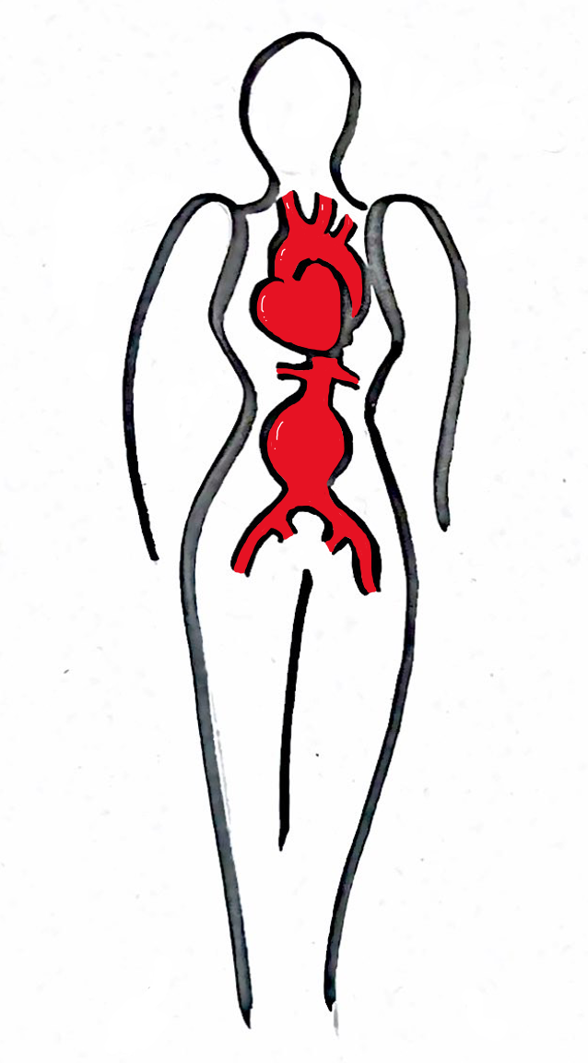
Abdominal aortic
aneurysm (AAA)
Background information about AAA

What is an abdominal aortic aneurysm (AAA)?
Abdominal aortic aneurysm (AAA) is a swelling of the main artery of the body (the aorta) that supplies blood from the heart to the tummy and the legs. When they are small, these swellings do not cause any symptoms or problems, but as the swelling continues to grow, the wall of the aorta becomes weaker. There are no treatments known which stop the steady growth of the AAA once it has formed. If the AAA becomes too large the aorta may burst. If this happens, it is very dangerous, causing internal bleeding, and death in 8 out of 10 cases. So, it is important for people with this condition to have the best possible care.

When do we repair an AAA?
Luckily, it is possible to have an operation to repair the AAA. The operation can be either by a big cut in the tummy (open surgery) or by a small cut in the groin (keyhole surgery).

The keyhole operation is called an EVAR (endovascular aortic repair). It carries a lower risk than open repair. The surgeon uses small cuts at the top of the leg to insert special equipment into your arteries and reline the AAA with a new tube from the inside. This will stop the AAA from growing. The procedure is generally safe and patients will normally only need to stay in hospital for a day or so to recover.

However, like any operation, EVAR carries a small risk of complications which may cause harm to health or death. Because of this we only consider repairing an AAA when the risk of bursting is greater than the risk of the operation. For men, we know this is when the AAA is over 5.5cm (2.2 inches) wide. We do not yet know the right size to repair an AAA in women.

Background information about AAA in women

Should we repair an AAA at a smaller size in women?
Currently we treat women at the same AAA size as men. This isn’t necessarily the right approach because we know that women have smaller aortas and an AAA in a woman is more likely to burst at a smaller size.

In about half of women, as the AAA grows, its shape becomes unsuitable for low-risk EVAR. This is much earlier than in men. If this happens women must then have open surgery, which carries a higher risk, or they cannot have a repair at all.

When we repair the AAA at the same size as men (over 5.5cm wide), the risks of death following AAA repair (keyhole or open) are twice as high in women. Women are also older than men by the time they have their AAA repaired.

In other words, repairing AAAs at a smaller size in women has many advantages:
- More women are suitable for a keyhole approach
- Women maybe younger and fitter if the repair is earlier
- Small aneurysms are easier to repair and so complications after the procedure may be less.

We think there is some evidence that women are being treated too late and would benefit from having their AAA repaired at a smaller size than men. We need this research to help us find out.

What is the WARRIORS trial?

The WARRIORS trial is an international research study to find out if women should have AAA repair at a smaller size than men. The term woman refers to having female sex assigned at birth.

Women with a small (4.0-5.4 cm wide) AAA, which is suitable for keyhole repair, will be randomly chosen to either have early keyhole surgery (EVAR) or to have standard care. The standard care group will continue to have their AAA size regularly monitored. The standard care group will not be offered AAA repair unless the AAA grows to 5.5cm wide, there are signs or symptoms of the AAA bursting or being about to burst.

Why have I been invited?

You have been invited because you are known to have a small AAA, which at the moment is not considered to be at risk of bursting. Your doctors are uncertain of the best management of women in your situation. We are hoping to find 150 women eligible for the trial in the UK and a total of 1112 women worldwide.

Do I have to take part?
It is up to you to decide whether or not to take part. If you do decide to take part, you will be asked to sign a consent form (electronic or paper) in clinic. Both the paper and electronic consent forms will include the version and date of the Participant Information Sheet. If you consent using an electronic consent form, a copy will be sent to your e-mail address. If a paper consent form is used, you will receive a paper copy. If you decide to take part, you are still free to withdraw at any time and without giving a reason. A decision to withdraw, or a decision not to take part, will not affect the standard of care you receive.

You can withdraw from the study by notifying any member of your clinical care team or by contacting the study co-ordinator at your hospital, <insert name, e-mail address, telephone number>.

Will I get paid for participating?

No, but you will receive an Amazon or other shopping voucher for completion of questionnaires about your quality of life and anxiety levels after 1, 3 and 5 years during follow up. You will receive this voucher when your completed forms have been received. This is a token of our appreciation for you doing this.

What will happen to women who take part in the WARRIORS trial or registry?

Since we do not know which way of treating women with AAA is best, we need to make comparisons. People will be put into groups and then compared. The groups are selected by a computer which has no information about the individual – i.e. by chance. In the WARRIORS trial there will be an equal chance of being allocated to the early keyhole surgery group or the surveillance group. The experiences and health of two groups will then be compared.

A summary of what will happen for women in each group and in the registry, are given below.

At the beginning and again after 1, 3 and 5 years, all women will be asked some questions about how easy and enjoyable their life is and how they feel about having an AAA.

All women in the trial will be offered the best available medicines to reduce their risk of heart disease and other diseases of the blood vessels. Each woman will be followed up for 5 years in the trial. Since we will recruit women over a 3-year period, the results may not be known until 5 years after the last woman has joined the trial. This means that the results are unlikely to be known until 8 years after the trial enrolment has started.

INFOGRAPHIC for WARRIORS trial
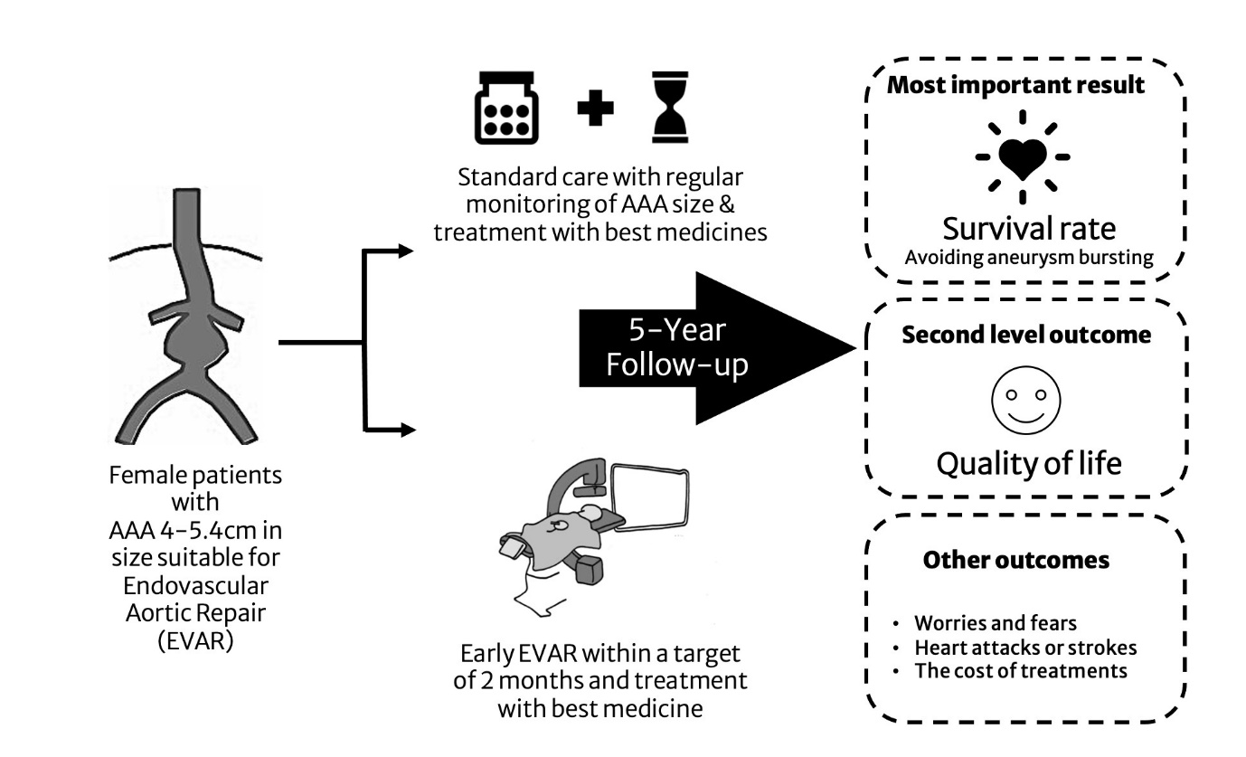

- Test group - EVAR (early keyhole surgery) group

The EVAR group will be offered keyhole surgery within about 2 months of joining the trial.

The surgeon will use small cuts at the top of the leg to insert special equipment into your arteries and reline the AAA with a fabric tube, supported by a metal scaffold, from the inside (this is called a stent). There will be a seal at the top and bottom of the stent so the blood flows through the stent and the aneurysm is excluded from the circulation and the pressure inside the artery is reduced. This will stop the AAA from growing.

Depending on what you and your surgeon prefer, the AAA repair can be performed either awake with numbing medicine, with some added sedation, or asleep (with a general anaesthetic). The operation takes place in a special operating theatre which allows x-ray pictures of the finished operation, to make sure the new lining is properly placed. The procedure is generally safe and very well tolerated and you will normally only need to stay in hospital for a day or so to recover. You will then return for a scan and a clinic visit to check on the AAA repair at about 6 weeks and again after 1 year. After that you will be asked to come back once every year, for another scan.

The risk of dying from keyhole surgery is between 1 and 2 in every 100. There is a 1 in 10 risk of needing another small surgery to make sure that the AAA repair continues to work properly.

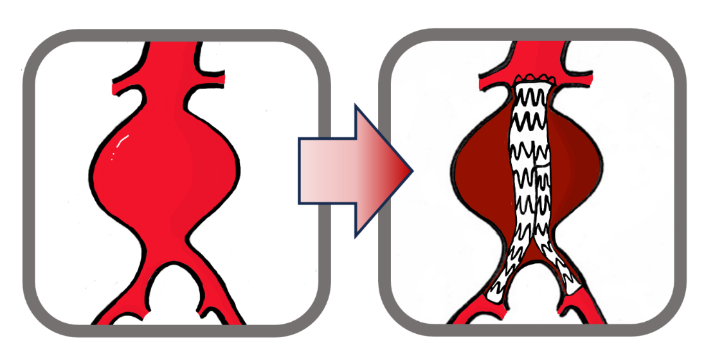
INFOGRAPHIC for keyhole surgery

- Standard care group - Surveillance (regular ultrasound monitoring) group with delayed repair if necessary
Women in the monitoring group will be asked to return to clinic at regular intervals to check the size of their AAA and make sure that it is not causing any problems. This is usually done with a “jelly” scan called an ultrasound, which is painless and risk-free and takes only a few minutes. The scans will be done every 6-12 months but may be more often as the AAA grows bigger.

If an AAA reaches 5.4 cm (2.2 inches) wide, your surgeon will discuss with the you and your family whether now is the right time for you to have an AAA repair. It is likely that the AAA will grow to 5.4cm wide during the 5 years of the study in about half of the women in the standard care group.

If you and your surgeon agree that it is right to have an AAA repair, your surgeon will use a CT scan to see if your AAA is still suitable for keyhole operation (about half will be) or whether a different operation is needed. This may be more complex keyhole repair or an open repair. Open repair involves a big cut in the tummy (see below) and about a week or two in hospital. The risk of dying from a planned operation for an AAA larger than 5.4cm are 2 in every 100 women for keyhole, 8 in 100 for complex keyhole and 6 in 100 for open repair.

For about 1 in 20 of women, their AAA may burst before being repaired. If the AAA bursts and the woman reaches hospital, they may be offered an emergency operation. Overall, 1 in 2 women with a burst AAA will survive.

Remember, this group will receive the same care that is normally offered to women outside of the study. There are no additional risks to this group of taking part in the study.

Only about half of all women will need an AAA repair during the study. If you are offered surgery, it is still always your choice whether you have it or not.

- Registry group for those ineligible or not wishing to join the trial.

If you do not wish to take part or are ineligible for the trial, you would continue with treatment according to standard local care but you would need to give permission for us to monitor your routine health records for aneurysm-related events, which include AAA rupture, AAA repair and other life-threatening disease. You would be assigned a registry identification number so that all information about you would be by code number only and you could not be identified. As it is an international study, the registry will be physical located at a secured website at Odense University in Denmark. You cannot be identified from the data held there.

Who will know if you decide to join the study.

We will write to your General Practitioner to advise them that you have joined the study with any relevant information relating to your regular prescriptions.

What should I do if I find this information worrying?

We appreciate that having an AAA can be worrying. It can also be worrying to be told a lot about the risks of having operations. You may be finding it difficult to decide what you should do for the best. Remember that your surgeon and team will guide you through the options and will help you every step of the way.

Please don’t hesitate to ask your team more questions today, or you can contact the us on [insert website], or [insert local contact details].

If you find it helpful to talk to your family or a close friend and would like them involved in discussions with your surgical clinic team, we are happy to do this, with your permission.

[Insert helpline or contact details for safety netting.]

What should I do if I find this information hard to understand?

We fully understand that this information is a lot to take in. You may find that you need some time to think things over and have some questions that will occur to you later. If this happens you can check out common questions on our website [insert website], contact our team [insert local contact details], or write them in a list to discuss with your surgeon.

Every question is important to us. Please do not hesitate to let us know if you think something is unclear.

There is an information video available for men which illustrates clearly their treatment options. This may help you visualise the treatments. This video can be found at https://sdm-library.medify.eu/surgery/index_keuzehulp-aneurysma_nl.html. You will need to select the English version.

A summary of your involvement in the study

If you would like to take part in the study, you will need to come into the hospital to have a CT scan of your aorta in the next few weeks, unless a recent CT scan is available. This scan will show whether your aneurysm can be treated by keyhole surgery. Within a week of the scan, you will be told the result.

If your aortic aneurysm is the right shape for keyhole surgery, you will be invited to join the trial and given this document and a separate patient decision aid to discuss with your family at home and with your doctors and nurses. If you agree to join the trial, the next steps will depend on which of the two treatment groups you are allocated. Below there is a summary showing what happens and when for each group.

If your CT scan indicates that your aneurysm is not a suitable shape for keyhole repair, you will be invited to join the registry. You will receive more information about what this involves. Briefly, you will have standard clinical care but provide permission for us to access your health records for AAA-related and other life-threatening events for the next 5 years.

If your CT scan is the right shape for keyhole surgery and you decide to join the trial, you will have an equal chance of being put in one of the two groups, with planned timing of events as shown below.

Time | - Keyhole surgery group | - Surveillance  Routine monitoring group | Comments for surveillance group
Start | Advice about lifestyle & cardiovascular risk prevention  Questionnaires about quality of life & anxiety | Advice about lifestyle & cardiovascular risk prevention  Questionnaires about quality of life & anxiety
0-6 months | Pre-repair assessment visit  Keyhole surgery (1-3 days in hospital)  4-6 weeks after repair check up with CT scan
7-12 months |  | Routine surveillance visit for scan of AAA | Frequency of routine surveillance visits every 6 or 12 months depending on AAA size
At 1 year | Questionnaires about quality of life & anxiety Standard care follow up with ultrasound or CT imaging. | Questionnaires about quality of life & anxiety  Routine surveillance visit with scan of AAA
At 2 years | Standard care hospital check up | Routine surveillance visit with scan of AAA | AAA repair will be offered if the AAA size reaches 5.4 cm, which will happen in over half of women.  AAA repair will also be offered if AAA bursts or shows signs of bursting.  About half of all these repairs are likely to be keyhole (2-5 days in hospital and half open repair (6-10 days in hospital)
At 3 years | Questionnaires about quality of life & anxiety Standard care check up | Questionnaires about quality of life & anxiety  Routine surveillance visit with scan of AAA
At 4 years |  | Routine surveillance visit with scan of AAA
At 5 years | Questionnaires about quality of life & anxiety Standard care check up | Questionnaires about quality of life & anxiety CT scan for those without AAA repair

For those who have the misfortune to suffer rapid deterioration in mental or physical health, your clinical care team has the discretion to withdraw the routine surveillance and questionnaires but the reporting of routine hospital data from administrative sources will continue.

NHS Digital Data

For NHS patients living in England, we will obtain data directly from NHS registers (NHS Digital) to assess for hospital visits and health status. For Scottish patients, we will obtain similar data from the Electronic Data Research and Innovation Service (eDRIS).

NHS Digital and similar data
- These data will be controlled by Imperial College London. No third parties will have access to the data.
- To access these data, patient identifiers will be transferred to NHS Digital or eDRIS to obtain record data. The data transferred will include NHS or CHI number, date of birth, postcode and study number.
- The data collected will be hospital records of events that relate to aneurysm and other cardiovascular hospital admission.
- NHS Digital will send us back information from the Hospital Episode Statistics dataset, which provides information about you including when you were in hospital and what treatment you received. Data also will be obtained from the civil registration databases to inform about deaths. There will be similar information for Scottish patients from eDRIS
- Data received back will be sent only to secure NHS computers as it will contain identifiable data.

All these data will have your name and other personal identifiers removed but keep your unique study number (pseudonymisation) before being added to the clinical study database by the research team. Once this has been done, these data will be verified and will be kept for 10 years in line with university policy.

What do I have to do? How will this affect my lifestyle?

If you decide to join the trial, we will try to help you stop smoking if you are a smoker. We also will offer advice about continuing or increasing your physical activity, to try and keep you as fit as possible. There are no other lifestyle restrictions.

What are the possible advantages, disadvantages and risks of taking part?

These are summarised in the table below.

Treatment group | Advantages | Disadvantages
Keyhole repair | Repair at younger age when fitter  Almost no risk of AAA bursting  Low risk of death (between 1 and 2 per 100 women) or complications from repair | About 10% of women may need another minor procedure to strengthen the repair  The main risks of repair come in the first few months, with about 1 in every 100 women dying in the first month.
Routine surveillance with delayed repair if necessary | No immediate risks  Repair may never be needed in almost half of women | Risk of AAA bursting increases as the AAA grows and will occur in between 3 and 4 in every 100 women. As AAA grows, its shape changes so that later keyhole repair may not be possible in about half of those needing repair.  About half of women will need a repair within 5 years, with higher risk of death (more than 4 deaths for every 100 women within one month) & complications.

What are the possible disadvantages and risk of taking part?

If you take part in this study you may have CT Angiography scans and an endovascular aneurysm repair. Some of these will be extra to those that you would have if you did not take part. These procedures use ionising radiation to form images of your body and/or provide treatment. Ionising radiation may cause cancer many years or decades after the exposure.

We are all at risk of developing cancer during our lifetime. 50% of the population is likely to develop one of the many forms of cancer at some stage during our lifetime. Taking part in this study may increase the chances of this happening to you to about 0.7 %.

What are the possible benefits of taking part?

There will be no direct benefit to taking part and this is made clear in the participant information sheet. However, all participants will be started on best medical therapy, and., if necessary, referred for smoking cessation.

The study may not directly help you but it will increase our understanding when best to treat women with AAA. This will provide evidence to improve the future treatment of AAA for women and inform clinical practice.
What happens when the research study stops?

When the research study stops, you will continue with standard clinical care.

PART 2

What if new information becomes available?

Sometimes during the course of a research project, important new information becomes available about the treatment that is being studied. If this happens, your research doctor will tell you about it in clinic and discuss with you whether you want to continue in the study. If you decide to withdraw your research doctor will arrange for your routine care to continue. If you decide to continue in the study you will be asked to sign an updated consent form.

What if something goes wrong?

Imperial College London holds insurance policies which apply to this study. If you experience harm or injury, as a result of taking part in this study, you will be eligible to claim compensation without having to prove that Imperial College is at fault. This does not affect your legal rights to seek compensation.

If you are harmed due to someone's negligence, then you may have grounds for a legal action. Regardless of this, if you wish to complain, or have any concerns about any aspect of the way you have been treated during the course of this study then you should immediately inform the Investigator (Insert name and contact details). The normal National Health Service mechanisms are also available to you and often the first point of contact is the hospital Patient Advice and Liaison service (insert phone number). If you are still not satisfied with the response, you may contact the Imperial College, Research Governance and Integrity Team. Further details are provided in the complaint section below.

Transparency Notice

Everyone involved in this study will keep the data collated as part of this study, including your personal data, safe and secure. We will also follow all privacy laws and legislation that are relevant to the specifics of the study.

At the end of the study, we will save some of the data in case we need to check it or for future research. For this purpose, your data will be stored under your unique study number, with all your name and all other identifying details removed, this is called pseudo-anonymisation. We do this to make sure no-one can work out who you are from the reports we write.

How will we use information about you?
Imperial College London is the sponsor for this study and will act as the data controller for this study. This means that we are responsible for looking after your information and using it appropriately. Imperial College London will keep your personal data for:

- 10 years after the study has finished in relation to data subject consent forms.
- 10 years after the study has completed in relation to primary research data.

The study is expected to finish in December 2034.

For more information / confirmation regarding the end date please contact the study team, see Where you can find out more about how your information is used section for contact information.

We will need to use information from you and from your medical records for this study.

This information will include your
- Name
- Address
- NHS number or Community Health Index (CHI) in Scotland
- Date of Birth
- Contact details
- Medical history
- Pictures of the CT scan of your aorta

People within Imperial College London and study team will use this information to do the research or to check your records to make sure that research is being done properly and the information held (such as contact details) is accurate.

We will keep all information about you safe and secure. Once we have finished the study, we will keep some of the data so we can check the results. We will write our reports in a way that no-one can work out that you took part in the study.

Legal Basis
As a university we use personally identifiable information to conduct research to improve health, care and services. As a publicly funded organisation, we have to ensure that it is in the public interest when we use personally identifiable information from people who have agreed to take part in research. This means that when you agree to take part in a research study, we will use your data in the ways needed to conduct and analyse the research study. Our legal basis for using your information under the General Data Protection Regulation (GDPR) and the Data Protection Act 2018, is as follows:
Health and care research should serve the public interest, which means that we have to demonstrate that our research serves the interests of society as a whole. We do this by following the UK Policy Framework for Health and Social Care Research

Where special category personal information is involved (most commonly health data, biometric data and genetic and ethnic data etc.), Imperial College London relies on “scientific or historical research purposes or statistical purposes.

International Transfers

There may be a requirement to transfer information to countries outside the United Kingdom (for example, to a research partner, either within the European Economic Area (EEA) or to other countries outside the EEA. Where this information contains your personal data, Imperial College London will ensure that it is transferred in accordance with data protection legislation. If the data is transferred to a country which does not meet the same data protection standards as the UK Imperial College London will enter into a data sharing agreement with the recipient research partner. This agreement will ensure that your personal data will be protected to the same standard.

Sharing your information with others

We will only share your personal data with certain other people for the purposes referred to in this participant information sheet. Below we tell you about some of the people with who we might share your personal data with.

Other Imperial College London employees (including staff involved directly with the research study or as part of certain secondary activities which may include support functions, internal audits, ensuring accuracy of contact details etc.), Imperial College London agents, contractors and service providers. For example, this includes suppliers of printing and mailing services, email communication services or web services, or suppliers who help us carry out any of the activities described above). Our third-party service providers are required to enter into data processing agreements with us. We only permit them to process your personal data for specified purposes and in accordance with our policies.

Research Collaborators/Partners
We also need to share your pseudonymised participant data with our research partners and funders. These include the British Heart Foundation (our main funder) and regulatory authorities where required. The pictures of CT scans will be shared with the laboratory responsible for measurements of your aorta. This laboratory is based at St George’s Hospital, London. Information about quality of life and costs will be shared with health economists at University College London and the University of Southern Denmark. The Trial Management Group and/or steering group may (depending on funding), share pseudonymised data along with trial samples with others including academia and charitable partners. We will ensure your name and any identifying details will NOT be given to these third parties, instead you will be identified by a unique study number. This means that any data analysis will not have the able to identify either you or which results come from you.

Some fully anonymised data will be shared with commercial partners who are contributing to the funding of this trial. These commercial partners make the stent grafts for keyhole surgery for aneurysm repair. The commercial partners also may use the data for education, research and development of better products for women. Commercial partners may use your data to monitor the use of products and to show that the products are safe and effective. Data that are shared might include age, body size, CT scan aneurysm images and details of any surgical procedures for your aneurysm. From the data which are shared with commercial partners, it will never be possible to identify you individually. The commercial companies that are working with us are:

  - Medtronic, 3576 Unocal Place, Santa Rosa, CA 95403, USA
  - Terumo Aortic, 799 International Parkway, Sunrise, FL 33325, USA

Potential use of study data for future research

When you agree to take part in a research study, the information collected during the study or in preparation for the study (such as your contact details) may, if you consent, be stored securely and used in other approved health research projects. This may include sharing pseudonymised information (with your name and identifying details removed) with researchers at Imperial College London and other universities or research organisations in the UK or abroad.

This information will only be used to conduct research in accordance with UK GDPR and the UK Policy Framework for Health and Social Care Research. It will not be used for marketing or other non‑research purposes, and it will not be combined with other information in a way that could identify you.

Some future projects may also involve linking your NHS number (or CHI number in Scotland) to your health records to look at your long‑term health outcomes after the study has ended. This linkage would only be carried out if you have agreed to this in the consent form and would always require Research Ethics Committee approval.

Commercialisation

Data from the study may also be provided to organisations not named in this participant information sheet, e.g. commercial organisations or non-commercial organisations for the purposes of undertaking the current study, future research studies or commercial purposes such as development by a company of a new test, product or treatment. We will ensure your name and any identifying details will NOT be given to these third parties, instead you will be identified by a unique study number with any data analysis having the potential to generate ‘personal data’.

Aggregated (combined) or anonymised data sets (all identifying information is removed) may also be created using your data (in a way which does not identify you individually) and be used for such research or commercial purposes where the purposes align to relevant legislation (including the GDPR) and wider aims of the study. Your data will not be shared with a commercial organisation for marketing purposes.

What are your choices about how your information is used?

You can stop taking part in the study at any time, without giving a reason. We will keep the information we have already collected about you, because some research using your data may already have taken place and this cannot be undone.

If you choose to stop taking part in the study, we would like to continue collecting information about your health from your hospital records and central NHS records (such as NHS Digital or eDRIS in Scotland) so that we can continue to monitor outcomes. If you do not want this to happen, please tell us and we will stop.

You have the right to ask us to access, remove, change, or delete information we hold about you for the purposes of this study. You can also object to our processing of your data. In some cases, we may not be able to do this if it would make the research unreliable or impossible. If this is the case, we will explain why.

Agreeing to take part in this study does not automatically mean your information will be used for future research. You will be asked to make a separate choice in the consent form about whether your data can be stored and used for future research, including retrospective linkage to your health records.

Where can you find out more about how your information is used?

You can find out more about how we use your information:
- www.hra.nhs.uk/information-about-patients/
- by asking one of the research team
- by sending an email to WARRIORS@imperial.ac.uk

Complaint

If you wish to raise a complaint about how we have handled your personal data, please contact the research team first by sending an email to WARRIORS@imperial.ac.uk.

Following our response, if you are not satisfied please contact Imperial College London’s Data Protection Officer via email at dpo@imperial.ac.uk, via telephone on 020 7594 3502 and/or via post at Imperial College London, Data Protection Officer, Faculty Building Level 4, London SW7 2AZ.

If you remain unsatisfied with our response or believe we are processing your personal data in a way that is not lawful you can complain to the Information Commissioner’s Office (ICO)- via www.ico.org.uk. Please note the ICO does recommend that you seek to resolve matters with the data controller (us) first before involving them.

Complaints about your clinical care should be through the Patient Advice and Liaison Service (PALS) and contact details are provided in the section on “What if something goes wrong” on page 14 above.

What will happen to the results of the research study?

The results (with all identifiable detail removed) may be published or presented and a clinical study report summarising study results will be prepared and sent to regulatory bodies. We will also prepare a newsletter to be sent to out to patients summarising the key outcomes of the study if you consent to this.

Who is organising and funding the research?

This research is sponsored by Imperial College London. This research is funded by the British Heart Foundation with support from two commercial partners Medtronic and Terumo Aortic. Your doctor is not being paid to include you in this study.

Who has reviewed the study?

This study has been reviewed and given favourable opinion by the British Heart Foundation, the Global Cardiovascular Research Funders Forum, Imperial College Research Governance and Integrity Team and Liverpool Central Research Ethics Committee.

Study Investigators Contact details:

Study Investigator | [ Insert Here ]
Study Nurse/ Coordinator | [ Insert Here ]
Email | [ Insert Here ]
Day time Telephone | [ Insert Here ]
Emergency Telephone (24 hours) | [ Insert Here ]

Thank you for taking the time to consider participating in this study.
If you accept to participate a copy of this information sheet and of the consent form will be given to you.

