Sub-collection Management for Persons Designated and Principal Investigators

- Operational Management of the HTA Licence

The HTA Research Licence (12275) that covers Imperial College London and Imperial College Healthcare NHS Trust is a hub and spoke Licence. The Hub is currently located at Charing Cross Campus, with spokes at the Hammersmith, St Mary’s, South Kensington and White City campuses. St Marks Hospital based on the Northwick Park campus of North West London University Healthcare NHS Trust (NWLUH) and the Chelsea campus of Chelsea and Westminster Hospital Foundation NHS Trust (C&W) are also spokes to the HTA Research Licence. Memorandums of Understanding have been signed with both NWLUH (TB-DOC-M7) and C&W (TB-DOC-M12). The Designated Individual (DI) has overall responsibility for ensuring that tissue collection, storage and distribution is carried in compliance with the HTA Legislation. The DI is assisted by a number of Persons Designated at each site (see Figure 1). The role and responsibility associated with the Persons Designated is given in TB-DOC-RP2.

The Tissue Bank is the organizational structure that provides REC approval for consent of patients attending Imperial College Healthcare NHS Trust and St Marks NHS Trust, to acquire tissue and fluids for research purposes. The Tissue Bank is also approved by a recognized Tissue Bank REC to issue de-identified residual material taken with diagnostic intent for research without the need for patient consent. The REC has also approved a mechanism whereby the Tissue Bank can approve access to these materials for research without the need for researchers to seek project specific research approval via REC. The REC approval also covers specific Research Tissue Banks such as the St Mark’s Tissue Bank, the Recurrent Miscarriage Tissue Bank and the Trophoblast and Germ Cell Tissue Bank, as well as use of material from patients consented using the Trust’s Post mortem consent form and those using the London Anatomy Office consent forms.

The HTA Research Licence not only covers the storage of material by the Tissue Bank, but also storage by number of other Tissue Banks such as the Parkinsons and Multiple Sclerosis Tissue Bank. Each of these are Research Tissue Banks in their own right and have their own Research Tissue Bank approval from REC. In addition, the HTA Research Licence covers storage of materials that were previously held under a project specific REC approval, but where REC approval has lapsed (e.g. clinical trial material – see 2.2 below) and collections of material that have been imported in from other Institutions or from abroad (see 2.3 below).

The main tissue collection comprises material from operative specimens that is surplus to diagnostic requirement. However, many of our clinicians also wish to collect fluid samples (e.g. blood and urine) or swabs from their patients to provide banks of material for future use in research projects. ICHTB therefore also provides a mechanism whereby local Principal Investigators can collect and store biological samples from patients under their care. Non-invasive samples (breath, saliva, sweat, stool and urine) can be obtained from patients or from healthy volunteers. Swabs can be obtained from patients who are undergoing a procedure that involves insertion of a probe into an orifice. Information on who is storing what and in which location is entered into a centralized database that provides local PIs with a tracking system to record the movement of samples in and out of their collection and to upload files relevant to their sub-collection e.g. SOPs for collection, annotation, etc. There are different types of sub-collections that are held under the HTA Licence at Imperial. Broadly these sub-collections can be divided into 3 categories.
Figure 1: HTA Research Licence – Organisational structure

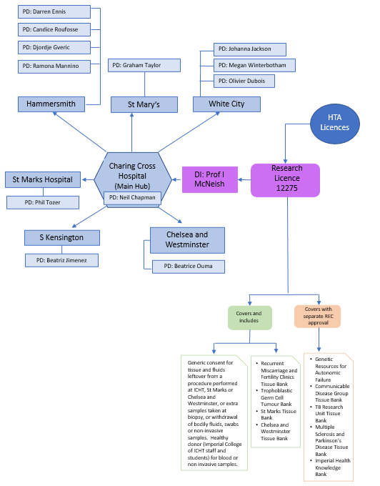
2 Sub-collection categories

There are 3 main types of sub-collection
- Those that use generic consent materials that are approved under the Tissue Bank’s own REC approval.
- Those that have used consent materials approved under a different REC approval, and the original REC approval has lapsed (e.g. a clinical trial that has finished recruiting but the Trial Management Committee wish to retain the human samples collected as part of the trial.
- Collections of human material that have been collected outside the UK or are being supplied by other Institutions in the UK.

2.1 Donors consented using ICHTB approved consent material
The majority of our sub-collections are those that use Tissue Bank consent material(s) or materials covered by the Tissue Bank REC approval (17/WA/0161) i.e. St Marks Tissue Bank, The Trophoblast and Germ Cell Tumour Tissue Bank and the Recurrent Miscarriage and Fertility Clinics Tissue Bank, to consent donors and materials are stored on ICHT/ICL premises. The SOPs that cover recording of consent using Tissue Bank consent materials are:
- TB-SOP-002CD: Recording consent for leftover tissue,
- TB-SOP-003CD: Recording consent for extra tissue,
- TB-SOP-004CD: Recording consent for healthy volunteers and
- TB-SOP-005CD: Recording consent for xenograft studies

The current versions of these SOPs are available from the Tissue Bank website.

Sub-collection registration enables PIs to collect and store material but not to use material from their collection. To use material for research they must, in addition, register a separate project that must be approved by the Application Review Panel (see Figure 2). Multiple different projects can be issued samples from each sub-collection, but each project must be approved via the mechanism agreed with REC.

2.2 Donors consented using separate specific HRA approved consent material (i.e. not part of the Tissue Bank’s current REC approval)

2.2.1 Clinical trials and human material
The majority of collections of human material that form part of a clinical study which involves additional interventions in the clinical pathway of the patient, are required to have separate project specific REC approval. These do not need to be registered under the HTA Licence and should be registered via the RGIT’s DOCUMAS system, which includes a specific tab on which information about human samples taken as part of the trial can be recorded. Frequently, biological samples are retained when the trial has completed recruitment and the REC approval for the trial has lapsed. At this point any remaining samples need to be brought under the protection of the HTA Research Licence. These collections are then treated as “imported” collections (see 2.3 below)

2.2.2 Sub-collections not covered under 2.2.1 that require cover of the HTA Licence
These are sub-collections where alternative consent materials, are used to consent donors and consent is on-going from donors in our Trust or College or as part of a national collection. These must have separate HRA approval as a Research Tissue Bank (e.g. the Parkinsons and Multiple Sclerosis Tissue Bank) and PIs must provide a blank copy of the consent form/PIS and a copy of their HRA approval letter. Research Tissue Banks must hold their collections under an HTA Licence. PIs must also provide amendments to the REC approval when made. Some of these will have agreed use of some, or all, of their samples within their specific HRA approval. In this case we do not need to have the specified use of samples approved by TMC as they are covered by the original HRA approval.

If the samples are to be used for other studies that have not been stated under the original HRA approval, the PI must seek an amendment when the sub-collection remains within the HRA approval dates. At the end of accrual of samples and HRA approval the PI can either seek renewal of specific HRA approval for their project or, where there is an element of generic consent for future unspecified use, place the samples under the HTA Licence as part of ICHTB. In the latter case any further use of samples must go through approval by the Application Review Panel (see Figure 2) and will be treated as “imported” sub-collections – see 2.3 below.

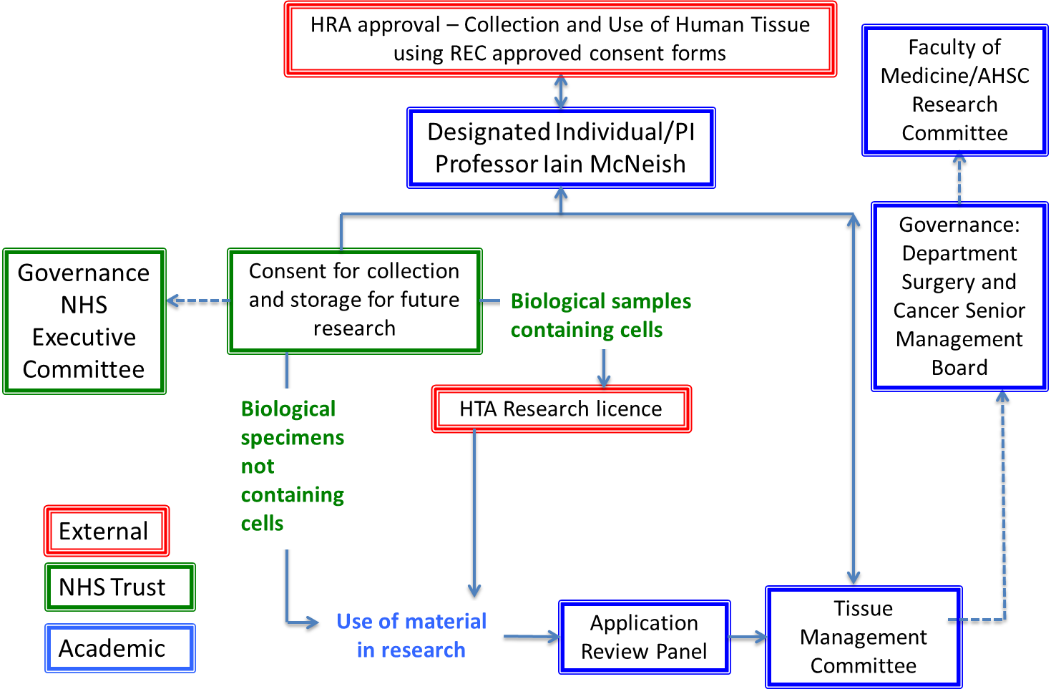
Figure 2: Governance of HTA Research Licence

2.3 “Imported” Sub-collection

These are sub-collections where the material is imported into ICL/ICHT from other institutions including those from outside the UK. These are like 2.2 above but will not necessarily have UK HRA approval. If they do not have UK HRA approval (i.e., they are imported from abroad), the PI must provide a document that states that the samples have been sourced in accordance with the local rules regarding ethics and law. These can also be collections of clinical trial materials, initially stored outside Imperial, where the original HRA approval has lapsed, but generic consent for research use of material was sought. All sub-collections must have a Material Transfer Agreement (MTA) that specifies where the samples have come from, and what they can be used for. Where the material has been consented using HRA approved forms a blank copy of the consent form and patient information leaflet must be provided. If the sub-collection has been established for use only within what is agreed on the MTA, approval for use is not required via the TMC, providing the information on the MTA is very specific and that any residual material is to be destroyed following completion of that specific project. Where future undefined research is to be carried out, and this has been agreed by the supplier of the material, each project must be approved by the Application Review Panel.

On registration, all sub-collections are given a code that links them to the Department of the PI, and to the PI themselves.

3 Roles and Responsibilities of PIs of sub-collections

Each sub-collection must have a nominated PI who is responsible for ensuring that the sub-collection is appropriately managed and who provides regular reports to the Designated Individual (DI) for the HTA Licence, through the Person Designate on their campus who has been allocated the responsibility for oversight of their sub-collection. The PI must register the sub-collection on the Tissue Bank database using an on-line tool. The guide for registering a sub-collection is TB-DOC-SCM13. PIs are expected to provide the following documents or to agree to abide by the SOPs provided by Tissue Bank staff that govern these elements when samples are received via Pathology for material left over from operations:
  - procedure for obtaining and documenting donor consent and receipt of samples
  - procedure for disposal of samples
  - procedure for transport of samples (into storage and from storage)
  - procedure for cleaning and decontamination
  - procedure for managing abnormal changes in storage temperatures
  - procedure for recording and reporting adverse events to the DI
Where the sub-collection falls into the type described in 2.2, the PI is also obliged to provide
- a blank copy of the consent form and patient information leaflet,
- a copy of the Ethics approval for the sample collection and use.
Where the sub-collection falls into the type listed in 2.3, the PI is also obliged to provide a copy of the MDTA provided by the supplier of the material, and if sourced from outside the UK, a statement that the material has been obtained according to the local ethics and law of the country in which the samples were sourced must also be provided. All the above should be uploaded to the sub-collection page on the database.
The Tissue Bank database provides an on-line tracking facility to check samples in and out of the sub-collection. New sub-collections must use this.
In some cases, legacy collections already have a tracking database. PIs may continue to use their own system but must agree with the Sub-Collection Manager a timescale to migrate to the ICHTB tracking database Where this is the case, there must be a statement to this effect provided to the Tissue Bank together with details on who has access to the database and could be asked to assist with any audits that may be required for the HTA Licence.
For new sub-collections the Prefix for sample reference numbers needs to be checked with the Sub-Collection manager at time of registration.
PIs are responsible for providing an annual report on the number of samples accrued and used (see TB-DOC-SCM9) for both HRA and HTA reporting purposes. PIs are permitted to nominate a deputy to carry out these tasks.
Any applications for access to a sub-collection must be approved by the PI of that sub-collection.
3.1 Change of PI
When a PI leaves employment at the College or the Trust they must nominate a current employee to take on their role on completion of the Change of PI form (TB-DOC-SCM2), but where they retain an honorary contract, they still retain rights over access to the material.
3.2 Transfer to new Institution
PIs may seek to take their collections with them to their new employer, but this can only be done with the consent of their Head of Department at Imperial and assurances must be provided by the new Institute that the material transferred can be stored appropriately. Removal of samples must be subject to an MTA stating what use can be made of the samples to ensure that the consent provided by the patient is respected. Document TB-DOC-SCM3 covers this procedure.
As with all documents relating to sub-collection management, these forms and their accompanying documentation, when completed, should be uploaded to the sub-collection page on the database.
- Database usage and Naming conventions

All new sub collections must use the Tissue Bank database to track their samples from acquisition to allocation to research projects (or destruction).

Database link: https://ichtb.med.ic.ac.uk/

The Database has access restrictions in place to ensure the security of details stored:
Please refer to the Database Access page to see options for logging in.

Login details: Once set up as a user, please use your ICL login details, we do not hold your login details.

If you are not yet set up as a user, please click on “Apply for an account”, you will be contacted by the tissue bank team to confirm your requirements.

Once logged into the system, please download the User Guide which can be found at the top of the left hand side menu.

All new sub collections must implement naming conventions for Donor IDs and Sample IDs. The naming conventions:
- Must be unique to the sub collection
- Must be unique to each donor / sample (including aliquots coming from the same parent sample)
- Must not include any NHS or hospital numbers, initials, or date of birth
Please follow the following naming convention:
For donors: <donor id>_<subcollection_id>
For samples: <sample_id>_<donor_id>_<subcollection_id>
For extracts: <extract_id>_<sample_id>_<donor_id>_<subcollection_id>

So, if the sub collection reference number is: ABC_FS_22_030

The first donor consented will be: 001_ABC_FS_22_030

The samples from the donor will be:

A_001_ ABC_FS_22_030 (for example this could be a whole blood sample)
B_001_ ABC_FS_22_030 (for example this could be a tissue sample)

Extracts (e.g., aliquots or sub sections) from the above parents samples will be:
A1_001_ ABC_FS_22_030 (for example this could be the 1st plasma aliquot)
A2_001_ ABC_FS_22_030 (for example this could be the 2nd plasma aliquot)
B1_001_ ABC_FS_22_030 (for example this could be the 1st smaller entity of the parent tissue sample)

- Reporting Serious Adverse Events
There are a number of areas in sub-collection management in which adverse events may occur. These should be documented using the appropriate form (TB-DOC-SCM7). PIs wishing to report SAEs should send this form to the PD copied to the DI. The PD will discuss the incident with the PI and the SAEs will be discussed quarterly at the DI/PDs meeting, where the SAE may be deemed closed when appropriate action has been taken by the PI, or further action may be requested. All SAEs will be recorded and will be reported to the Tissue Management Committee at its next meeting, and form part of the annual report to the DI’s Departmental Senior Management Board. Where an event is regarded as serious (see Table 1 for examples) this should be reported via the DI to the HTA.
Table 1 - Examples of categorization of adverse events are shown below:
Category | Example
Serious | - Conduct of non-licensed activities (e.g. storage of relevant material for research without NHS REC approval)  - Non-recoverable loss of unique relevant material (e.g. through freezer/alarm failure)  - Relevant material removed from a participant, stored or used without appropriate consent  - Staff member seeking consent without appropriate training  - Loss/compromise of relevant material and/or patient records during transportation  - Relevant material used for a research study without NHS REC/ARP approval  - Breach of Data protection/confidentiality (This must also be reported via the College’s Notification of a Data Breach System)  - Failure to dispose of material appropriately
Moderate | - Relevant material transported without appropriate transfer agreement (e.g. MTA) in place  - Labelling error that lead to the incorrect use of samples  - Inappropriate transport of specimens
Minor | - Incorrect version of policy or SOP in use  - Not registering new SOPs or updating existing SOPS to reflect changes in practice  - Documentation temporarily misplaced
Near Miss | An adverse event could have occurred if intervention had not been made, e.g.  - Short term cold storage failure with no harm to tissue  - Freezer failure leading to the requirement to transfer samples to alternative locations.  - Alarm failure with no harm to tissue  - Labelling error that was remedied  - Unauthorised access to tissue under licence with no harm to tissue

- Auditing of sub-collections
The HTA regard audit as an important component in operating a Research Licence. Audits should be carried out according to the relevant SOP (TB-SOP-003SCM). A report should be issued detailing the findings of the audit (TB-DOC-SCM4). Where a serious shortfall is identified, the PI must complete a Corrective and Preventative Action Plan (TB-DOC-SCM6). A tracking system for the auditing process is provided in the relevant area of the Tissue Bank SharePoint site. Completed Audit Reports and CAPAs must be uploaded to the sub-collection page on the database.
All other documents referenced in this document can be provided on request by the Tissue Bank by emailing tissuebank@imperial.ac.uk

