
V12 2026

Digital Foundry Handbook

Welcome to Imperial Digital Foundry. We are an interdisciplinary initiative bringing together staff and students with expertise in AI, machine learning, data science, and digital technologies. We hope you enjoy working from or visiting our office. In this handbook, we’ve pulled together some information about working on level 5 and level 6 that you might find helpful.

Core days
We aim for the Digital Foundry to be a hub for events and networking around AI, but we recognise that some people will also need to work from other locations. We have implemented Tuesdays and Thursdays as ‘core days’ – regular days where we encourage users to be present within the space. These will be the common days when more events, talks and seminars will be taking place and where networking and collaboration opportunities will be greater.

Office Etiquette
The Digital Foundry offices are a professional working space for Imperial staff and students that also welcome internal and external guests every week. Please treat the offices and your colleagues with respect by keeping your desk and area clean and tidy, taking dirty crockery to the kitchen and loading them in the dishwasher. We do not expect to see anyone sleeping on sofas or desks or using the space for personal item storage. We appreciate your cooperation in making the office a nice place for everyone to work from.

Please keep these guidelines in mind to ensure a harmonious workplace:
- Respect Personal Space: Be mindful of your colleagues' workspace. Give them the space they need to concentrate and work effectively.
- Noise Levels: Maintain a moderate noise level in the open plan areas. Remember that some tasks require deep concentration, and excessive noise can disrupt workflow. Please keep conversations at a reasonable volume and consider using designated breakout areas for louder discussions.
- Conversation Etiquette: Engage in conversations with consideration for those around you. If you need to have a lengthy discussion, consider moving to a more private area or using designated meeting spaces.
- Visitor Etiquette: When showing visitors around the office, be mindful of noise levels. Avoid speaking loudly or creating disruptions while giving tours.
- Cleanliness: Keep your workspace clean and tidy. Remove dirty dishes from your area and load them into the dishwasher. Dispose of trash properly and be considerate when using shared resources like printers and kitchen facilities, making sure to clean up after yourself.
- Meetings: Reserve meeting rooms for discussions that require privacy or may be disruptive to others.
- Breakout Areas: Utilise designated breakout areas for casual discussions, brainstorming sessions, or taking breaks. These spaces are designed to accommodate more dynamic conversations.

Facilities

Kitchens
Kitchens are located on level 6 and are available for everyone to use, however please be aware that on occasion, we may reserve a small area for events and/or catering.

Both kitchens have a fully functional coffee machine, a kettle, microwave(s), a variety of teas, hot chocolate and brown/white sugar, which are visible on all kitchen counters. Although monitored regularly, please do alert the Ops Team if you experience any issues with the equipment.

There is filtered hot and cold water from Zip taps in both kitchens. To operate these, hold down on either the red or blue button.
There are also dishwashers located under the kitchen counters which will display a status sign on the front. Please load your dishes accordingly and do not leave crockery piled up on the sides or in the sink.
There are also vending machines on levels 5 and 6, which are restored regularly by Selecta. Please be aware we are not responsible for the vending machine but if you have any issues with it, a member of the Ops Team will reach out to them to rectify.

Bathrooms
On Level 5, bathrooms are located opposite the lifts. You will need your swipe card to enter back into level 5. Bathrooms are cleaned daily by I-HUB's housekeeping team. If you notice any defects or problems with these bathrooms, please let the Ops Team know who will then raise the issue with building facilities management.
On Level 6, there are bathrooms located opposite the lifts on level 6, which again are cleaned daily by I-HUB's housekeeping team. You will still need your swipe card to enter back into level 6.
There are also bathrooms located in the north core of the floor in Zone A.
Mail
All post and packages addressed to the Digital Foundry, I-HUB, are delivered to the server room at the back of the office on level 5. If your delivery hasn’t arrived, please reach out to the mail room team:
I-Hubpostroom@cbre.com
Printer & Copier
There is a printer & photocopier located in the server room on level 5 and by the goods lift on level 6. All ICL users can access this printer using their Imperial swipe card. Please visit this How-To Guide for further information.
Stationary
If you require anything specific, please contact your departmental administrator to order. Our offices at the I- HUB are listed as a delivery option on ICIS.

Meeting Rooms on Level 5
We have three bookable meeting rooms on level 5 – Meeting Room 3 (capacity 8), Meeting Room 4 (capacity 10)
and The Conference Room (max capacity 45). You can book Meeting rooms 3 and 4 by searching for the rooms calendar in Outlook and adding it to the calendar appointment. Firstly, add the shared calendars to Outlook to
check availability by following the instructions below. Please note you will need to do this separately for each calendar.
If you would like to book The Conference Room for a meeting or event, please contact the Ops team for enquiries.
Outlook365:
Open 'Calendar' > above 'My Calendar', click 'Add Calendar' > 'Add from directory' > choose your account > search for
e.g. shrm3whi / shrm4whi > the calendar will then open.
Outlook Desktop App:
Open 'Calendar' > from the top ribbon, select '+ Open Calendar' > 'Open Shared Calendar' > type in e.g. shrm3whi / shrm4whi > the calendar will then open.

Once you can see your preferred rooms availability, please invite the rooms Surface Hub (shrm3whi or shrm4whi) as a required attendee. This will also enable you to use the Surface Hub within the room for hybrid or online meetings.

Meeting Rooms on Level 6
We have two bookable meeting rooms on level 6 - Meeting Room 5 (capacity 8) and Meeting Room 6
(capacity 6). You can book Meeting rooms 5 or 6 by searching for the rooms calendar in Outlook and adding
it to the calendar appointment. Firstly, add the shared calendars to Outlook to check availability by following
the instructions below. Please note you will need to do this separately for each calendar.

Outlook365:
Open 'Calendar' > above 'My Calendar', click 'Add Calendar' > 'Add from directory' > choose your account > search for e.g. rmihubwc5 / rmihubwc6 > the calendar will then open.

Outlook Desktop App:
Open 'Calendar' > from the top ribbon, select '+ Open Calendar' > 'Open Shared Calendar' > type in e.g. rmihubwc5 /
rmihubwc6 > the calendar will then open.

Once you can see your preferred rooms availability, please invite the room (rmihubwc5 or rmihubwc6) as a required attendee. This will ensure the room is booked by you and unable to be booked by other users.

Teaching/Lecture Room Theatres:

On level 6, we also have four teaching rooms - 608A (capacity 45), 608B (capacity 45), 612A (capacity 25)

and 612B (capacity 25). 608A and B can be joined, as can 612A and B. For enquiries, please reach out to the MSc Admin Team. Please note, any teaching will take priority over bookings.

Hot Desks & Hot Offices
We have 10 desks that are bookable for the day on level 5 - desks 30 to 34 within Zone A (pink, floor plan below)
and desks 1 to 5 within Zone C (yellow, floor plan below). 5 of these desks will be equipped with a desktop monitor with mouse and keyboard. This will be defined and visible when booking a desk.

To book a desk, please use the 'Desk Bookings' app which can be found on the Teams General channel along the top tabs.
We also have three bookable hot offices on this app; however, these are only permitted to be booked by PhDs/Researchers/Academics.

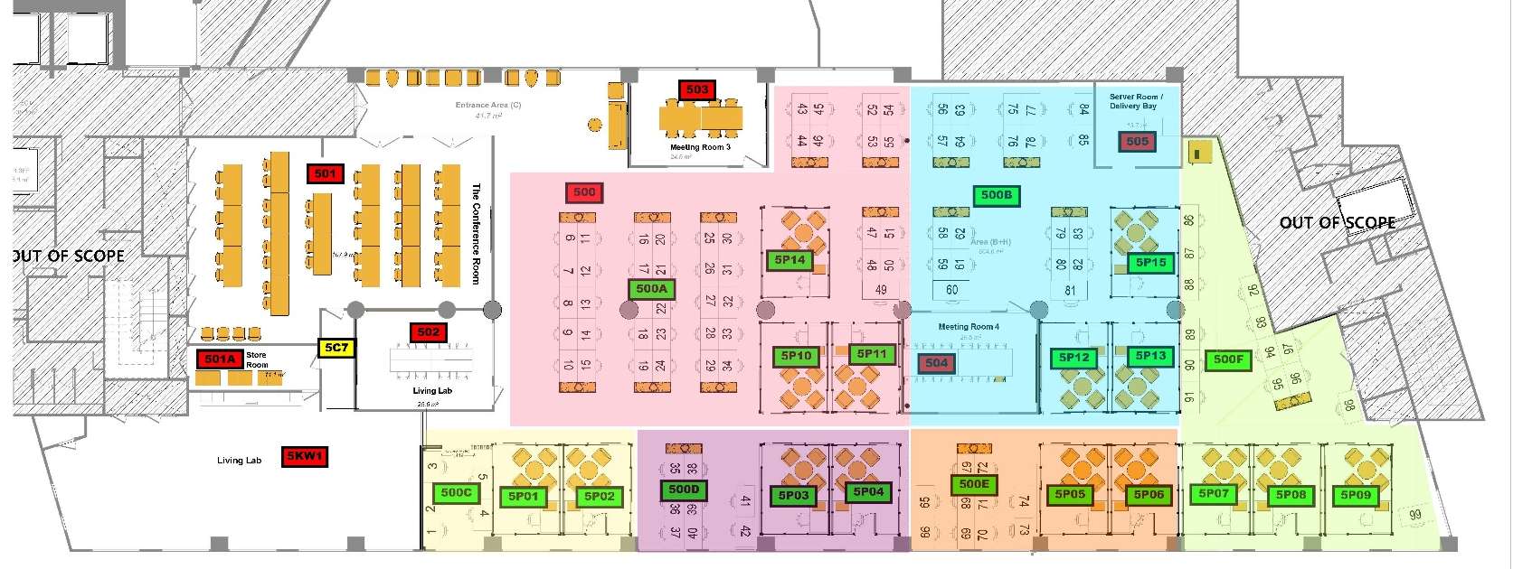

Access Cards

Although we are within an Imperial building, the I-HUB is not on the same access control system as other college buildings. Users of level 5 and 6 who will be in the office at least three times a week can apply for a Digital Foundry ID card; This will give you access to the I-HUB.

If you are planning to be in the office less than this, you can register as a visitor on the Sine visitor registration platform in reception. This will allow you to receive an access pass each time you visit. Please note, these passes need to be returned to Front of House at the end of each day as if not returned, they will be deactivated for security reasons. Please contact the Ops Team to organise either option.

Onboarding

If you have or are expecting a new student or member of staff to join the Digital Foundry, please reach out to
Lauren Burton and your departmental administrator. We will then be able to reach out with our onboarding documents and everything else needed to get them set up.

For any further information or details on this process, please speak to the Ops Team.

Events

As we are part of the I-HUB and Scale Space community as residents in the I-HUB, Digital Foundry
members are welcome to join events, socials and talks organised by the I-HUB's Community
Engagement Manager, Scale Space Events Team and the Front of House Team. To learn more about
these and register, you will need to join the platform Connect.

If you are hosting an event and would like to book our Conference Room or LRT's, please reach out to the Ops
Team to make arrangements.

For catering needs, you are welcome to use your preferred supplier if external. For internal catering bookings,
Campus services Catering will be able to provide this for you. Please be advised you will be responsible for
making these arrangements via your departmental administrator.

Health & Safety

At Imperial the safety of all staff, students, contractors and anyone else affected by the College’s activities is recognised as being of prime importance. Establishing and maintaining a strong safety culture requires high standards of safety management, demonstrable leadership and personal commitment from everyone. The security of personal property, equipment and the building depend on the vigilance and care of all.

In an emergency, your key contacts are as follows:
For the I-HUB, call Front of House on +44 (0)20 8811 6700
For the White City Campus, call Imperial Security on +44 (0) 20 7594 7565

Alternatively, you can use ‘Safezone’, the university’s emergency response app, which you can download via your device App store.

If required, first aid provision is available on both level 5 and level 6. You will find signage stating who your closest first aider is at both the East and West exit points on both floors.

If you are involved in or witness an incident, you should complete an online incident report form as soon as possible.
The form is available via CoreStream. If the person involved in an accident is unable to complete the form, a supervisor or colleague should submit the report on their behalf. Please refer to the CoreStream Incident Reporting Guide for step-by-step instructions on how to complete the form.

Fire Safety

Every Tuesday morning at 10am there is a building fire alarm test. No action is required for this. Any fire alarms should be taken seriously if sounded at any other time. For your reference, the Fire Assembly Point for the I- HUB is Perkins Green (square in the centre of Campus).

Lauren Burton and Anca Gourlay are your designated fire wardens for level 5 and 6, and Lauren and Fadong Shi (PhD) are also your designated first aiders. The I-HUB security team are on site 24/7 and are also qualified fire wardens and first aiders should you need assistance.

This video is an important refresher on I-HUB fire safety and must be viewed before collecting your ID card: https://www.youtube.com/watch?v=3OdRC4pDcic

In the event of discovering a fire, gas leak, security incident or any other serious issue, you must raise the alarm. This can be done by either:

- Activating the nearest call point (in the event of a fire), or
- Alerting Security for all other incidents (see H&S contacts above)

When you hear a fire alarm, you must leave the building immediately by the nearest safe exit and go to the designated assembly point, and you must follow all instructions given by the building and your designated fire warden.

Ensure you are aware of all escape routes and not just your normal entry routes.
- Always check to ensure your emergency exits are not blocked.
- Ensure you know where your assembly points are.
- Make sure you go to a designated assembly point and wait there.
- Do not return to the building until you are told that it is safe.

All College buildings are equipped with the means to detect fire/smoke, for an alarm to be raised, and for the occupants to reach a place of final safety. A Personal Emergency Egress Plan (PEEP) is required for anyone who has difficulties in hearing the alarm or evacuating a building unaided. In the event of an emergency either due to a mobility or sensory impairment, a temporary injury (e.g. on crutches) or difficulty coping in crowds, a PEEP should be in place. Please contact Lauren Burton to assist with getting your PEEP organised.

Some electrical items are not permitted within our demise, such as hot plates, rice cookers and electric heaters. Whilst we appreciate some users who may spend a great deal of time at the office, and the use of these items would prove convenient; these prohibitions are in place for a reason and must be adhered to for the safety of all users as well as the protection of the building. Imperial is subject to the requirements of the Regulatory Reform (Fire Safety) Order 2005.

This is a self-regulating article of legislation and for the College to fulfil its obligations, several Codes of Practice are in place. Good management of fire safety is essential to ensure that fires are unlikely to occur; that if they do occur, they are likely to be controlled or contained quickly, effectively, and safely; or that, if a fire does occur and grow, everyone is able to escape to a place of total safety easily and quickly. In recognition of the risks and the serious consequences of a fire, the College has agreed to this Fire Safety Policy and associated Code of Practice.

Imperial policies, Codes of Practice and safety regulations prohibit the use of the following equipment, which includes, but is not limited to:

Candles

Chip pans

Coffee makers (anywhere other than the kitchen)

Deep-frying equipment

Electrical tools

Electric hot pot and hot pans

Element heaters

Electric heaters* (CoP below)

Hot plates

Incense sticks

Kettles (anywhere other than the kitchen)

LED strip lights

Oil burners

Plug-in air fresheners

Pressure cookers

Rice cookers (anywhere other than the kitchen)

Toasters

As a reminder, all electrical equipment not in use should be turned off at the main power source and

unplugged and all electrical equipment should be PAT tested.

We appreciate your cooperation in keeping our space and fellow users safe; please remain attentive

and report any use of prohibited items to the Operations Team, who will also be carrying out checks to

ensure restricted items are not being used in the office space.

You can find all Codes of Practice below:

https://www.imperial.ac.uk/safety/safety-by-topic/fire-safety/fire-safety-cop/

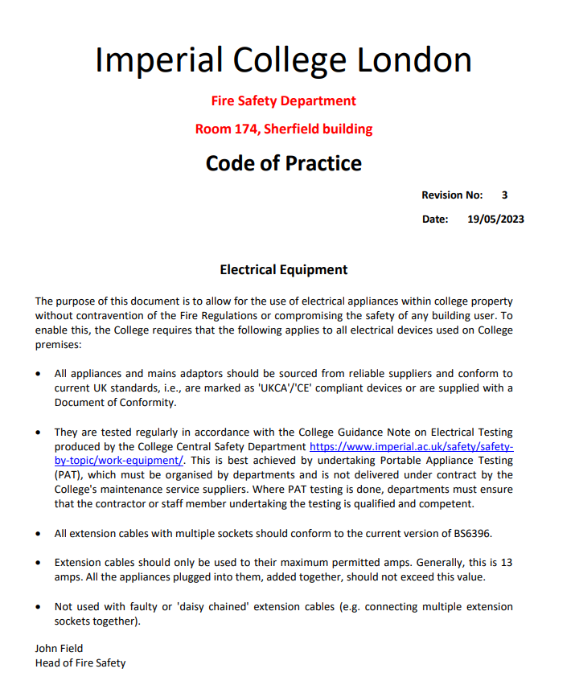

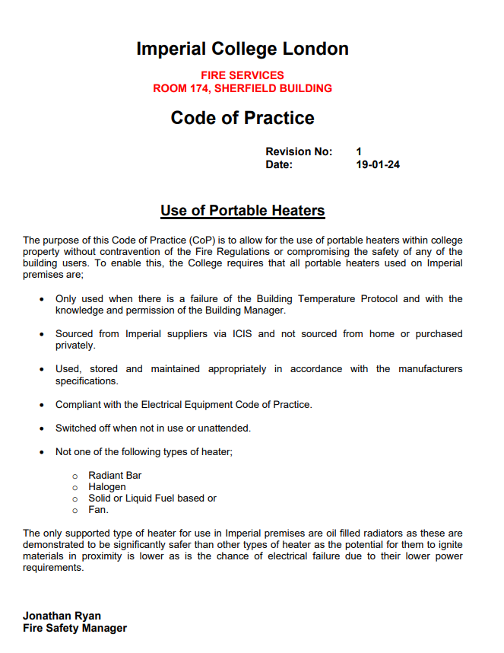

Useful Information

Waste Disposal
Please ensure all boxes and waste are flat-packed and broken down before taking to the waste room, located in the basement of the I-HUB.

You can access the basement by going to the back of the office and taking the goods lift down to the basement (B). Please note you will need to press your ID card against the reader to operate the elevator. Once you get to the basement, turn right, and continue walking until you get to the end, and the disposal area is through the doors on your left.

External Support
Some aspects of our office are managed by Imperial Estates and some by our I-HUB building management company CBRE. In the first instance, please report your issue to the Ops Team. In case of team absence, here are some contact details for the teams if it is an emergency:

Front of House:
020 8811 6700 / foh_tih@imperial.ac.uk

CBRE:
ihub.helpdesk@cbre.com

Imperial Estates:
020 7594 8000 / eo.csc@imperial.ac.uk

