CI9.S.1.0 Systems approaches in engineering: introduction and foundations
Course leader: | 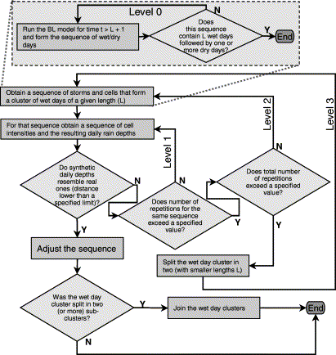  Professor David Fisk
Other contributors: | Dr Christian Onof, Ms Sarah Noyé
Term: | Autumn
Contact hours: | 25

1.0 Aims

This introductory module aims to introduce the ‘Systems thinking’ used to handle the engineering of large and complex systems, into Services engineering. It begins with a high level view of what is meant by systems and how those ideas can be extended from engineering to much wider range of applications in problem definition and management. The static descriptions of systems will be used to introduce critical path analysis and analyse the flaws in conventional design processes. The concept of feedback loop forms the introduction to dynamic systems and state space descriptions. Stochastic dynamics are explored through the noisy temperature signal induced by weather variation. Systems approaches will be applied to ‘wicked’ problems.

2.0 Syllabus

After an initial taught segment students will develop and amplify their application skills throughout the course. The main topics covered are:
- Static systems in process optimisation
- Dynamic systems and time series analysis
- Uncertainty in systems – probabilities and beyond
- Complex systems analysis
- Management of design as a systems process

3.0 Intended learning outcomes

- Skilled in the basic concepts of static and dynamic systems
- Applying systems analysis to managerial and more general systems problems
- A grasp of the concepts of system state and modelling, and controlling systems dynamics
- Understanding complexity and complication as systems concepts

4.0 Assessment

- Assessment of this module is in the form of progress tests usually given as in class group work and individual follow-up assignments.

5.0 Recommended reading:

C = Core, S = Supplementary
C | NASA. (2007) Systems Engineering Handbook, (NASA/SP-2007-6105 Rev 1), Chapters 1 & 2.  [Online] Available from: http://ntrs.nasa.gov/archive/nasa/casi.ntrs.nasa.gov/20080008301_2008008500.pdf [Accessed 08 March 2013].
C | RAEng. (2007) Creating systems that work: Principles of engineering systems for the 21st century, [Online] Available from: http://www.raeng.org.uk/education/vps/pdf/rae_systems_report.pdf [Accessed 23 March 2008]

Students are also advised to register for the following programme:
Imperial College London. (2013) Maths & Stats Online Catch-Up. [Online] Available from: http://www3.imperial.ac.uk/graduateschool/currentstudents/mathsandstatscatchup [Accessed 23 August 2013]
This is the baseline competence in mathematics for the course. Once you are enrolled use this link if you think your maths might need freshening

