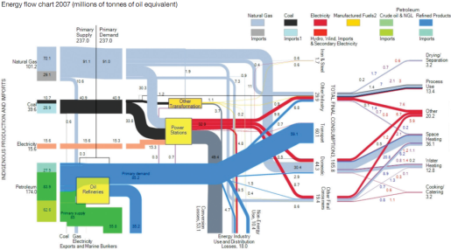
CI9.S.1.2 National Energy Systems and Energy Policy
Course leader: | Dr Robert Gross
Other contributors: | Dr Adam Hawkes, Dr Ned Ekins-Daukes, Dr Ausilio Bauen, Dr David Hart, Philip Baker, David Milborrow, Dr Gordon Edge, Dr Mark Bilton
Term: | Spring
Contact hours: | 35-40

1.0 Aims

This module aims to provide students with an understanding of the major drivers of future energy policy, and its relationship to the national energy system, as well as demand and supply side engineering. This module is run in conjunction with the Energy Policy option of the MSc in Environmental Technology and provides an opportunity to interact in class with our more policy-orientated students.

2.0 Syllabus

- Introduction to energy policy
- Electricity systems and markets
- Technology overviews including solar PV, biomass, hydrogen and fuel cells, wind power, decentralised generation, demand-side management
- Energy markets
- Renewables policy

3.0 Intended learning outcomes

- Understanding energy supply as a system
- Understanding of the role and direction of national and international energy policy
- A knowledge of instruments and interventions for decarbonisation of energy consumption
- Understanding the characteristics of the major low-carbon electricity generation technologies and their implication for the energy system and policy

4.0 Assessment

- There are two Courseworks associated with this module worth 15% each. Both need to be completed successfully in order to complete this module.
- Progress tests in the form of group work.

5.0 Recommended reading:
C = Core, S = Supplementary
C | DECC 2013 Consultation on the draft Electricity Market Reform Delivery, Department of Energy and Climate Change, London, available from: https://www.gov.uk/government/consultations/consultation-on-the-draft-electricity-market-reform-delivery
C | IEA, 2012, Key world energy statistics, International Energy Agency, Paris, available from https://www.iea.org/publications/freepublications/publication/kwes.pdf
C | Ramage, Janet (1997), Energy - A Guidebook, 2nd edition, Oxford University Press Source, Level 3 Physical Sciences & Engineering Earth Resources, 620.9 RAM (STANDARD) and Mechanical Eng 620.9 (STANDARD) and bookshop
C | Slade et al. 2011, Energy from biomass: the size of the global resource, UK Energy Research Centre http://www.ukerc.ac.uk/support/tiki-index.php?page_ref_id=3026
C | Stern, N. 2007, The Economics of Climate Change: The Stern Review. The Cabinet Office-HM Treasury: London. [Chapters 14 and 15]
C | UKERC 2006, The costs and impacts of intermittency, available from: http://www.ukerc.ac.uk/support/tiki-index.php?page=Intermittency
C | UKERC 2007, Investment Decisions in electricity generation, the role of costs, incentives and risks, available from: http://www.ukerc.ac.uk/support/tiki-index.php?page=InvestingInPower
C | UKERC 2010, Great expectations: the costs of offshore wind in UK waters, understanding the past and projecting the future, available from: http://www.ukerc.ac.uk/support/tiki-index.php?page=Great+Expectations%3A+The+cost+of+offshore+wind+in+UK+waters

