INVESTIGATOR SITE FILE

Is your Investigator Site File up to date?
Please make sure all available study documents are filed in the relevant sections of your ISF. Before each monitoring visit Study Manager will provide you with the ISF checklist to help you identify any missing paperwork.

WITHDRAWALS, LOST TO FOLLOW UPS , and STUDY COMPLETION
Please complete End of Study form (EOS) , for any patient that has withdrawn from the study and for all patients that completed their participation so far.
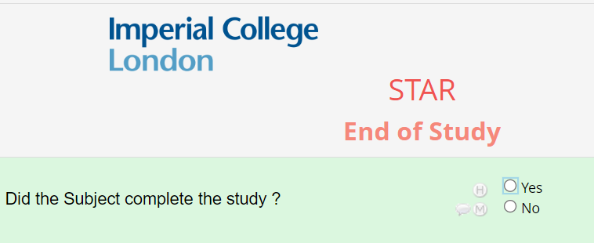
Any questions ? We are happy to help.
STAR Coordinating Centre Email : starstudy@imperial.ac.uk

Study study website :
STAR Study | Faculty of Medicine | Imperial College London


STAR - Vascular Research UK

IMPORTANT UPDATE
FINAL RECRUITMENT END DATE *** 3O JUNE 2025

NEW PATIENTS FOLLOW UP TIMELINES , FOLLOWING RECRUITMENT EXTENSION:
- FOR PATEIENTS RECRUITED BEFORE SEPTEMEBER 2024 –
12 MONTHS FOLLOW UP
- FOR PATIENTS RECRUITED BETWEEN SEPTEMBER 2024 – FEBRUARY 2025
6 MONTHS ACTIVE FOLLOW UP / 12 MOTNHS FOLLOW UP FROM PATIENT NHS RECORDS ( TBC)
- FOR PATIENTS RECRUITED BETWEEN MARCH 2025 – JUNE 2025 –
3 MOTNHS ACTIVE FOLLOW UP
Implementing this new approach and conducting a minimum follow-up at 3 months post-operation, will allow us to collect data for thorough statistical analysis and offer the STAR pathway to more eligible patients. There are no recorded serious adverse events (SAEs) or complications observed between 6 and 12 months postoperatively. We are in the process of submitting a substantial amendment to update the study documentation.
ON- SITE MONITORING VISITS CONTINUE
Site 03 – Frimley Health NHS Foundation Trust – 29th November 2024 – completed
Site 02 – Norfolk and Norwich University Hospitals NHS Foundation Trust - 4th December 2024

You can email our friendly team at starstudy@imperial.ac.uk for all things STAR related. We are happy to help.

You can email our friendly team at starstudy@imperial.ac.uk for all things STAR related. We are happy to help.

STAR * N E W S L E T T E R *
DECEMBER 2024
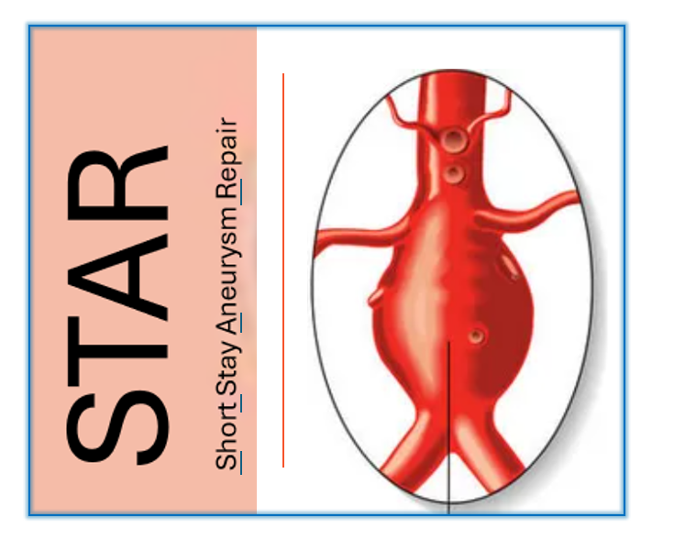
Welcome to the 5TH edition of our Newsletter! We are excited to share with you hot STAR updates. Thank you for your participation in STAR study and for all your efforts in screening and recruiting patients.
“Dreams do not work unless you do …’’ John C. Maxwell

STAR Numbers, Numbers, Numbers ….
- 30 /100 Patients successfully enrolled
- 471 Patients screened in total
- 5 Sites actively recruiting

Norfolk and Norwich- SCR 147 / Enrolled 15
Imperial College London – SCR 110 / Enrolled 9
Frimley Health - SCR 178/ Enrolled 5
Leicester University Hospitals-- SCR 16 / Enrolled 1
Newcastle Upon Tyne – SCR 20 / Enrolled 0

