Participant Information Sheet (PIS)

Imperial Knee health cohort: New Exploration of Early-stage changes study

You are being invited to take part in the Imperial KNEE research study. Before you decide it is important that you to understand why the research is being done and what it will involve for you. Please take time to read the following information carefully and discuss it with others if you wish.
PART 1 tells you the purpose of this study and what will happen to you if you take part.
PART 2 gives you more detailed information about the conduct of the study.
Please ask us if there is anything that is not clear of if you would like more information. Take time to decide whether or not you wish to take part. Thank you for reading this.
PART 1
DO I HAVE TO TAKE PART?

No, your participation is entirely voluntary. It is up to you to decide whether or not to take part.
If you decide to take part, you will be given this Participant Information Sheet (PIS) to keep and will first be asked to sign a consent form. If you decide to take part, you are still free to withdraw at any time and without giving a reason. Your decision to withdraw at any time, or a decision to take part, will not affect the standard of care you are receiving, now or in the future.

WHAT IS THE PURPOSE OF THE STUDY?

Everyone’s joints go through damage and repair during their lifetime, but sometimes the body’s process to repair our joints can cause changes in their shape and structure. When these changes happen in your knee and are associated with knee symptoms (like pain, stiffness, and reduced mobility), it is known as knee osteoarthritis. Osteoarthritis is the most common form of arthritis.
The development of osteoarthritis can be quite unpredictable. Early on symptoms (and structural changes) can get worse (‘progress’) or get better, but we do not know why.
The Imperial KNEE study is designed to help better predict these processes, which could help us to develop new treatments in the future.
To understand the changes happening in the knee joint, we want to analyse biological samples: blood, knee synovial fluid (knee joint fluid) and for some participants, the saliva.
In our joints, knee joint fluid is a gel-like fluid that helps cushion our joints from impact and lubricates our joints during movement. This fluid contacts different parts of our joints, and we believe that by studying this fluid from your knee, we could understand more about the processes happening in the knee joint that predicts worsening of osteoarthritis. We want to study if the same processes can be detected in blood.
We also want to analyse DNA (Deoxyribonucleic acid). DNA is your unique genetic code which holds the instructions for building and operating your body. It is responsible for your characteristics like your eye colour, but it can also affect features about your health, for example, what medical conditions you might be more at risk of developing. We want to understand more about the genetic reasons that make some individuals more likely to develop osteoarthritis changes in their knees. For this study, DNA can be analysed from a blood sample, or with an extra test that is carried out using a saliva sample.

The Imperial KNEE study will also look at how knee injuries (such as an Anterior Cruciate Ligament rupture or a meniscal tear) may affect someone’s risk of developing osteoarthritis. It will explore the differences between osteoarthritis which began with a sudden knee injury compared with those whose osteoarthritis started with other changes (for example, a degenerative meniscal tear).
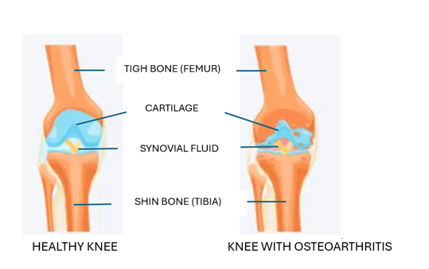
The left side shows the thick, smooth cartilage in a healthy knee. The right side shows how osteoarthritis can lead to shape changes in cartilage (narrowing) and bone (new bone forming) and shows the knee joint fluid inside the knee joint which bathes these tissues.
By knowing someone’s individual risk of developing osteoarthritis, this could allow doctors to intervene earlier, with more effective treatments, tailored to someone’s individual needs. In the future, this could lead to improved outcomes and quality of life than is possible today.
WHY HAVE I BEEN CONTACTED?

You have been invited to consider taking part in this study because you have experienced a knee injury in the past, which may increase the risk of future joint changes.

Specifically, you were identified through one of the following ways:
- Your hospital doctor has identified you from a list of patients who have previously been treated for a knee injury.
- The research team reviewed your details from a mailing list or registry for which you previously gave consent to be re-contacted.
In either case, your medical records or prior consent details were reviewed to confirm your potential eligibility for this study. We hope to recruit 200 individuals that will take part in our study.
WHAT WILL HAPPEN TO ME IF I TAKE PART?

You would take part for a minimum of 2 years and a maximum of 5 years.
Most study activities, like questionnaires and follow-up data collection, will be conducted remotely, with information collected at yearly intervals.
Having received this Participant Information Sheet, you will also find an Invitation Letter and an Informed Consent Form included in your pack. Please take as much time as you need to decide if you are interested.

Screening Telephone Call and Baseline Visit – combined (Estimated time: 20-30 minutes)

Once we receive your signed Informed Consent Form, a member of the research team will schedule a brief Screening telephone call (approximately 10 minutes) with you. We will ask you a few questions to check whether you meet the study criteria (to confirm your eligibility). This ensures we have accurate information that may not have been fully captured in your hospital medical records.

If the screening call shows that the study isn’t right for you, we will stop the process there. We will record the reason why you weren’t able to join, and the researcher will explain this to you. In these cases, we will thank you for your time, but you will not take any further part in the study.

If the screening shows that the study is right for you, you will be enrolled in the study, and our research team will begin collecting part of your Baseline Visit information (Estimated time: 10-20 minutes).

We will call your first visit the ‘baseline’. It is the starting point of the study that helps us understand your health situation before we move forward. A researcher will briefly review your previously shared knee health data and update your profile with any relevant details from your recent medical records. This ensures that the data we already hold is current and accurate before we proceed further. We will collect the following information:
● Basic information, such as your sex, current: age and body mass index (BMI); smoking status, ethnic background (optional)
● Confirmation of which knee is affected
● Past/current treatments for your knee/knee injury
● Past/current medications that you take
● Any recent knee imaging (X-ray/MRI scan) that you have had, if applicable.
There will also be a chance to discuss preferences for receiving future follow up questionnaires (e.g., email link or post). We will send you a Welcome Pack that includes the following items:
● Confirmation Letter: A letter officially welcoming you to the study and confirming your enrolment.
● Study Core Questionnaire Pack:
You will complete 2 short questionnaires about your knee health, pain, and activity levels, in an electronic format (either via email link or by post, as per your preference):
- The Knee Injury and Osteoarthritis Outcome Score (KOOS) questionnaire. This takes around 10 minutes to complete. You will be asked questions describing the activities which cause you pain and the type of symptoms that you are experiencing.

- Tegner Activity Scale (TAS) questionnaire. This is one question and takes a maximum of 5 minutes to complete, and you will be asked what level of activity you currently participate in.

Baseline Visit - Second part of the Screening telephone call (Estimated time: 10-20 minutes)

● Study Core Questionnaire Pack completion, as outlined above (15 minutes)

● Saliva Sample Collection Kit for DNA analysis (1 millilitre - equivalent to one-fifth of a teaspoon of saliva will be needed). The pack includes a complete kit with step-by-step instructions and a pre-paid envelope to post back to us, making it easy for you to complete and return it from home. Collecting the sample usually takes 2-5 minutes.

Follow Up Visits: Years: 1, 2, 3, 4 and 5 - Remote (Estimated Time: 17 Minutes each)
● Study Follow Up Questionnaire Pack, which includes:
- The same two short questionnaires as in the Core Questionnaire Pack listed above (to see if anything has changed)
- You will also answer few questions about any surgical procedures (including the timing and type) performed on your affected knee between Year 1 and Year 5, post-enrolment.
Typically, a personalised link to the questionnaire pack will be sent to you by email if you have agreed to this. Alternatively, we can post you a paper pack to fill in and send back in a stamped addressed envelope.
A full summary of the study remote visits and what is involved at each timepoint can be found in the Schedule of Study Visits table below:
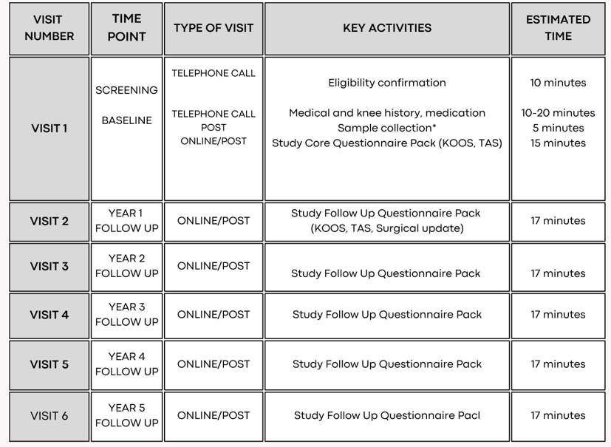
WHAT IS INVOLVED IN PROVIDING A SALIVA SAMPLE?

To make this as convenient as possible, the collection kit includes step-by step instructions and pre-paid return packaging so you can complete it at your convenience.
Once your eligibility is confirmed at screening, we will post your saliva kit to you within 2 weeks.
The process is straightforward and involves spitting into a small tube until you reach the necessary volume of 1 millilitre (equivalent to one-fifth of a teaspoon). The image below (Figure 1) shows an example of what the saliva collection kit will look like.

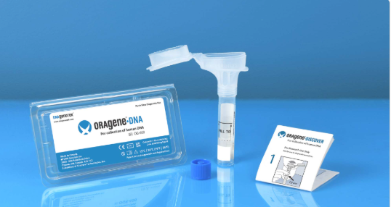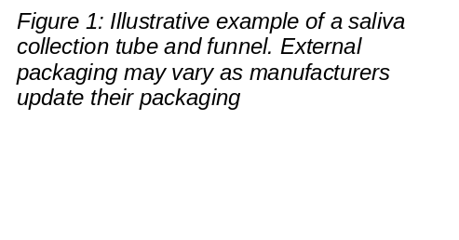

To ensure a good quality of the sample:
- Do NOT eat, drink, smoke, or chew gum for 30 minutes before giving your saliva sample.
- Do NOT remove the plastic film from the funnel lid.
Precautions: Do NOT ingest any contents of the saliva collection kit. The stabilising liquid in the kit is an irritant, if it comes into contact with eyes or skin, wash with water. The small cap that is used to close the tube may pose a choking hazard and the kit should be kept away from small children.
If you are providing a saliva sample, your schedule of visits (described below) remains the same as the main study, with the addition of a single, one-off activity to collect the sample at the start of the study (at the baseline stage). Most people take between 2 and 5 minutes to collect the sample.

DURING THE STUDY
You will have the opportunity to contact our research team if you have any questions or concerns. For our full contact details (including phone number and email), please refer to the 'Contact Details' section on Page 14.

WILL I GET PAID FOR TAKING PART?
There is no payment for taking part in this study. However, we will ensure there is no cost to you for participating in the study and we will provide you with pre-paid envelopes for any postal questionnaires (if you opt for these) and for your saliva sample that you complete.

WHAT TESTS WILL BE CARRIED OUT ON MY SAMPLES?

Genetic tests (DNA Analysis): We will analyse your genetic material, to measure genetic factors that might be linked to knee health, injury responses, knee joint healing or osteoarthritis.

Differences in DNA between individuals exist and can be important, for example influencing disease risk or treatment response. In this research, we want to understand how variations in DNA might relate to differences in disease risk and getting worse.

We will use your sample to study these variations specifically related to knee osteoarthritis. We will not look for risk factors for any other health conditions that would affect your medical care or insurance. Sometimes we look at individual genes and sometimes thousands of variations across genes.

WHAT WILL HAPPEN TO MY SAMPLES AFTER COLLECTION?
Your sample will be transferred to Imperial College London laboratory at the Hammersmith Hospital site processed and stored securely. Your sample will be kept for the duration of the study and anything not used up by the end as part of the analysis would be destroyed, or else transferred to a Biobank (if you give your permission).

WHAT IF I DECIDE TO WITHDRAW AFTER PROVIDING CONSENT?
You are free to withdraw from the study at any time, without giving any reason, and this will not affect the standard of care or treatment you receive from your NHS doctor. You can do so by informing the research team in writing (via post or by email), to let us know that you want to withdraw from the study. Please see section ‘Contact Details’ on Page 14.

You can withdraw partially - you stop attending any further follow up visits but allow us to keep and use the research data and samples you have already provided up to that point. You can withdraw totally - you ask us to destroy all existing research data and samples.
If you decide to withdraw and not instruct us what to do with your data and sample, we will assume we can continue to use them. If you wish for your sample or data to be destroyed, you must specifically let the study team know. (Please note that sample and data already used in analysis cannot be removed, but we will destroy any remaining unused sample).
The investigator also has the right to withdraw you from the study in case of an adverse event, or if there is any unplanned departure from that official study plan. For example, if you have a knee joint replacement surgery, we will record this information, and you may then be withdrawn from the study beyond that point and no longer contacted for follow-up.
In the unlikely event that you lose capacity during the study period; you will be withdrawn from the study and no further data about your care will be collected. Data/samples already collected with consent will be retained and used for analysis.
This completes PART 1 of the Information Sheet. If this Information has interested you and you are considering taking part, please continue to read the additional information in PART 2 before making any decision.
PART 2
WHAT ARE THE POSSIBLE SIDE EFFECTS OF TAKING PART IN THE STUDY?

Saliva sample collection: Mild discomfort from holding saliva in your mouth and spitting.

WHAT ARE THE POSSIBLE DISADVANTAGES AND RISKS OF TAKING PART IN THE STUDY?

Time commitment and inconvenience
Participation in the study will require time for the Screening Telephone Call and Baseline Visit (these are combined) and subsequent follow-up visits. All visits will be done remotely via your preferred contact method.
Saliva sample collection and sample storage:
To minimise any labeling risk, the study team will pre-label your kit with your unique study identification number.
- Your kit could be lost in the post. If your kit is lost in transit, we will send you a replacement kit.
- If accidental leakage occurs, we will send you a replacement kit. The kit’s packaging contacts absorbent material to prevent the escape of any liquids.
- If you have any concerns about collecting and posting your saliva sample safely, please let the study team know.

Genetic samples:
When you donate sample for genetic research, you are sharing information contained in your DNA (your unique genetic code). There is a theoretical potential for re-identifying you that could lead to a loss of privacy. Genetic technology is changing very quickly, which means the potential future uses (and so risks) of use of your genetic data may be unknown The study team will take every security measure possible to protect your privacy and the confidentiality of your data both now and in the future.
WHAT ARE THE POSSIBLE BENEFITS OF TAKING PART IN THE STUDY?

There will be no direct benefit to taking part in this study, but the results may help patients and assist doctors by advancing the understanding of the process of knee injury progression over time, including developing improved diagnostic tests and better treatments in the future. This information may also help to design more personalised patient care for the long-term.
WHAT IF THE NEW INFORMATION BECOMES AVAILABLE?

Sometimes during the course of a research project, new information becomes available that might affect your safety or wellbeing. . If this happens, your research team will tell you about it and discuss with you whether you want to continue in the study. If you decide to withdraw, your standard NHS medical care will not be affected in any way. If you decide to continue in the study, you will be asked to sign an updated Informed Consent Form.

INVOLVEMENT OF THE GENERAL PRACTITIONER (GP) / FAMILY DOCTOR

With your permission, your GP will be kept informed of your participation in the Imperial KNEE study, but otherwise all information about you and your remote visits will remain confidential. In the event where incidental findings relating to your health (i.e. medical conditions unrelated to your knee condition) are discovered, your clinical team will ensure your GP is informed. This may involve them arranging appropriate follow up with the relevant team.

WHAT HAPPENS IF THE RESEARCH STOPS?

When the research study stops, you will continue to receive your standard clinical care.

WHAT IF SOMETHING GOES WRONG?
Imperial College London holds insurance policies which apply to this study.
If you experience harm or injury as a result of taking part in this study, you will be eligible to claim compensation without having to prove that Imperial College is at fault. This does not affect your legal rights to seek compensation.

If you are harmed due to someone's negligence, then you may have grounds for a legal action. Regardless of this, if you wish to complain, or have any concerns about any aspect of the way you have been treated during the course of this study, then you should immediately inform the Investigator (Insert name and contact details). The normal National Health Service mechanisms are also available to you. If you are still not satisfied with the response, you may contact the Imperial College, Research Governance and Integrity Team.
TRANSPARENCY NOTICE

Everyone involved in this study will keep the data collected as part of this study, including your personal data, safe and secure. We will also follow all privacy laws and legislation that are relevant to the study. At the end of the study, we will keep data in case we need to check it, or for future research. For this purpose, your data will be stored under your unique study number, with your name and all other identifying details removed. This is called ‘pseudo-anonymisation.’ We do this to make sure no one can work out who you are from the reports we write. Individual researchers will not receive any personal payment over and above normal salary, or any other benefits or incentives for taking part in this research.
HOW WILL WE USE INFORMATION ABOUT YOU?

Imperial College London is the sponsor for this study and will act as the Data Controller for this study. Being a Data Controller means that we are responsible for looking after your information and using it appropriately plus are responsible for explaining this to you. Imperial College London will keep your personal data for:

- 10 years after the study has finished in relation to data subject consent forms.
- 10 years after the study has completed in relation to primary research data.

The study data will then be fully anonymised and securely archived or destroyed.

The study is expected to finish in July / 2031.

For more information / confirmation regarding the end date please contact the study team, see ‘WHERE CAN YOU FIND OUT MORE ABOUT HOW YOUR INFORMATION IS USED’ for contact information.
We will need to use information from you and from your medical records for this research project. This information will include your:

● Name ● Medical history, including any data on surgical
● Address procedures
● NHS Number ● Images of your knee X-rays/MRI, collected as
● Date of Birth part of your usual care.
● Contact details

People within the College and study team (see section sharing your information with others) will use this information to do the research or to check your records to make sure that research is being done properly and the information held (such as contact details) is accurate.

Imperial College London is the sponsor of this research and is responsible for looking after your information. We will keep all information about you safe and secure by:
● Data management plans have been created and reviewed in line with Imperial’s Information Governance Policy Framework. This covers the collection, movement, processing, and storage of the data
● Data to be stored in a dedicated secure environment which underpins security measures
● Robust pseudonymisation has been implemented to prevent identification
● Access controls have been implemented to ensure only key personnel can access the data.

Once we have finished the study, we will keep some of the data so we can check the results. We will write our reports in a way that no-one can work out that you took part in the study.
As a university we use personally-identifiable information to conduct research to improve health care and services. As a publicly-funded organisation, we have to ensure that it is in the public interest when we use personally-identifiable information from people who have agreed to take part in research. This means that when you agree to take part in a research study, we will use your data in the ways needed to conduct and analyse the research study.
LEGAL BASIS

Our legal basis for using your information under the General Data Protection Regulation (GDPR) and the Data Protection Act 2018, is as follows:
● Imperial College London - “performance of a task carried out in the public interest;” Health and care research should serve the public interest, which means that we have to demonstrate that our research serves the interests of society as a whole. We do this by following the UK Policy Framework for Health and Social Care Research.
Where special category personal information is involved (most commonly health data, biometric data i.e. fingerprints or facial recognition and genetic data, racial and ethnic data etc.) Imperial College London relies on “scientific or historical research purposes or statistical purposes’’.

INTERNATIONAL TRANSFERS
We may share data about you outside the UK for research-related purpose to:
● Where necessary, share with a collaborator who is also involved in related research
● Where necessary, provide access to a data processor (or service provider, if applicable) who will utilise your anonymised personal data as instructed by us. These could be your genetic information or X-ray imaging.
If this happens, we will only share the data that is needed. We will also make sure you can’t be identified from the data that is shared where possible. This may not be possible under certain circumstances – for instance, if you have a rare illness, it may still be possible to identify you. If your data is shared outside the UK, it will be with the following sorts of organisations:
● University researchers working with us on these research questions in osteoarthritis
● Companies developing drugs who are working with us via international consortia.

We will make sure your data is protected.
Anyone who accesses your data outside the UK must do what we tell them so that your data has a similar level of protection as it does under UK law. We will make sure your data is safe outside the UK by doing the following:
● We use specific contracts which stipulates that personal data must maintain the same level of protection when outside the UK as it has within the UK. For further details visit the Information Commissioner’s Office (ICO) website - www.ico.org.uk
● We do not allow those who access your data outside the UK to use it for anything other than what our written contract with them says
● We have procedures in place to deal with any suspected personal data breach. For further details about UK breach reporting rules visit the Information Commissioner's Office (ICO) website - Personal data breaches: a guide | ICO

SHARING YOUR INFORMATION WITH OTHERS

We will only share your personal data with certain third parties for the purposes referred to in this Participant Information Sheet and by relying on the legal basis for processing your data as set out above.

● Other Imperial College London employees (including staff involved directly with the research study or as part of certain secondary activities which may include support functions, internal audits, ensuring accuracy of contact details, etc.)

● Imperial College London agents, contractors, and service providers (for example, suppliers of printing and mailing services, email communication services or web services, or suppliers who help us conduct any of the activities described above).

Our third-party service providers are required to enter into data processing agreements with us. We only permit them to process your personal data for specified purposes and in accordance with our policy.

RESEARCH COLLABORATORS AND PARTNERS IN THE STUDY

We might need to share your anonymised data with our research collaborators; these include regulatory authorities where required.
We will ensure your name and any identifying details will NOT be given to these third parties, instead you will be identified by a unique study number. This means that any data analysis cannot identify either you or which results come from you.

POTENTIAL USE OF STUDY DATA FOR FUTURE RESEARCH

When you agree to take part in a research study, the information collected either as part of the study or in preparation for the study (such as contact details) may, if you provide consent, be used to contact you about participating in other research studies conducted by researchers within our department at Imperial College London.
Your information will only be used to conduct research in accordance with legislation including the GDPR and UK Policy Framework for Health and Social Care Research.
This information will not identify you and will not be combined with other information in a way that could identify you, used against you or used to make decisions about you.
COMMERCIALISATION

COMMERCIALISATION

Sample(s) and data from the study may also be provided to organisations not named in this Participant Information Sheet, e.g. commercial organisations or non-commercial organisations for the purposes of undertaking the current study, future research studies or commercial purposes such as development by a company of a new test, product or treatment. We will ensure your name and any identifying details will NOT be given to these third parties, instead you will be identified by a unique study number with any sample/data analysis having the potential to generate ‘personal data’.

Combined or anonymised data sets (all identifying information is removed) may also be created using your data (in a way which does not identify individuals) and be used for such research or commercial purposes where the purposes align to relevant legislation (including GDPR) and wider study aims. Your data will not be shared with a commercial organisation for marketing purposes.

WHAT ARE YOUR CHOICES ABOUT HOW YOUR INFORMATION IS USED?
You can stop being part of the study at any time, without giving a reason, but we will keep information about you that we already have, unless instructed by you otherwise.
You have the right to ask us to access, remove, change, or delete data we hold about you for the purposes of the study. You can also object to our processing of your data. We might not always be able to do this if it means we cannot use your data to do the research. If so, we will tell you why we cannot do this.
We need to manage your records in specific ways for the research to be reliable. This means that we may not be able to let you see or change the data we hold about you if this could affect the wider study or the accuracy of data collected,
WHERE CAN YOU FIND MORE ABOUT HOW YOUR INFORMATION IS USED

You can find out more about how we use your information, including the specific mechanism used by us when transferring your personal data out of the UK:
- at https://www.hra.nhs.uk/about-us/what-we-do/our-role-protecting-research-participants/
- by asking one of the research team (contact details given on Page 14)
- by sending an email to imperial.OAresearch@nhs.net
- by ringing us on 07858 367326
- by visiting our dedicated Imperial KNEE study website:https://www.imperial.ac.uk/immunology-inflammation/research/cid/imperial-joint-health/
COMPLAINTS

If you wish to raise a complaint about how we have handled your personal data, please contact the research team first by sending an email to imperial.OAresearch@nhs.net , or by ringing us on (+44) 07858 367326.

Following our response, if you are not satisfied, please contact Imperial College London Data Protection Officer via email at dpo@imperial.ac.uk via telephone on 020 7594 3502 and/or via post at Imperial College London, Data Protection Officer, Faculty Building Level 4, London SW7 2AZ.

If you remain unsatisfied with our response or believe we are processing your personal data in a way that is not lawful you can complain to the Information Commissioner’s Office (ICO) - via www.ico.org.uk. Please note the ICO does recommend that you seek to resolve matters with the data controller (us) first before involving them.

WHAT WILL HAPPEN TO THE RESULTS OF THE STUDY?

Only anonymous group information and no personal information will be presented so you will not be identified as being involved with this research.

A summary of the study results will be sent to you at the end of the project via your preferred contact method (as indicated on the consent form). This ensures that you are kept informed about the impact of the research you contributed to. You can opt out of receiving this summary at any time by simply informing a member of the research team.

We intend to share the results of the study via peer-reviewed scientific journals, conference presentations and publications, on the Imperial KNEE study website and the Health Research Authority (HRA) website:
- Imperial KNEE Study website: https://www.imperial.ac.uk/immunology-inflammation/research/cid/imperial-joint-health/

You can also scan this QR code with your smartphone camera to go


directly to our study website.

- HRA Website: https://www.hra.nhs.uk

WHO IS ORGANISING AND FUNDING THE STUDY?

This study is being organised by Chief Investigator Dr Fiona Watt and sponsored by Imperial College London. It is funded by the UK registered charity - Arthritis UK and supported by the UK Research and Innovation (UKRI).

WHO HAD REWIEVED THE STUDY?

This study was allowed to go ahead after being approved by the Research Ethics Committee having given a favourable ethical opinion for conduct in the NHS by the London - Riverside Research Ethics Committee.

CONTACT DETAILS

📞 Imperial KNEE study Coordinator:

You can contact Malgorzata Kochanska, directly by telephone on 07858 367326 - during working hours (Monday-Friday, 09:00-17:00)

▶️ Osteoarthritis Research Group:

Email: imperial.OAresearch@nhs.net - during working hours (Monday -Friday, 09:00–17:00) A member of the research team will get back to you.

Address: Centre for Inflammatory Disease, 9th Floor, Commonwealth Building, Department of Immunology and Inflammation, Imperial College London Hammersmith Campus, Du Cane Road, London, W12 0NN

Patient Advice and Liaison Service (PALS): offers independent advice for your concerns, suggestions, and queries. They are available Monday to Friday 09:00-17:00. The PALS team can be contacted on 0203 313 3322 or through email at imperial.pals@nhs.net.

Research Governance and Integrity Team (RGIT) offers independent oversight and ensures that your rights and safety as a research participant are protected. Contact details: Room 215, Level 2, Medical School Building, Norfolk Place, London, W2 1PG, Tel: 0207 594 9480.https://www.imperial.ac.uk/research-and-innovation/research-office/research-governance-and-integrity/

You can find more information on knee osteoarthritis on:

Arthritis UK - is a leading arthritis charity in the UK, dedicated to changing lives through research, campaigning and support. Osteoarthritis (OA) of the knee | Knee pain | Arthritis UK.

NHS England - NHS England leads the National Health Service (NHS) in England, Making a decision about knee osteoarthritis.

NHS - a government body that promotes high quality health and care for all through the NHS Long Term Plan, Osteoarthritis - Treatment and support.

Thank you for taking time to consider taking part in the study.
If you accept to participate a copy of this written Participant Information Sheet and signed informed consent will be given to you.



